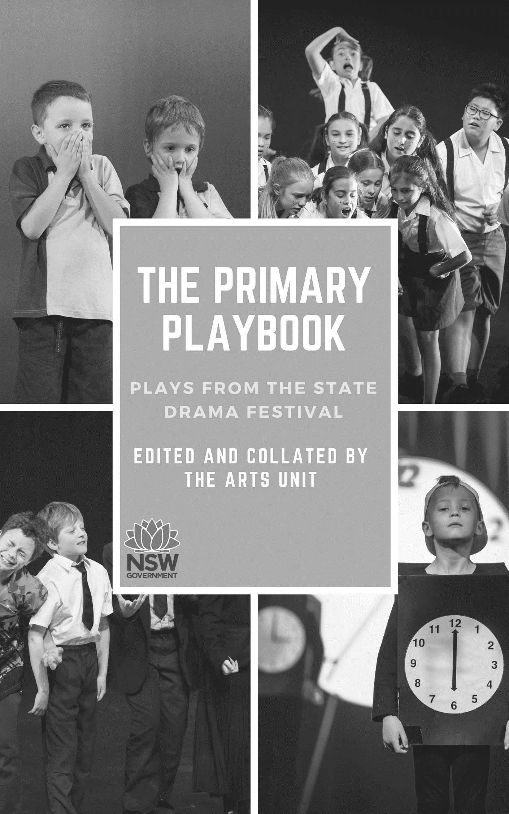
The Primary Play Book: Plays from the State Drama Festival
1st Edition
Collated and Edited by The Department of Education’s The Arts Unit

First published by The Arts Unit
Locked Bag 1500
Petersham, NSW 2049

Publisher: Violet House
Project Management: Jane Simmons
Project Coordinator: Elizabeth Rosser
Cover Design: Created by Violet House using Canva
Text Design and Typesetting: Violet House
Cover Images: courtesy of The Arts Unit
Chapter Opening Images: Created by Violet House using Canva
Contributors:
Time is Ticking Julie Parker (Newport Public School)
Day One Catherine Simpson (Regentville Public School)
Fly! Jenny Nylund (Boronia Park Public School)
Adrift David Todd (Vaucluse Public School)
Imaginitis Jessica Venables and Lynda Leavers (Sylvania Heights Public School)
Are We There Yet? Narelle Walton (Harbord Public School)
The Time Machine Tamara O’Rourke (Beverly Hills North Public School)
NAPLAN Ben Van Biljon (Mosman Public School)
Never Centre Stage Ben Van Biljon (Mosman Public School)
Supermarket Frenzy Ben Van Biljon (Mosman Public School)

© 2019 The Department of Education’s The Arts Unit
Copyright notice
COPYING FOR EDUCATIONAL PURPOSES
The Australian Copyright Act 1968 (Act) allows a maximum of one chapter or 10% of this book, whichever is greater, to be copied by any educational institution for its educational purposes provided that the educational institution (or the body that administers it) has given a remuneration notice to Copyright Agency Limited (CAL) under the Act.

COPYING FOR OTHER PURPOSES
Except as permitted under the Act, for example a fair dealing for the purposes of study, research, criticism or review, no part of this book may be reproduced, stored in a retrieval system, or transmitted in any form or by any means without prior written permission. All enquiries should be made to the publisher at the address above.

For full details of CAL licence for educational institutions contact CAL, 11/66 Goulburn Street, Sydney, NSW 2000. Email: info@copyright.com.au
Table of Contents
Foreword by Jane Simmons | 4
Plays for Kindergarten, Year 1, Year 2 | 5
Time is Ticking by Julie Parker | 6
Day One by Catherine Simpson | 17
Plays for Year 3 and Year 4 | 28
Fly! by Jenny Nylund | 29
Imaginitis by Jessica Venables and Lynda Leavers | 55
Are We There Yet? by Narelle Walton | 74
Plays for Year 5 and Year 6 | 91
The Time Machine by Tamara O’Rourke | 92
NAPLAN by Ben Van Biljon | 116
Never Centre Stage by Ben Van Biljon | 136
Supermarket Frenzy by Ben Van Biljon | 153
Adrift by David Todd | 173
Glossary | 197
Foreword

The NSW Public Schools State Drama Festival showcases excellent pieces of devised drama by Kindergarten to Year 12 public school students from across NSW. This event, which takes place in October each year, is a wonderful exemplar of the work happening in classrooms throughout the state and, whilst delightful to watch, these performances reinforce the talent of the teachers in our schools.
To expand on the final product seen at the festival, we examined the processes that help teachers nurture their groups to that final performance. We worked with teachers who have consistently produced outstanding scripts and stagecraft and asked them to compile their scripts, align them to syllabus outcomes and expand on the classroom activities that assisted them in preparing the students for performance.
Knowing that effective primary scripts for school performances, assemblies and events are not always easy to source, the NSW Department of Education is committed to ensuring that teachers have access to quality creative arts teaching and learning resources across all educational stages.
This resource is a guide for teachers with user-friendly scripts, activities and suggestions about how to incorporate them into your classroom programming.
Engaging in drama can increase students’ confidence and creativity by allowing them to craft their imagination into a narrative, to shape ideas and express themselves in different ways. As a pedagogy, drama teaches students how to collaborate, it ignites an awareness of the world, and encourages empathy for others. We hope this book goes some way into giving teachers the confidence to pursue drama in their own classrooms with success.
A huge thank you to all of the passionate teachers who generously provided their work for this book and the department for supporting best classroom practice.
May your drama classroom be vibrant and enjoyable and we will see you at a future NSW Public Schools Drama Festival!

Jane Simmons
Drama Performance Officer
The Arts Unit
NSW Department of Education
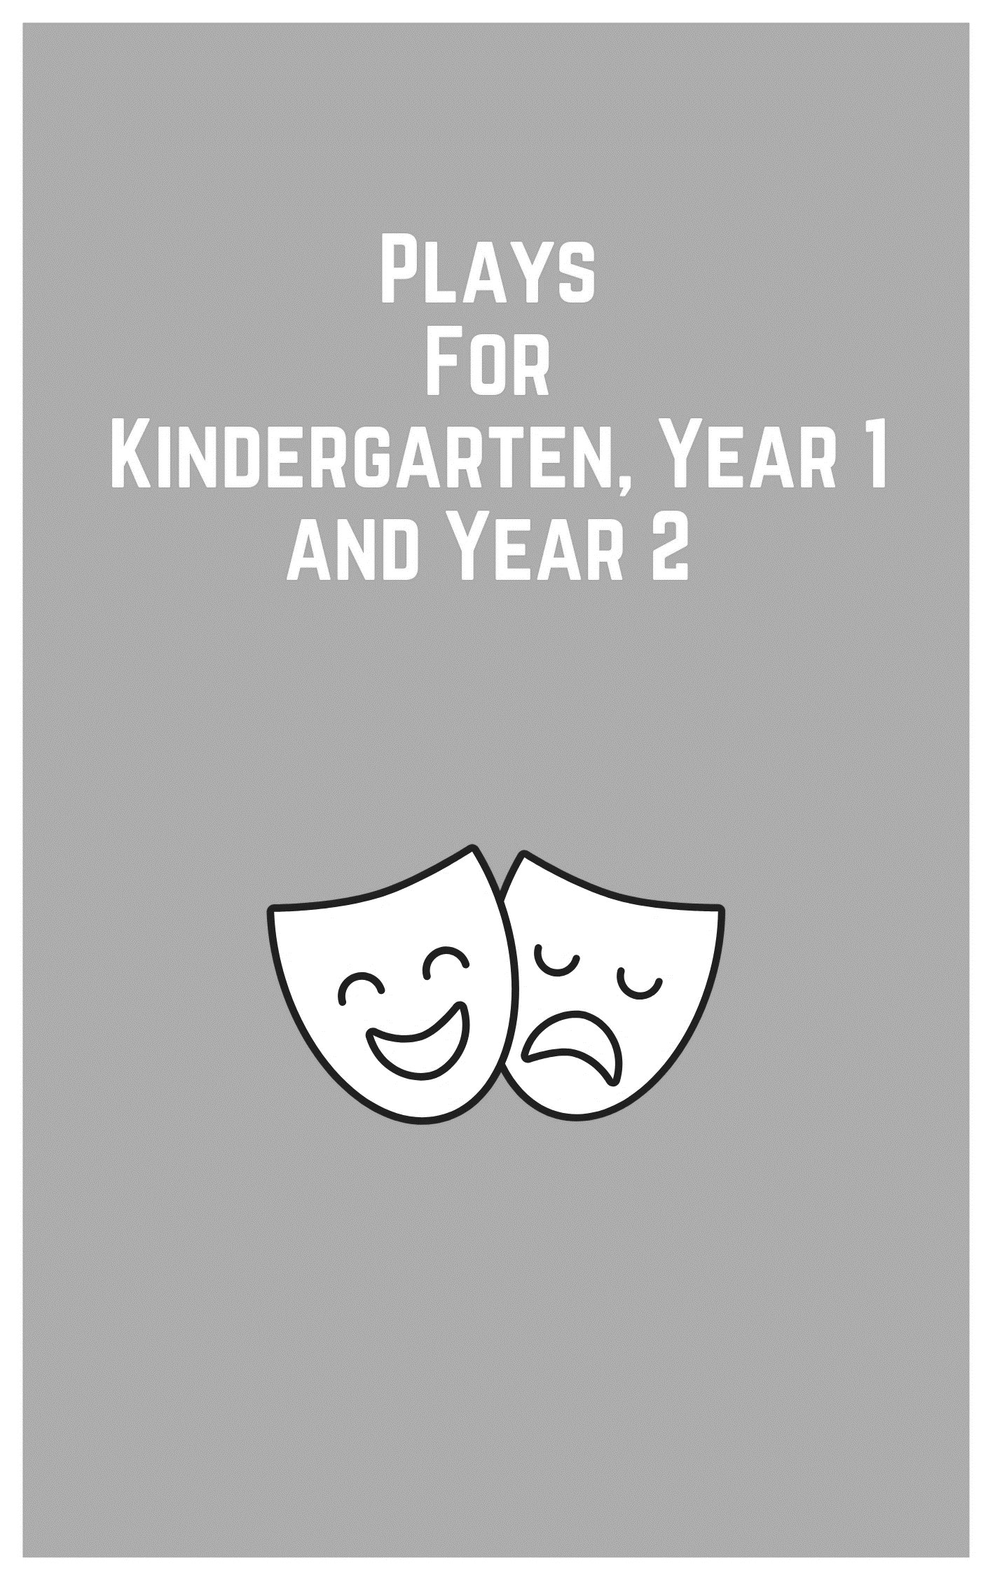
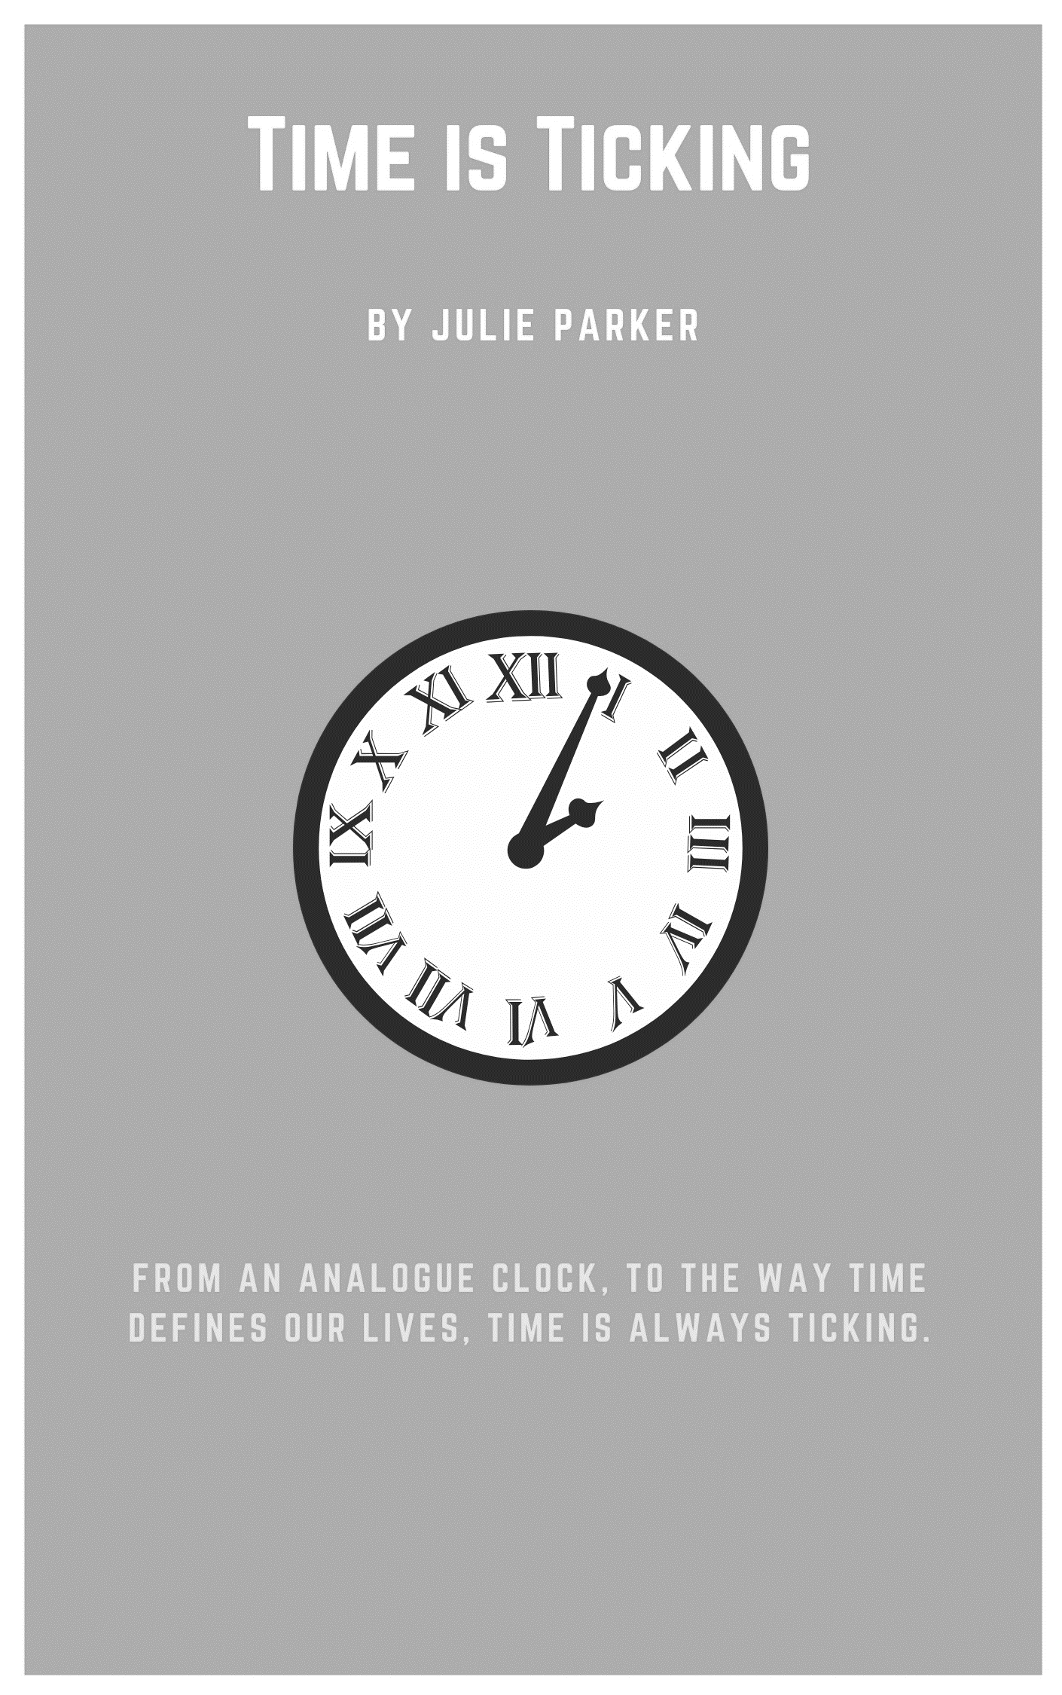
Time is Ticking
By Julie Parker

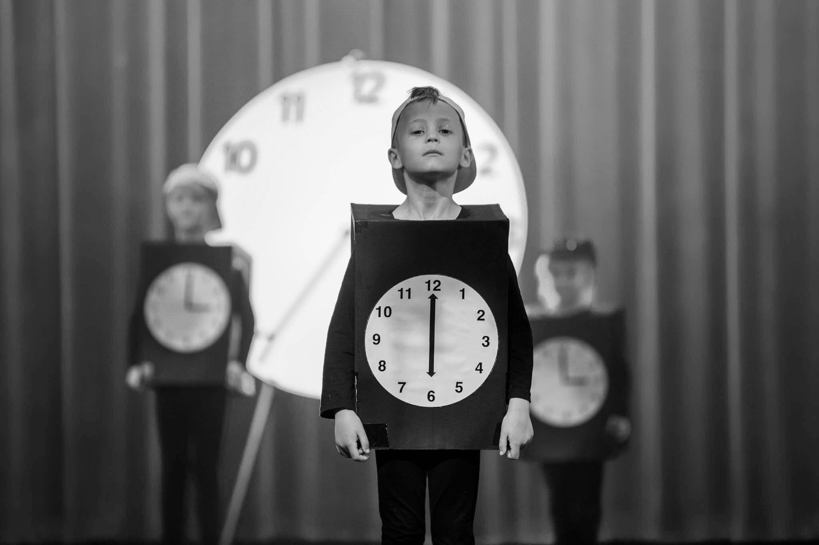

Synopsis
This play was written for kindergarten students to reinforce concepts of time. The play has two parts for two separate groups of children performing. The first group performs the rap and the second group performs the reader’s theatre section.
The rap version of a poem enables the students to describe the analogue clock and the function of each hand. In the style of reader’s theatre, another group of students act out different parts of our lives that are dependent upon time.

Cast - in order of appearance

The Clock Crew 3 groups of students (could be any number and any gender)

Chorus 6 students (start on stage)

Reader’s Theatre Crew In speaking order:
1. Mother
2. Father
3. Boy and 2 fish
4. Nurse and 2 children
5. Professors (1 boy and 1 girl)
6. Teacher
7. Children (racing girl and dawdling boy)
8. Chorus Member
9. Chorus Member

Before you begin

Prior knowledge

Prior to engaging with the script, the children had explored reader’s theatre using books and poems. The students devised actions for different parts of a book. Books used included One Fish, Two Fish by Dr Seuss and Sun Sea Crab Me by Nigel Gray.

Curriculum links
The Australian Curriculum: The Arts – Drama
Explore role and dramatic action in dramatic play, improvisation and process drama (ACADRM027)
Use voice, facial expression, movement and space to imagine and establish role and situation (ACADRM028)
Present drama that communicates ideas, including stories from their community, to an audience (ACADRM029)
Respond to drama and consider where and why people make drama, starting with Australian drama of Aboriginal and Torres Strait Islander Peoples (ACADRR030)

The Australian Curriculum: Mathematics
Tell time to the half-hour (ACMMG020)
Tell time to the quarter-hour, using the language of ‘past’ and ‘to’ (ACMMG039)

© Australian Curriculum, Assessment and Reporting Authority (ACARA) 2010 to present, unless otherwise indicated. This material was downloaded from the Australian Curriculum website (www.australiancurriculum.edu.au) (Website) (accessed 21August 2018) and was not modified. The material is licensed under CC BY 4.0 (https://creativecommons.org/licenses/by/4.0). Version updates are tracked on the ‘Curriculum version history’ page (www.australiancurriculum.edu.au/Home/CurriculumHistory) of the Australian Curriculum website.
ACARA does not endorse any product that uses the Australian Curriculum or make any representations as to the quality of such products. Any product that uses material published on this website should not be taken to be affiliated with ACARA or have the sponsorship or approval of ACARA. It is up to each person to make their own assessment of the product, taking into account matters including, but not limited to, the version number and the degree to which the materials align with the content descriptions and achievement standards (where relevant). Where there is a claim of alignment, it is important to check that the materials align with the content descriptions and achievement standards (endorsed by all education Ministers), not the elaborations (examples provided by ACARA).
Getting started
Vocal warm up
In preparing the students for their performance, the drama sessions begin with a physical and a vocal warm up.

Crouching and jumping
The students begin in a crouched position, slowly rising to a standing position, finally jumping up at the end. Like their bodies, the student’s voices start down low and quiet then rise in pitch and volume, so they shout as loud and high as they can on the jump. Our students liked to do this as a group.

One-word nursery rhymes
Choose a nursery rhyme that the students are familiar with. A good example is Incy Wincy Spider. The game begins with one person singing the first word from the song, the next word is sung by the person on their left, and so on. The difficulty of the warm-up can be increased by adding an action to chosen words, for example, when the students hear ‘spider’ they bend their knees.

Character development exercises
Rap group
To develop the rap group’s movement and beat, we listened to rap music that had a beat with no words. This set the pace and beat for the rap.
It was also important to practice the entrances, exits and movements of the students so that they don’t crash into each other.

Reader’s Theatre Group
For the actions of the Reader’s Theatre Group, the whole class can talk about what they can physically do as they are saying their line, or what action they could do after they have said their line. Through practice they learn to incorporate their action into the rhyme, so the rhyme flows smoothly.
Once they are on stage the students bob down before and after their line and stay very still. To help the students with this, they can play statues and similar games where they have to freeze in one spot until they are asked to move again.

Set, Costuming and Props

Set
Large clock for the stage
Coloured spots to help students find their placement on the stage

Props
Tea towels
Briefcase
Large serving spoon
Plastic flowers
Teacher’s pointer

Costume
Mother: Dressing Gown
Father: Suit
Children: Pyjamas
Nurses: Nurses clothing
Teacher: conservative clothing
Rappers: Packing boxes painted black with clock faces on the front

Time is Ticking
By Julie Parker

Introduction

The Clock Crew: Three groups of children dressed as clocks
Group 1 enters from the back and goes downstage centre. They split left and right to form the front row
Group 2 enter from stage left to form the second line - centre stage
Group 3 enter from upstage right to form the third line.
They are chanting tic- toc.
When in position all turn to face audience.

Scene one: Clock Crew Rap

All: (heads nodding) Tic tic tic tic toc (repeat 4 times)

All: We’re in the clock crew and we’re okay!
We tick all night and we tick all day.

All: Tic tic tic tic toc,
Tic tic tic tic toc.

Group 1: We’ve got two hands, we’re having a ball, we have no arms… at all!

Front line goes to the back and the second and third lines move forward to the front as they chant.

All: Tic tic tic tic toc,
Tic tic tic tic toc.

Group 2: Our big hand moves sixty minutes in one hour; it’s the one with the strength and power.

Front line goes to the back and the second and third lines move forward to the front as they chant.

All: Tic tic tic tic toc,
Tic tic tic tic toc.

Group 3: Our small hand isn't quite as fast! If in a race, it would come last!

All: Tic tic tic tic toc,
Tic tic tic tic toc,
Tic tic tic tic toc,
Tic tic tic tic toc.

Group exits. Chorus and other characters enter from the left. Characters stand on their spots.

Scene Two

Chorus: The question that is asked the most; we hear it every day.

Children: (each character says the line and then bobs down) What time is it?

All Chorus: They want to know, and then they go away.

Mother: (Mother in pyjamas, dressing gown with story book in hand) It's time for bed!

Dad: (Dad dressed in business suit with suitcase) It's time for work!

Boy and 2 fish: It’s time to feed the fishes! (Boy pretends to feed the fish as they circle around him)

Nurse: (dressed accordingly medicine bottle and spoon administering to child) It's time to take your medicine!

Child: Yuck!

2 Children: (reluctantly drying dishes tea towel in hand) Or wash and dry the dishes.

Chorus: Time in seconds, time in hours, so many freckles past a hair.

Boy and Girl Professors enter dressed like professors.

Boy Professor: Depending on the zone.

Girl Professor: Or whether daylights savings there.

Teacher: Time is measured many ways from minutes to months. Time is what keeps everything from happening at once!

Chorus: If there ever comes a time when time will be no more,

Child: I wonder how we'll know to quit, or when it was before.

Racing Girl: (running on stage to centre) Do we hurry?

Dawdling Boy: (dawdling slowly on stage to centre) Or do we dawdle?

Chorus: It depends upon the time...
Child: Had we started earlier, we'd be finished with this rhyme.

All: hands on hips Yeah!!

All walk off.

END

Concluding
Reflection
After the students have engaged with the text, use the following questions to hold a reflective class discussion:
- What does each hand on a clock tell us?
- What are some of the things we do in the morning, in the evening, through the day?
- Which hand moves the fastest, slowest?

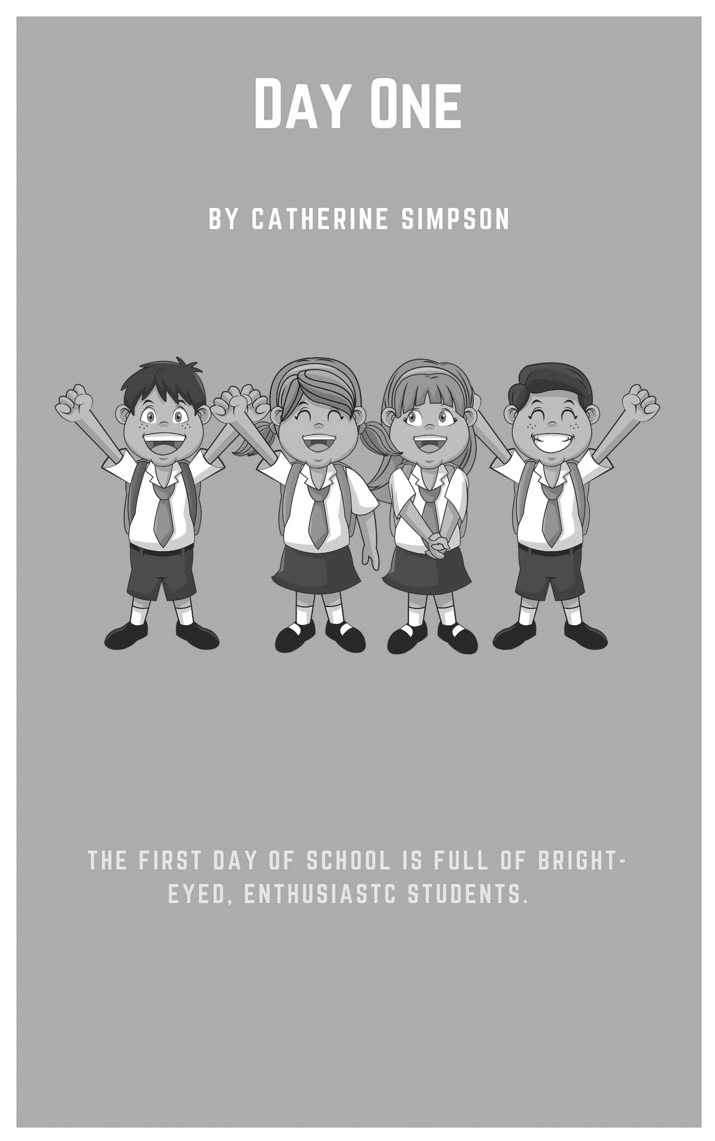
Day One
By Catherine Simpson

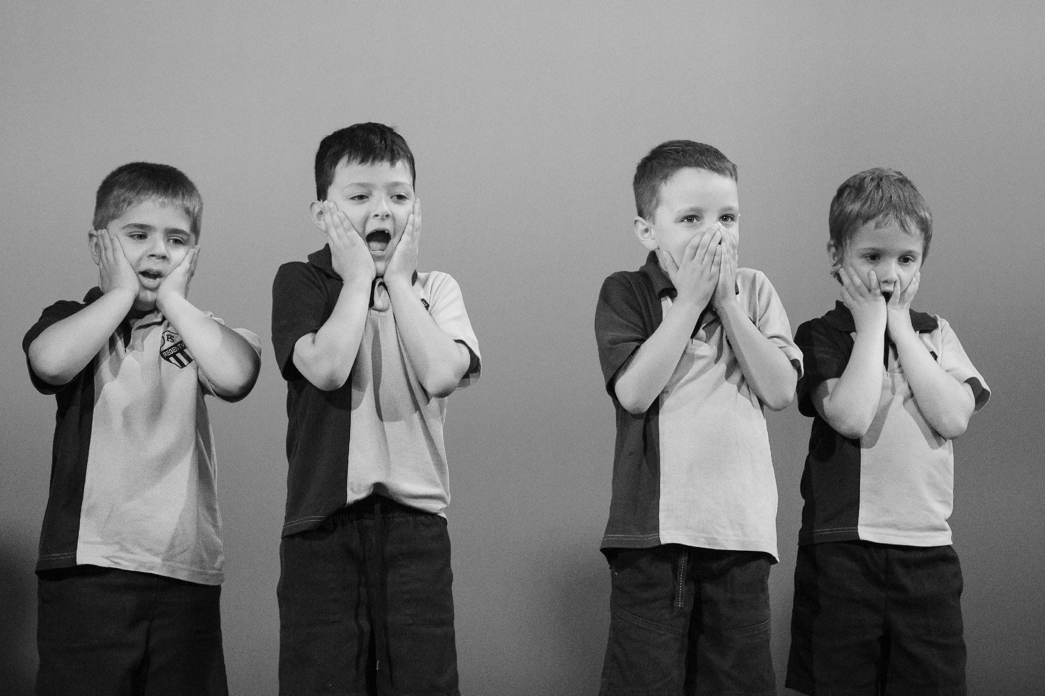

Synopsis
Day One depicts the first day of Kindergarten using movement, chorus and mime. The first day of kindergarten is full of bright, shiny faces. Teachers should recognise the familiar lines that the children regularly say as part of their transition into “big school”.

Cast - in order of appearance
This piece requires a class group of kindergarten students, boys and girls. Alternatively, the characters could be played by older students reliving their Kindergarten days. Another variation could be just using a group of 7-10 children rather than the groups prescribed below.

Child 1: boy or girl

Child 2: boy or girl

Child 3: boy or girl

Seven small groups: (2-3 students in each), including child 1, 2, and 3 – these students will speak in chorus. However, depending on the students’ confidence and age each of the seven small groups above could be covered by 7 students rather than a chorus.

Before you begin
Prior knowledge required
If the actors are Kindergarten students, skills such as walking in lines, moving together and copying each other’s actions are crucial prior knowledge, students should acquire these skills before embarking on the piece.
Students will need to be aware of their personal space when moving in the rehearsal / performance area. Describe, and demonstrate that they need to be equal distances from each other rather than bunched up when placing themselves in the performance space. Practice this step by having the students clear the performance area and then having to enter and space themselves out when a bell is rung. This can be done as a game, and warm up activity.

Curriculum links
The Australian Curriculum: The Arts - Drama
Explore role and dramatic action in dramatic play, improvisation and process drama (ACADRM027)

Use voice, facial expression, movement and space to imagine and establish role and situation (ACADRM028)

Present drama that communicates ideas, including stories from their community, to an audience (ACADRM029)

The Australian Curriculum: English
Understand that texts can take many forms, can be very short (for example an exit sign) or quite ling (for example an informative book or film) and that stories and informative texts have different purposes (ACELA 1430)

Understand the use of vocabulary in familiar contexts related to everyday experiences, personal interests and topics taught at school (ACELA 1437)

The Australian Curriculum: HASS
Pose questions about past and present objects, people, places and events (ACHASSI001)

How the stories of families and the past can be communicated, for example, through photographs, artifacts, books, oral histories, digital media and museums (ACHASSK013)

© Australian Curriculum, Assessment and Reporting Authority (ACARA) 2010 to present, unless otherwise indicated. This material was downloaded from the Australian Curriculum website (www.australiancurriculum.edu.au) (Website) (accessed 21 August 2018) and was not modified. The material is licensed under CC BY 4.0 (https://creativecommons.org/licenses/by/4.0). Version updates are tracked on the ‘Curriculum version history’ page (www.australiancurriculum.edu.au/Home/CurriculumHistory) of the Australian Curriculum website.
ACARA does not endorse any product that uses the Australian Curriculum or make any representations as to the quality of such products. Any product that uses material published on this website should not be taken to be affiliated with ACARA or have the sponsorship or approval of ACARA. It is up to each person to make their own assessment of the product, taking into account matters including, but not limited to, the version number and the degree to which the materials align with the content descriptions and achievement standards (where relevant). Where there is a claim of alignment, it is important to check that the materials align with the content descriptions and achievement standards (endorsed by all education Ministers), not the elaborations (examples provided by ACARA).
Getting started
Warm ups
Mirror, Mirror
Aim
To refine the skills of copying the actions of others and moving in unison. This activity can also be used to get muscles moving as a physical warm-up.
What you need
An empty space
- The teacher sits or stands opposite the class groups and slowly moves arms and legs through a variety of positions. The students slowly follow the movements the teacher makes. The students should try to move with the teacher rather than after. This can be assisted by the teacher starting with large, exaggerated movements.
- Students are paired up and take turns being the leader while their partner is the mirror. Reinforce the need for slow movements and accurate following.

Zig-Zag Walks
Aim
to develop awareness of others in the performance space, and a sense of deliberate, directional movement rather than aimless wandering through the performance space.
What you need
An empty space; a bell or similar to indicate changes in direction
- The students arrange themselves in the performance space without bunching up or forming groups. As the students find their place, it is important to ask the students to ensure that they do not touch any other student or object during the exercise.
- The students choose a direction in which they wish to travel (locomotion). The students slowly proceed in the chosen direction until the bell is rung. Once the bell is rung, the students move in a new direction.
- If the students meet another student or object they change direction.

Vocal warm ups
Vocal warm-ups
Aim
To warm up the voice as well as practice speaking in unison, following a leader
What you need
An empty space
- Starting with a gentle hum, students follow the teacher in moving their voice through a range of high and low sounds by listening, following her / his hand as a visual indicator of pitch.
- Move from a hum to an “ahh”, again following the teacher.
- Children repeat a series of words (nibble, nibble, nibble, babble babble, babble etc) trying to all speak at the same time, following the teacher’s lead. Teacher varies the tempo, pitch and volume of the words as the students’ progress.
- Practice choral speaking by repeating known rhymes, song lyrics together. Variations could include changing the tempo, pitch and volume.

Set, costuming and props
Day One does not require elaborate sets, props or costuming. The aim is to keep it as simple as possible from both a production standpoint and for the parents of the participating students.

As the piece progresses through a day in the life of a group of kindergarten students the performance space becomes the playground, and a classroom all indicated by the students’ action.

Costumes consist of the students’ own school uniforms if it is a school class or group. Alternatively, students should wear matching uniforms if the group comes from a number of different schools.

Day One
By Catherine Simpson

On the sound of a school bell the children enter from both sides of the stage cheering and excited. They place themselves around the stage so as to fill up the stage. It is important that the students do not form lines. As the students will be moving into small groups, they will need to position themselves roughly in their groups.

ALL: I want to go to big school. I’m a big kid now. I’ve got my school bag. (mime wearing a school backpack)
I’ve got new shoes. (mime showing off their new shoes)
I look great in my uniform. (mime showing off their new uniform)
Quick Mum. Take a picture. CLICK! (pose for a photo on “Click”)

Cue music: students move into four circle groups, holding hands and following a designated leader. The lines move in a snake like pattern.

Music dims: student groups move from the snake like pattern to small circles holding hands.

The circles move downstage to perform.
The other circles hold hands and move in their circle silently.
Circle 1 moves to downstage centre.

Circle 1: A sailor went to sea sea sea
to see what he could see see see
but all that he could see see see
is the bottom of the deep blue sea sea sea.

Cue music: groups break from the circles and begin to move in the snake like lines, the same as previously. The four groups are led by the same leader.
Music dims: student groups move from the snake like pattern to small circles holding hands.

Circle 2 moves to downstage centre.

Circle 2: What’s the time Mr. Wolf?

Child 1: (hiding eyes, with their back to their friends) 3 o’clock.

Circle 2: (steps towards Child 1) 1, 2, 3. What’s the time, Mr. Wolf?

Child 1: Dinner Time!

Cue music: groups break from the circles and begin to move in the snake like lines, the same as previously. The four groups are led by the same leader.
Music dims: student groups move from the snake like pattern to small circles holding hands.

Circle 3 moves to downstage centre.

Child 2: I’ve got a secret everybody.

Child 2 whispers secret to the person next to him, who passes the secret around the circle. The secret comes back to Child 2.

Child 2: That’s not what I said! (Children giggle)

Cue music: groups break from the circles and begin to move in the snake like lines, the same as previously. The four groups are led by the same leader.
Music dims: student groups move from the snake like pattern to small circles holding hands.

Circle 4 students fly around stage imitating planes then all students fly around the stage, and move to form an arc downstage.

NOTE: The following groups could be a solo child if the children are confident enough. Otherwise small groups of student’s work, dividing them up into seven small groups. Each group performs a simple action to go with their dialogue, and then all copy the words and actions.

Group 1: Is it home time yet?

All: Is it home time yet?

Group 2: Teacher, Teacher!

All: Teacher, Teacher!

Group 3: Yawn! I’m Tired.

All: Yawn! I’m tired

Group 4: I want my mummy

All: I want my Mummy

Group 5: (crying) Waaaaaaaaa!

All: Waaaaaaaaa!

Group 6: What’s your name? What’s your name?

All: What’s your name? What’s your name? What’s your name? What’s your name?

Group 7: I’m busting. I’m busting!

All: I’m busting. I’m busting!

A beat.

Group 7: I’m not busting anymore!

All children snap a look at Group 7 and then back at the audience with shocked looks.

Cue: marching style music.

The downstage arc splits in the centre and, one side turning left, and the other right, children march on the spot and then move, still marching, in circles to meet at the back of the stage and then line up forming a v shape with the point down stage.

End music.

ALL: Good afternoon, (insert teachers name here).

Cue: school bell.

All children cheer the end of their first school day.

Child 3: Mummy! Mummy! I’ve finished big school!

All: What do you mean I have to come tomorrow? Oh No!

Kids freeze, looking horrified.

Blackout

END

Concluding
Reflection
After the students have engaged with the text, use the following questions to hold a reflective class discussion:
- What do you remember about your first day of school?
- What does your teacher remember about their first day?
- How have you changed since you started school?
- What changes have you noticed to your voice or the way you move your body since you started school?

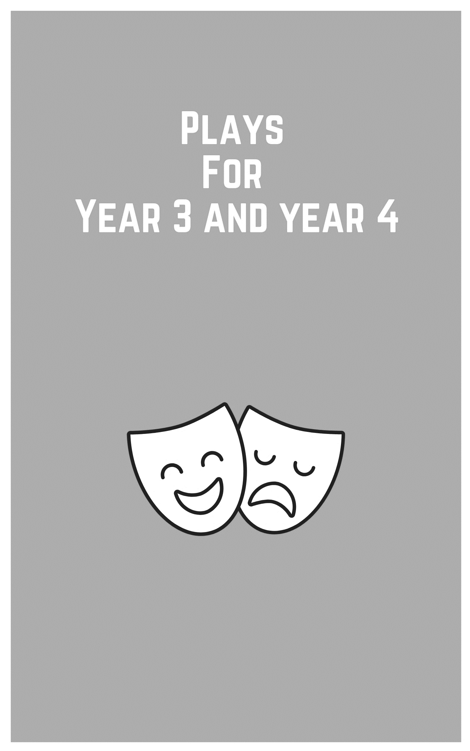
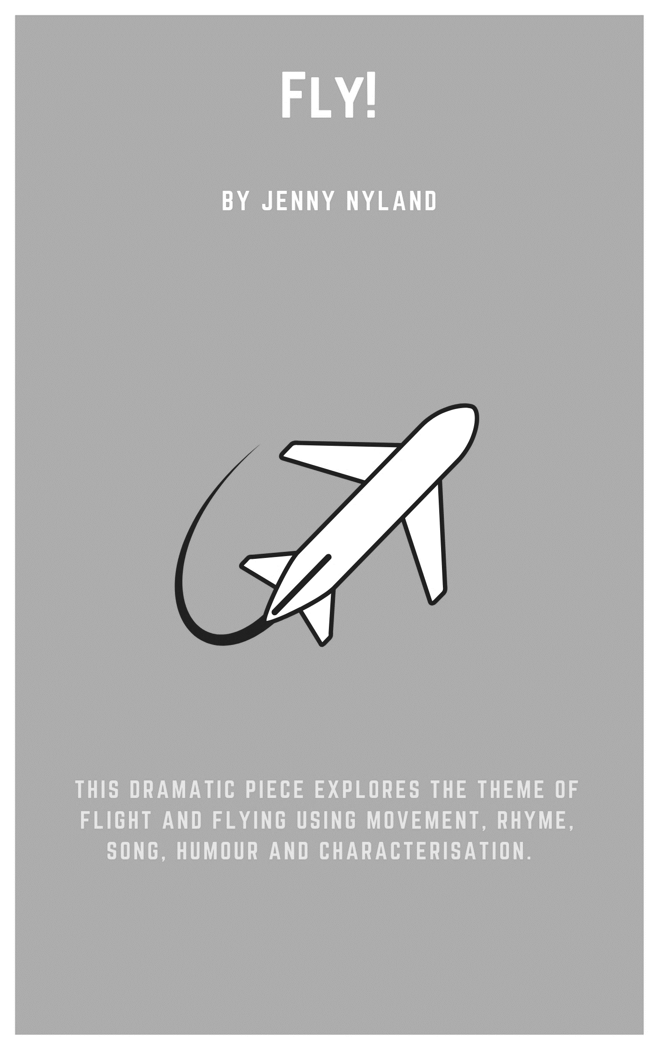
Fly!
By Jenny Nylund

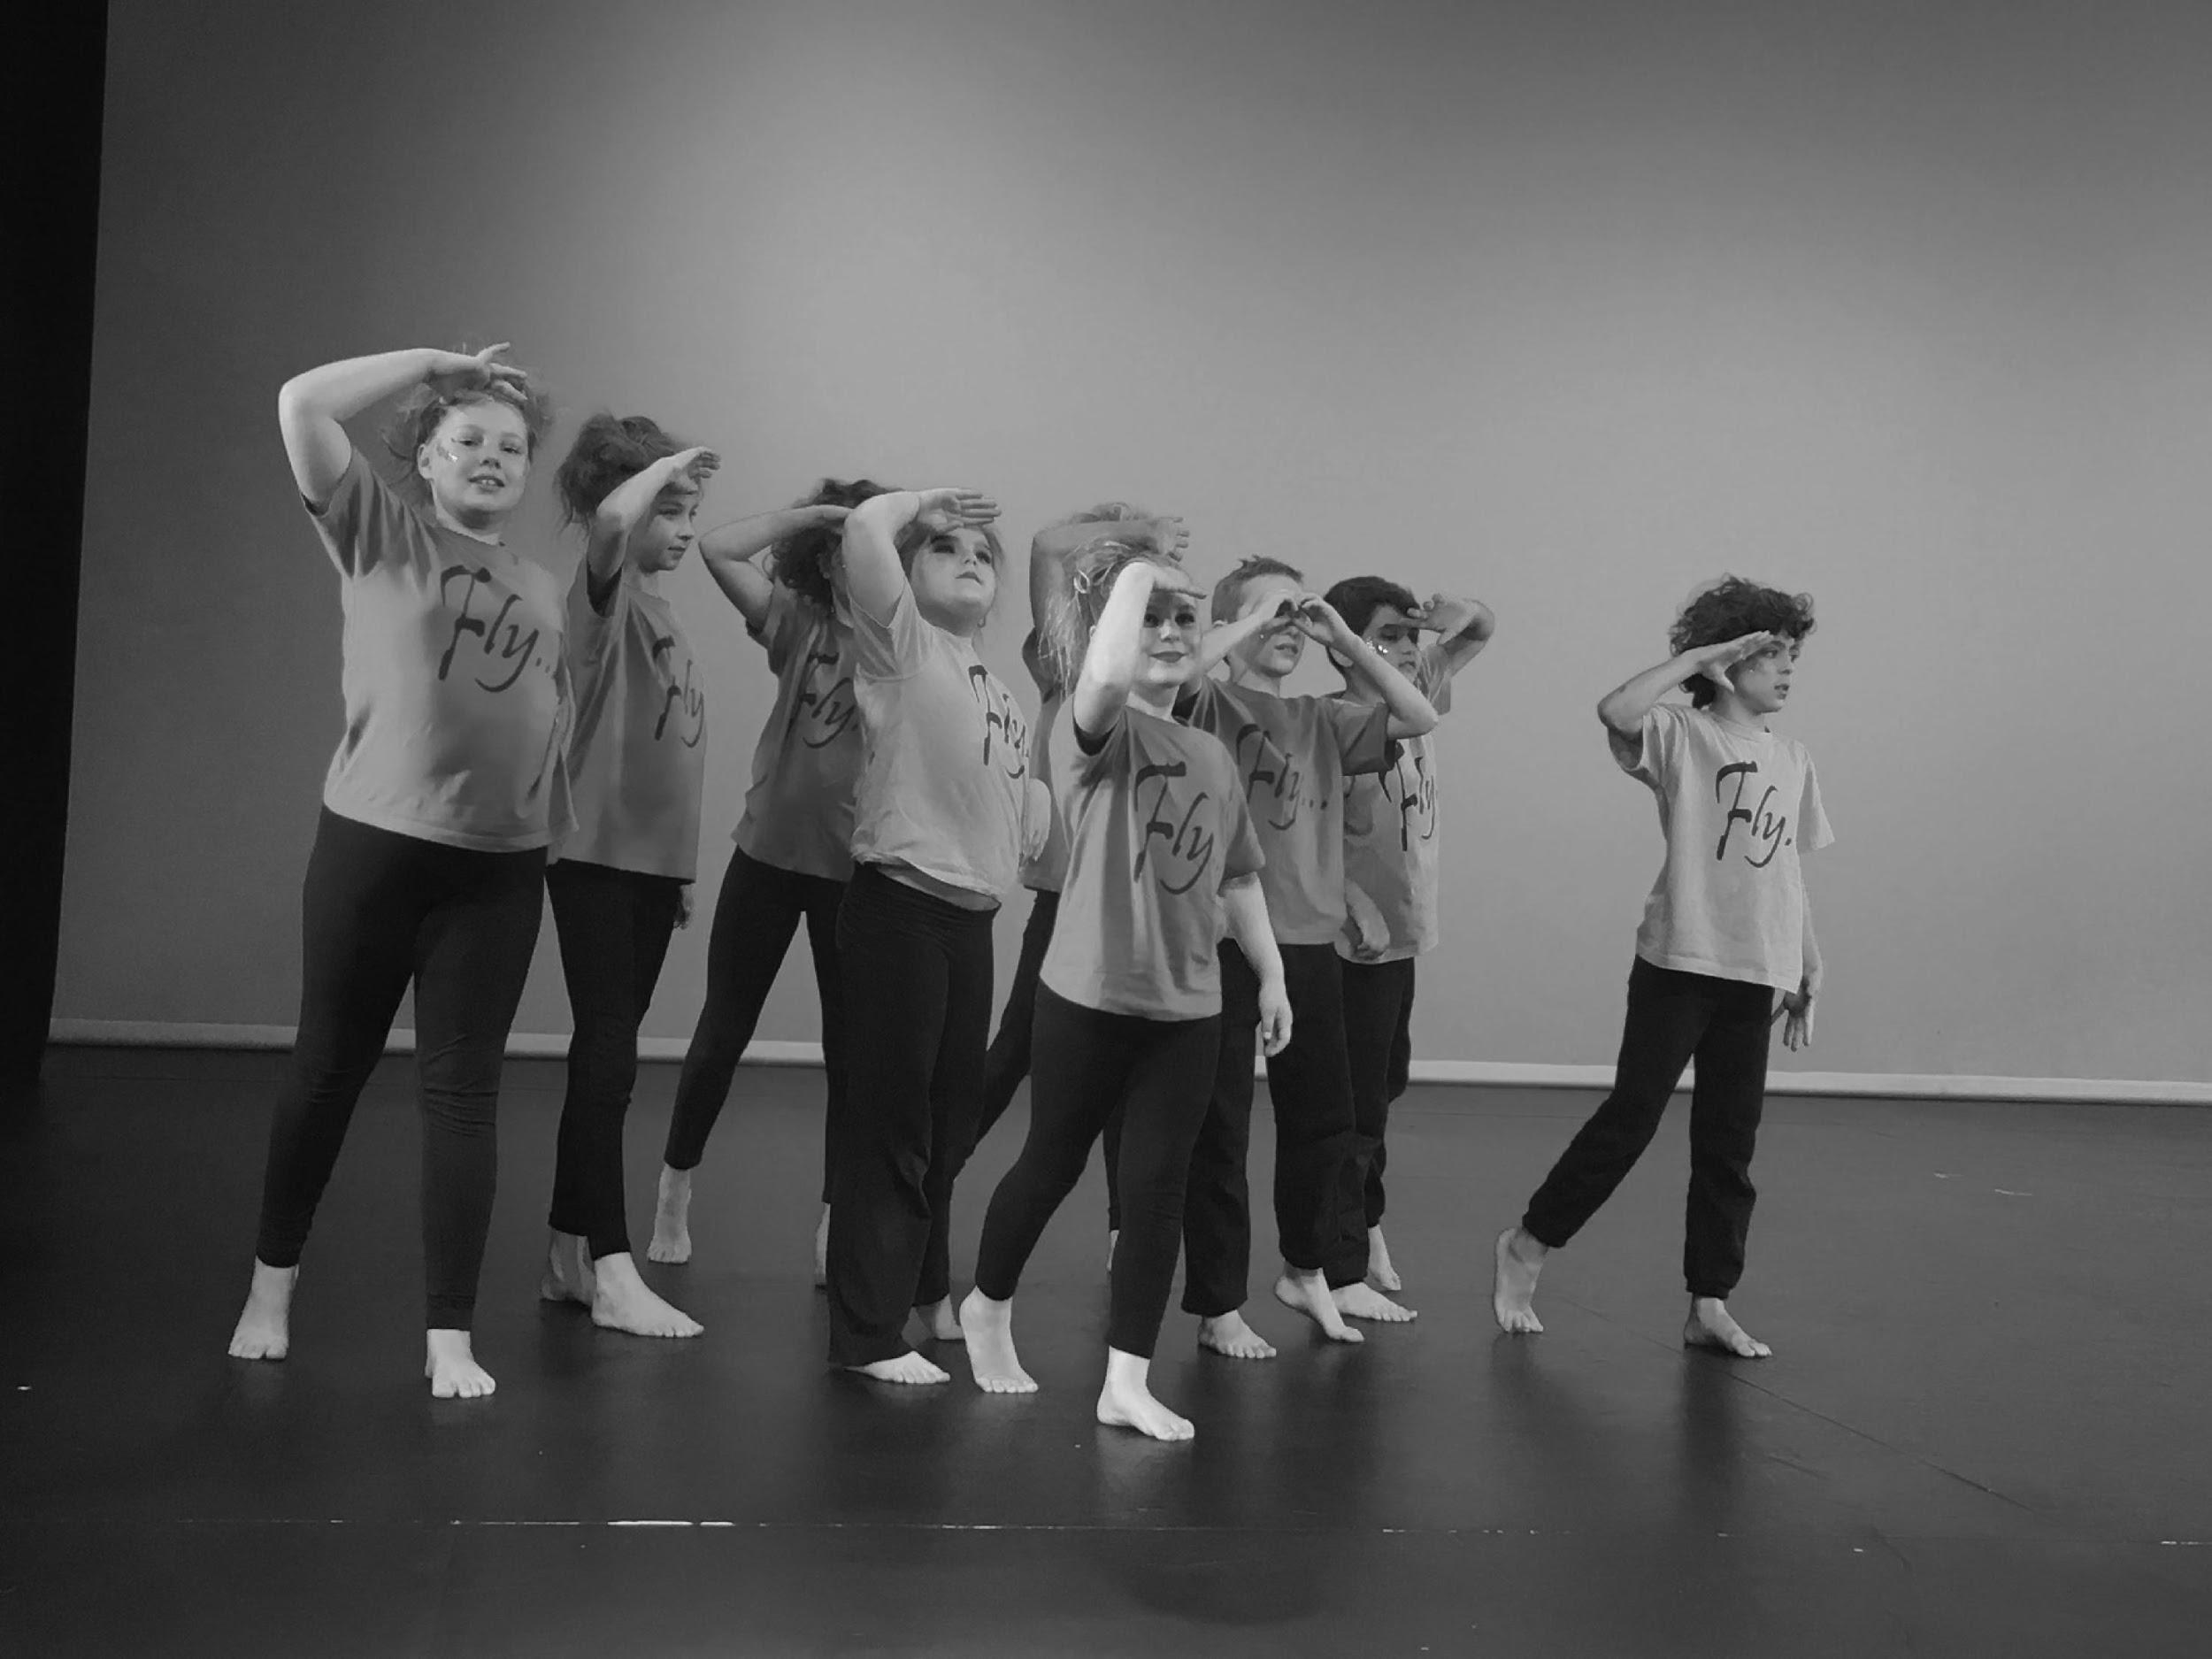

Synopsis
This script was developed from a playbuilding process created over a term with a Stage 2 class. Fly! can also be used with a Stage 3 group. Each short section has its own particular feature, and each section fits together like pieces of a puzzle to highlight different aspects of the theme. The process of creating the script involved researching and brainstorming ideas, selecting and sequencing those ideas, improvising individually and in groups, collaborating, revising, polishing and refining. By engaging with Fly! students are provided with the opportunity to explore all of the dramatic processes: making, performing and appreciating. The dramatic elements of space, tension, mood, symbol and contrast are all highlighted in the teaching and learning process. Music and dance are part of this piece. The piece explores the theme of flight and flying using movement, rhyme, song, humour and characterisation. The theme of flight and flying lends itself to study in other curriculum areas including history, geography and STEM.
Cast - in order of appearance
The script caters for a whole class with roles assigned by the teacher according to the skills and strengths of individual students. For example, a student with a talent for singing or dancing could perform the roles involving song and dance, or a student with a talent for comedy might take on the role of Louie the Fly. Each student should be assigned at least one individual line and there are many shared lines, actions, and movement sequences involving the whole cast.

Speakers 1-30

Speakers A-S

Dancers

Singers

Teacher

Doggy Choir Conductor

Louie the Fly

Poets 1 – 9

Actors 1-16

Before you begin
Prior knowledge
Before working on the script, teachers should brainstorm the theme of flight and flying and create a mind map of ideas. Students can decide what they know and what they would like to find out through a process of inquiry and discovery. For example, students could research the Royal Flying Doctors Service, the Wright Brothers, and Amelia Earhart. Students might view Mortein’s ‘Louie the Fly’ advertisements on YouTube, and look at how and why advertisements have changed over time. The teacher might facilitate discussions on how jingles and characters are use in advertising were so successful. In English, students could work in groups to write a list of phrases or sayings which use the word fly, flew, or flying. In music, students could research songs based on the theme of flying or a related topic such as birds, kites, planes or rockets.

Curriculum links
The Australian Curriculum: The Arts - Drama
Explore dramatic action, empathy and space in improvisations, playbuilding and scripted drama to develop characters and situations (ACADRM305)

Develop skills and techniques of voice and movement to create character, mood and atmosphere and focus dramatic action (ACADRM036)

Rehearse and perform devised and scripted drama that develops narrative, drives dramatic tension, and uses dramatic symbol, performance styles and design elements to share community and cultural stories and engage an audience (ACADRM037)

© Australian Curriculum, Assessment and Reporting Authority (ACARA) 2010 to present, unless otherwise indicated. This material was downloaded from the Australian Curriculum website (www.australiancurriculum.edu.au) (Website) (accessed 21August 2018) and was not modified. The material is licensed under CC BY 4.0 (https://creativecommons.org/licenses/by/4.0). Version updates are tracked on the ‘Curriculum version history’ page (www.australiancurriculum.edu.au/Home/CurriculumHistory) of the Australian Curriculum website.
ACARA does not endorse any product that uses the Australian Curriculum or make any representations as to the quality of such products. Any product that uses material published on this website should not be taken to be affiliated with ACARA or have the sponsorship or approval of ACARA. It is up to each person to make their own assessment of the product, taking into account matters including, but not limited to, the version number and the degree to which the materials align with the content descriptions and achievement standards (where relevant). Where there is a claim of alignment, it is important to check that the materials align with the content descriptions and achievement standards (endorsed by all education Ministers), not the elaborations (examples provided by ACARA).
Getting started
Each learning sequence is designed to run for a lesson of approximately 45 minutes to 1.5 hours. Implementing the sequence is flexible and could involve electing to teach only one or two activities in the learning sequence, or teaching all of the activities over a number of sessions. Before starting each sequence, make sure there is a clear space that the students can move around in.

Learning sequence 1
Exploring
Ask the students to find their own space in the room. Once in their own space, ask the students to stand still with complete focus. Ask the students to imagine that they have a large blank canvas in front of them and a paintbrush with which they will paint images that represent flight or flying (a flock of birds, an airplane, a kite, a skydiver etc.). The teacher should model doing this and provide plenty of ideas to get the students’ imaginations flowing. Give the students a short time to paint their images. Ask selected students to call out one of the images they have drawn in a strong, clear voice. Keep this process flowing quickly so the students are encouraged to improvise (think on their feet) and not edit or block their ideas.
Tell the students that the space in the room is now a shared space where they will move around the room as individuals, but not touch anyone else. Ask the students to move slowly through the space in response to the words and phrases the teacher calls out (gliding, twirling, floating, shooting up in slow motion, soaring like an eagle etc.). A piece of classical music can be used to accompany the movement. Encourage the students to use their whole body and to use different levels as they move (up / down, high / medium / low).

Developing
Organise the students into groups of 4 or 5 in their own space around the room. Ask the groups to work quickly to make a series of fly-themed objects called out by the teacher. Students should keep talk to a minimum and to respond to the words using their bodies, shapes, gesticulations and facial expressions to communicate with other group members. Examples of objects could include: a flying house, Santa’s sleigh, a soaring eagle, an aeroplane, a hang glider, a rocket shooting up in space.
Use selected students to model the task with explicit instructions from the teacher. Assist each group as they work, providing ideas and asking questions, for example:
What parts of an airplane will you represent?
You will need the wings, tail, body, feet and head of the bird.
What shapes could represent a rocket?

Performing
Each group chooses one object that they created with their bodies to show to the class. The group performs their image as a postcard or tableau (frozen image). The teacher should take a photograph of each group’s image to put up in the classroom.

Appreciating
After each group performs, the teacher should provide brief constructive comments about each performance, referring to the elements of drama. Examples of statements include:
I liked how you used a variety of levels and shapes that created contrast.
You kept very still and created focus, drawing our eyes to the top point of the rocket.
Your group’s image was a symbol that represented the bird with your bodies.
Invite students to make brief positive comments about each performance. The appreciating part of the process is very important.

Learning sequence 2
This sequence may run over two lessons or take a 1.5 hour session.

Exploring
Ask the students to find their own space in the roomand ask them to lie down with their eyes closed. Once settled, tell the students that you are going to take them through a guided visualisation. In the visualisation, the students will travel though a range of landscapes using all their senses. Ask students to imagine they are a famous aviator like Amelia Earhart, the Wright Brothers, Charles Kingsford Smith or Nancy Bird Walton flying high across the earth from one country to another. Guide the class through a visualisation exercise where they are in the role looking down upon the earth below. Speak slowly and with pauses to allow the students time to visualise.

You are travelling high above the earth on your flight across the ocean.
You are wearing your aviator helmet and goggles and a big leather jacket to protect you.
Feel the wind in your hair.
Hear the sound of the engine as it splutters and judders.
See the propellers spinning around rapidly, making a whirring sound.
Peer down through the clouds.
In the distance you spy a ship making its way across the water.
It is large boat carrying many passengers, but from a distance it looks small, with tiny people dotted along the decks.
The water is a deep green with white foamy waves.
Imagine the crashing sound the waves make.

Now you are flying across tall mountains with snowy peaks.
The air is cold.
Feel it freezing on your face.
You see a line of hikers trudging slowly along a trail in single file, like a line of ants, marching in a steady rhythm.

Now the air becomes warmer as you find yourself flying across a wild rainforest.
You look down and see large colorful flowers dotted amongst the lush green bush.
You smell the strong scent of the flowers.
You see a spotted jaguar prowling through the undergrowth and hear a soft growl as he looks for food.

Now you fly up again, soaring above the ocean again.
Land is in sight.
A busy, hustling bustling city awaits you.
As you fly your airplane down, you see the tops of tall city buildings looming large.
The streets are filled people and old fashioned cars and horses and carts moving along cobbled streets.
You imagine the noises of chatter and clatter and clip-clopping hooves.

Finally, you see a green field, not far off in the distance.
You prepare to land.
Looking down, you see cows and sheep in a paddock beside the grassy field.
You ease your plane down for landing and see the ground of the paddock getting closer and closer.
Your plane hovers for a moment above the ground before lightly touching the earth and coming to rest.
The propellers turn slower and slower before they stop completely.

All is silent.

You carefully climb out of the cockpit of the plane and jump to the ground with a thud.
You feel the firm earth beneath your feet and smell the familiar scent of grass.
You are home!

Ask the students to lie still for a moment and to bring their awareness back to their bodies. Ask the students to slowly sit up. Ask selected students to say one word to describe the flying ‘journey’ they experienced. Words that the students may use include: exhilarating, exciting, noisy, scary, amazing, tiring etc.
Developing
In this activity, the students will be working in the space to create and represent an old fashioned plane with their bodies. They will begin with a still image then add machine like movement and sound effects. They will need to use a range of body shapes and connect together carefully.
Print out or use an electronic whiteboard to show image of planes including the Wright Brothers inventions and the planes Amelia Earhart, Charles Kinsgford Smith and Nancy Bird Walton flew in. Describe the shapes and parts of the plane viewed.
Organise students into groups of 4 - 6. Ask them to work collaboratively to make the parts of the plane – tail, wings, body etc. They should use a variety of shapes and levels. Once they have established the parts of their plane, each group should create a short, simple movement sequence that represents flying. The teacher should provide plenty of ideas e.g. wings go up, wings go down; everyone leans to one side, then everyone leans to the other side; propellers spin slowly, then faster. The teacher can introduce the terms synchronized (all moving in unison at the exact same time with the same movement) or canon (moving one after the other in a sequence to create a strong visual effect). One student could be in the role as the aviator or aviatrix flying the plane.

Performing
Each group presents their plane and accompanying movement sequence to the rest of the class. Groups should start and finish in a postcard or tableau (frozen pose) to create a sense of focus. The teacher can take a photo of each group to label and display in the room, alongside real plane images.

Appreciating
The teacher should provide constructive feedback on each performance. Examples of feedback include:
You worked well collaboratively to make the different parts of the plane.
Your movements were well synchronized.
Learning sequence 3
Exploring
Part 1
Divide the class into pairs. Ask the students to find a space in the room, sitting on the floor with a partner. Explain that they will be playing ‘word tennis’ with their partner. The teacher calls out a ‘flying’ themed word and the students ‘hit’ words quickly back and forth to each other. The exercise should be completed quickly so students don’t try and edit their thinking. The teacher should explain and demonstrate the exercise clearly. Examples of word associations include:

Teacher: Flying
Student A: Plane
Student B: Wings
Student A: Bird
Student B: Nest

Freeze

Teacher: Eagle
Student A: Soaring
Student B: Diving
Student A: Sky
Student B: Blue

Part 2
Explain to the class the importance of using a clear and expressive voice when performing. Discuss and model how the lips, teeth and tongue all contribute to articulation.
Research a number of tongue twisters, and give the students a number to work with. Ask the students to find their own space and practice saying the tongue twister three times, expressively and clearly, using all the muscles of their mouth.
Tell students that you are going to call out a range of ‘feeling’ words and they should present the tongue twister to reflect this. Emotions could include angry, excited, scared, amused, tired or confused. Coach the students using questions such as:
How does your voice change to reflect the feeling?
Is your voice high or low?
Is this emotion fast or slow?
What expression is on your face?
How does your face make this expression?
What actions or gestures is your body making to show the feeling?

Developing
Research and choose a poem that reflects the idea of flying. For example, ‘Imagination’ by Sesame Street.
Explain to students that their next task will be to work in small groups to present the chosen poem to the class. In presenting the poem, the students should use articulation, expression and gesture. In their performance, the students can speak as a chorus (speaking lines in unison), take a line each, or divide lines up in a variety of ways.
Ask the students to think of an engaging way to present their piece, rather than just standing in a straight line. Provide plenty of examples for example sitting and standing in poses that represent the poem; surprising the audience by turning their backs when not speaking and facing the audience to deliver a line; squatting down and popping up their line; using the words of the poem to create a scene.

Before the students break into their groups, read the poem to the class. Practice the poem as a whole class, line-by-line. Show the students the different ways you can manipulate the voice to create variety, for example, words can be emphasized, drawn out or whispered.

The poem could be written on the board or each student could receive a sheet with the words. Students need to work quickly and cooperatively with their groups to practice their presentation. Emphasise to the students that making a mistake is fine and that you are looking for group energy and focus rather than perfection.

Performing
Invite the groups to perform for the class one at a time. Before the groups perform, reiterate the importance of being a positive and engaged audience member.

Appreciating
After each performance, point out specific aspects of the performance which were strong and provide constructive feedback. For example:
The different levels worked well.
You could add gestures to reinforce the words.

Extension
An extension of this activity would be to film each group performing. Each group could evaluate their own performance to see how they could improve. It is essential that the teacher carefully guides this process and reinforces that analysis should be free from personal criticism targeting individual students.

Learning sequence 4
In this activity the students work in groups to create an action sequence based on the script.

Exploring
Ask students to find a personal space in the room and stand completely still in a neutral position. When the teacher calls out a word, the students should create a shape with their body that represents that image and freeze in that position. This exercise should be done quickly so the students do not overthink their response. The teacher calls out the sentence then the students quickly strike a pose. It is important to stress that there is no right or wrong and you do not need to look at what other students are doing. On a given signal the students should return to neutral pose ready for the next sentence.
- I’m flying up and down on a roller coaster!
- I’m gliding through the air on a flying fox!
- I’m bouncing up to the sky on a trampoline!
- I’m shooting up into space in a rocket ship!

Developing
Each group is given one of the action sequences above. The group will have a short time to develop their piece to present to the class. Movement, mime and sound effects can all be used. Movement could be synchronized or in canon or combination of both. Provide the students with a number of examples to help them create their piece, for example: three students can form the shape of the flying fox in two lines facing the middle with arms up. The fourth student can hold an imaginary handle and move forward between the two lines, ‘gliding’. The flying fix students could make a sound to represent the noise the motion of the flying fox.

Performing
The groups perform for the class twice; once at normal speed and once in slow motion. Before the groups perform, discuss and demonstrate how slow motion requires body tension and focus and can look very effective.

Appreciating
Comment on each performance and emphasise effective elements. Phrases you may choose to use include:
Great use of different body shapes.
It was very effective how you used ‘boing, boing’ for your trampoline sound.
Your up-and-down roller coaster was very well coordinated.
The flying fox looked great in slow motion with lots of tension and expression used.

Set, costuming and props
This piece requires no props or set. The costumes consist of black leggings or pants, with a blue t-shirt printed with the word “Fly” (to highlight the theme). Teachers can discuss how the printed word is a visual symbol for the theme, and how the colour blue represents the sky.
Fly!
By Jenny Nylund

/ indicates where one character cuts straight into another character’s line

SCENE 1

Students begin on stage, in a freeze frame representing flight symbol

Student 1: (Pointing into the sky) Look!

All look to where student 1 is pointing, maintaining strong focus.

GROUP 1: Is it a bird?

GROUP 2: Is it a plane?

Student 3: No, it’s a shooting star!

Student 4: A flying car!

Student 5: A flying house!

Student 6: A flying mouse?

Student 7: Santa’s reindeer racing through the sky/

Student 8: A bold eagle soaring high/

Student 9: A flying fish who made a wish?
Student 10 & 11: A dragon, a unicorn, mystical creatures.

Student 13: Bats, bees, butterflies, all sorts of features.

Student 14 & 15: A superhero saving the day.

Student 16: Angels and fairies flying away.

All sit smoothly and gently on the words “flying away”, except student 17.

Student 17: In my mind it can be anything because when I look up into the sky, my imagination takes wing and…

ALL: Flies!

SCENE 2

Movement sequence to signal new scene. Students move into two groups on either side of stage, in rows (sitting, kneeling or standing). Selected students stand one at a time and move to centre stage between the two groups. Once there, they recite a line of the poem “Imagination”.

Student 20: Here in the middle of imagination

Student 21: Right in the middle of my head,

Student 22: I close my eyes and my home isn’t home

Student 23: And my bed isn’t really my bed.

Student 24: I look inside and discover things/

Student 25: That are sometimes strange and new/

Student 26: And the most remarkable things I think/

Student 27: Have a way of being true.

ALL: (Sings) “Come fly with me, let's fly, let's fly away” (from the Frank Sinatra song)

Students performing the poem move back to their positions with each group.

SCENE 3

As each student speaks they move centre stage, collectively forming the shape of an airplane.

Student 28: In my dream, I can fly up high in the sky and visit the little people who live on the clouds. (sits at front)

ALL: Fluffy, puffy little cloud people

Student 29: In my dream I’m Amelia Earhart, the first female aviator to fly solo across the Atlantic Ocean.

Mimes actions then kneels behind.

Student 30: “You haven’t seen a tree until you’ve seen its shadow from the sky.”

Mimes action then stands behind.

Student A: In our dream we’re the Wright Brothers from the late 1800’s

Student B: Inventing and flying the world’s first aeroplane/

Student C: With aircraft controls.

Mimed action as they stand either side of the ‘body’ of the plane and become the wings.

ALL: (singing) “Those magnificent men in their flying machines, they go up diddly up up, they go down diddly down down” (Ron Goodman song from the soundtrack to the British film of same name)

Students who have become the plane, bob up and down comically as everyone sings.

Student D: (Italian accent) In my dream I am the famous Italian painter Leonardo da Vinci, designing my own flying machines!

Student E: “When once you have tasted flight, you will forever walk on the earth with your eyes turned skyward…”

Student F: “…for there you have been, and there you will always long to return.”

All gaze upwards, poetically.

SCENE 4
Groups create freeze frames using each of the key words. As they say their word, each group makes a “frozen picture” - an abstract representation of their word – using levels, tension, expression and gesture.

Group1: Freedom!

Group 2: Beauty!

Group 3: Discovery!

Group 4: Adventure!

Freeze in positions.

SCENE 5

Student G: I wish I was a bird and could fly through the sky

Students move to new positions with selected dancers in a row at the front and other students in 3 rows – sitting, kneeling and standing.

All sing the chorus of the song while selected students dance gracefully in a lyrical style in front. A solo singer could also be used.

ALL: (From the ABBA song Eagle)
Flying high, high, I'm a bird in the sky
I'm an eagle that rides on the breeze
High, high, what a feeling to fly
Over mountains and forests and seas (REPEAT ALL)

Student H: (Speaking) And to go anywhere that I please!

ALL: (With excitement) Anywhere that I please!?

SCENE 6

Students become noisy students in a class, chatting and laughing in an animated way. One student takes on the role of ‘the teacher’, clapping hands and calling for quiet before delivering the important history lesson.

Teacher: The Royal Flying Doctors Service started in 1928 with its founder Reverend John Flynn.

Student I: (Calling out enthusiastically) I’ve seen his face on the Australian $20 note.

Teacher: (Continues following the interruption) Aeroplanes with medical equipment, doctors and nurses could fly into remote areas like the bush/
Student J: (another enthusiastic child) /and help people get help if they were sick or injured.

Student K: Yeah! Help!

Teacher: The service is still going strong in Australia today.

SCENE 7

Mood change

Students remain in their three rows to form a choir of dogs. A selected student becomes the daggy conductor, using their paw to conduct. The choir ‘woof-sing’ the Star Wars theme tune

Student L: The first animal to fly into space was Laika, a Soviet space dog who orbited the earth.

Charli: Not pigs might fly…. (makes a pig face and snorts)

ALL: Dogs can fly!

SCENE 8

Student M: (Pointing into the air, horrified) Fly!

All look to where the student is pointing, then move quickly and with excitement to form a large semi-circle on the stage. One student takes on the role of ‘Louie the Fly’ buzzing around wildly in the semi-circle.

Louie the Fly: (In character, flying around) “I’m Louie the fly Louie the fly, spreading disease with the greatest of ease”.

Rest of the group gets their imaginary spray cans ready.

ALL: (Calling out) Buzz off, Louie!

Mime spraying with a sound effect.

Louie falls to a dramatic death on the floor, comically!

SCENE 10

For this section, groups demonstrate through movement, mime and sound effects whatever is described. Use canon and synchronicity in movements for contrast.

Student N: I’m flying up and down on a roller coaster! (weeeeeeeeeeeee!)

Student O: I’m gliding through the air on a flying fox! (w-shhhhhh)

Student P: I’m bouncing up to the sky on a trampoline! (boing, boing, boing)

Student Q: I’m shooting up into space in a rocket ship! (5,4,3,2,1 – blast off!)

Student R: I’m flying a kite!

Student R becomes the kite and everyone else quickly makes a long connected line behind, becoming the kite. As they move, students sing the beginning of the famous song from Mary Poppins.

ALL: (Song is Let’s go Fly a Kite from Mary Poppins)
“Let’s go fly a kite, up to the highest height!” (REPEAT)

Students peel off and go to new positions, one group in a semicircle behind, and the other in a row at the front.

Student S: I’m flying by the seat of my pants!

ALL: She’s flying by the seat of her pants!

All turn and comically point their bottoms at the audience before slowly turning around to face audience.

SCENE 11
Students in the back row become trees in a forest, moving their arms gracefully from side to side like branches of a tree moving in the breeze.

Front row recite a poem. A poem composed by a student around the theme could be used instead of this one. The first student in the line holds an imaginary paper plane and moves it slowly through the air to the next student as they say their line of the poem.

POET 1: I threw a paper aeroplane, across a frozen world.

POET 2: I watched it as it flew out of my hand.

POET 3: It zoomed through whispered snowflakes.

POET 4: It twirled between the trees.

POET 5: I watched it almost sigh and softly land.

POET 6: And lying on a snow flake, all lines of paper white.

POET 7: My little airplane fluttered folded wings.

POET 8: I wondered if it wished that it could fly all by itself.

POET 9: The way I dream of doing greater things.

Pause
SCENE 12
Definitions of flying: adjectives, nouns and phrases. As each student speaks they move positions on the stage so that they are back in the three-row formation, with the front row bent down on the floor. Each time the word “flying’ is chanted, students lift their heads and make a different action or gesture that symbolically represents flying.

ALL: Flying.

Actor 1: Moving or able to move through the air with wings.

ALL: Flying.

Actor 2: Launching oneself forward.

Actor 3: He took a flying kick at the soccer ball!

ALL: Flying.

Actor 4: Hasty or brief.

Actor 5: We had a flying visit to grandma’s house.

ALL: Flying.

Actor 6: To fall or be knocked over.

Actor 7: Rob tripped over a branch and went flyyyyyy-ing! Wooahh!

ALL: Flying.

Actor 8: With distinction.
Actor 9: She passed the test with flying colours!

ALL: Flying.

Actor 10: To work by feel or instinct.

Actor 11: “There is an art, or, rather, a knack to flying.”

Actor 12: “The knack lies in learning how to throw yourself at the ground—and miss”.
(NOTE: the above quote is from The Hitchhiker’s Guide to the Galaxy by Douglas
Adams.)

SCENE 13

Motivational speaking—rousing words of wisdom—all moving in together— in a clump centre stage.

Actor 13: Don’t let the fear of falling stop you from flying.

Actor 14: Let your dreams take flight.

Actor 15: Use the wings of the flying universe.

Actor 16: The sky’s the limit!

ALL: I’ll spread my wings,
And start to fly,
I’ll do what it takes ‘til I touch the sky!

All sing as they gradually move back into their original opening position.

ALL: (Song is Fly Away by Edgar Winter)
“Fly away, fly away, close your eyes and you can fly… away… FLY!”

Finish in a frozen pose, faces up to the sky.

END

Concluding
After the students have engaged with the text, use the following questions to hold a reflective class discussion:
- What did you enjoy most about the drama unit and performance? Why?
- What do you think makes an effective performance? (refer to elements of drama as well as specific performance skills)
- What skills does a performing group need to have in order to create a strong performance, (referring to groups skills of cooperation and team work rather than individual skills).

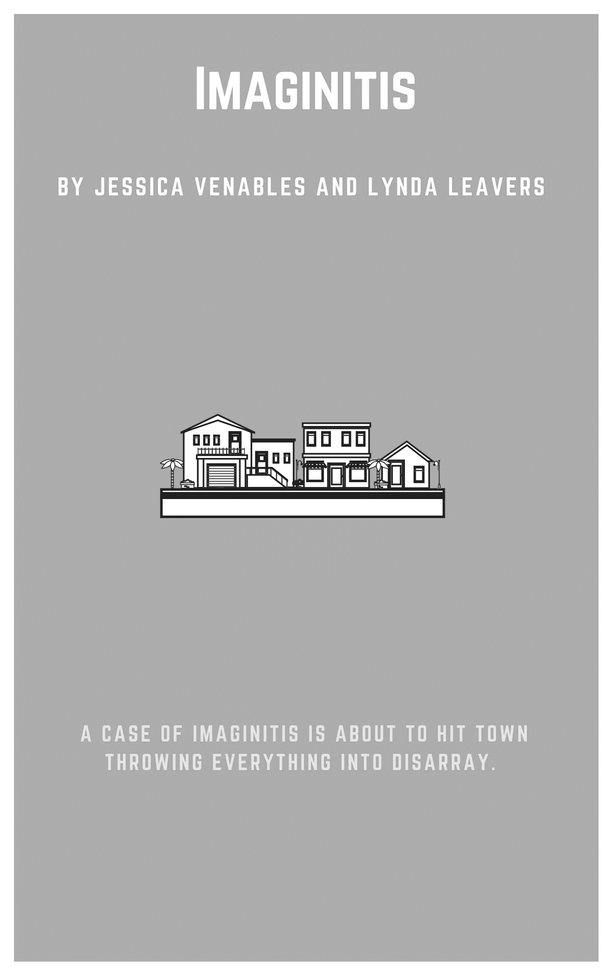
Imaginitis
By Jessica Venables and Lynda Leavers
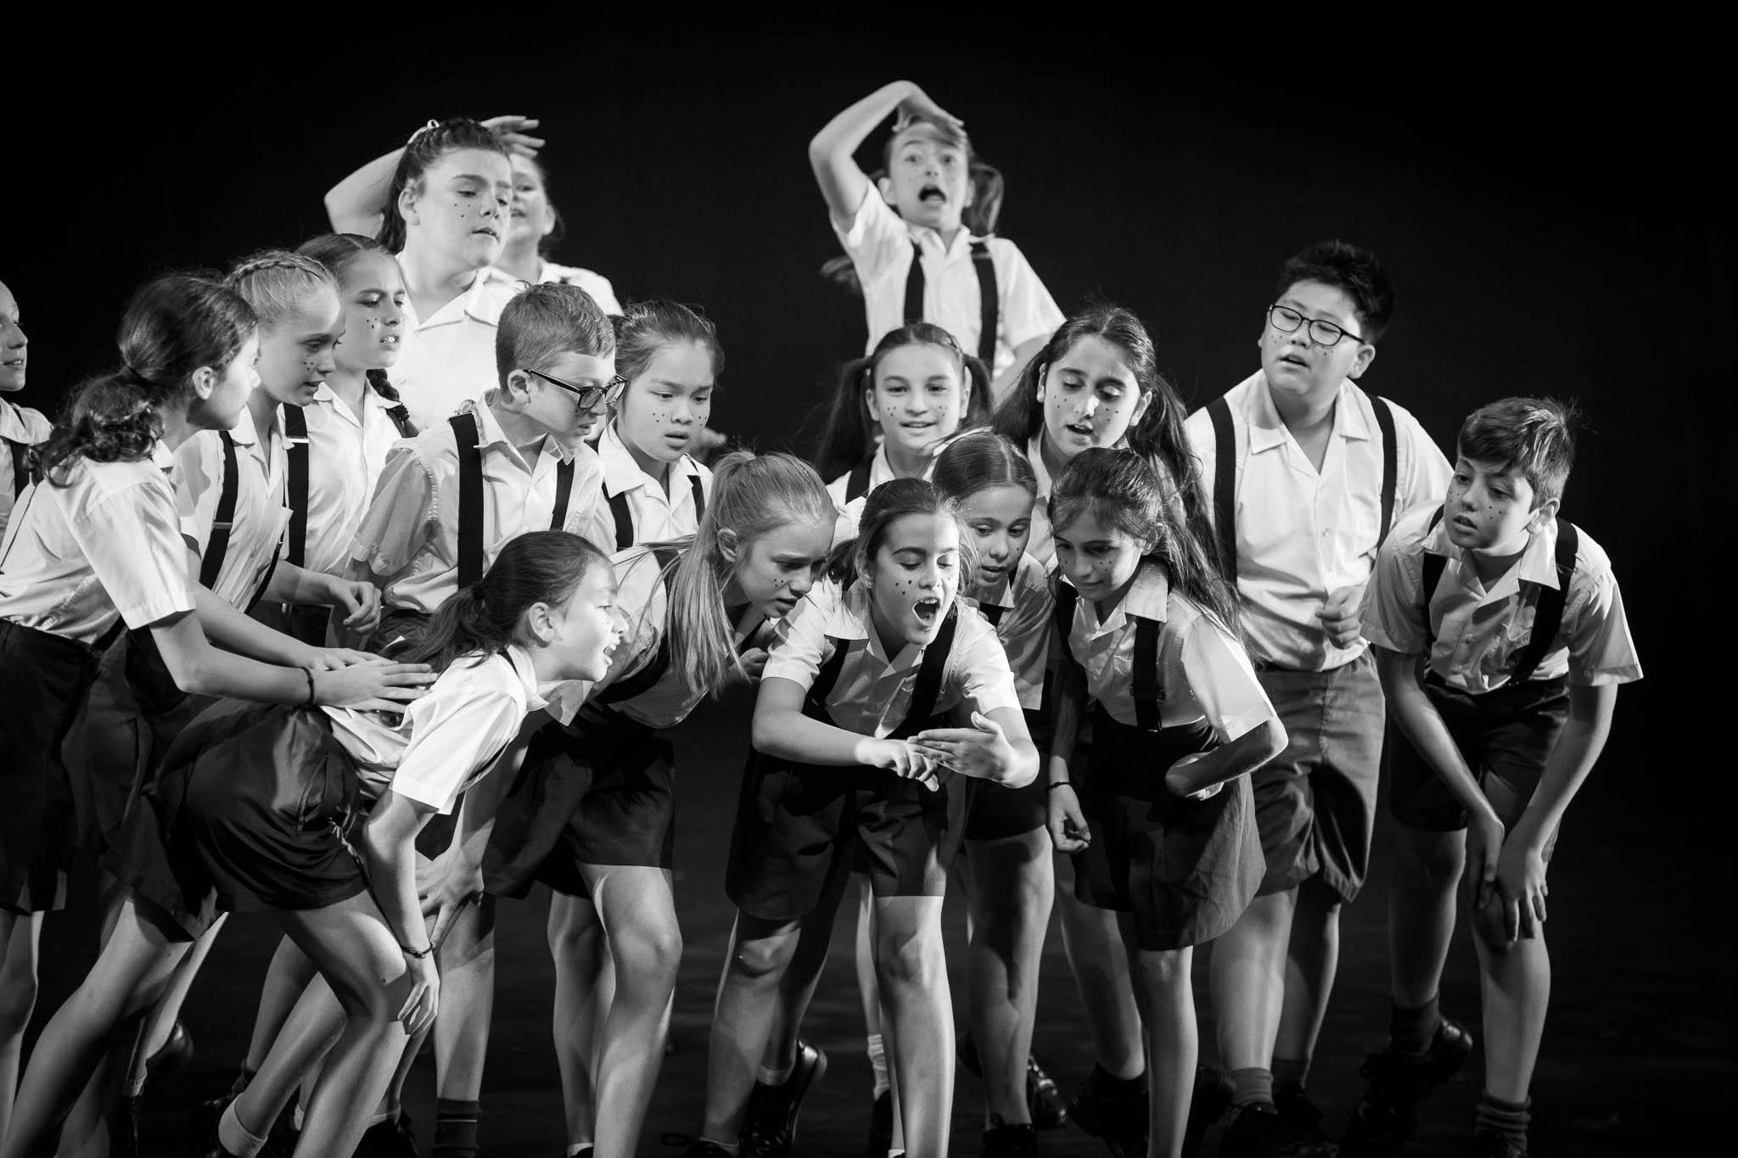

Synopsis
An ordered, structured and regimented town falls into disarray when a bad case of Imaginitis hits town. When Clare arrives at school infected, she spreads the disease across her entire class.

Cast - in order of appearance
The gender of the cast is only specific for one character, Clare. This play is suitable for children aged nine years and over.
Adults x 12
Children x 12
Newspaper salesperson
News reporter
Teacher
Students 1 - 23
Clare (female)

Please Note: Adults and children at the beginning are also Students 1-23. Students 1-23 may be doubled up with one character saying more lines if there are not enough students. The teacher may also join the ensemble once the teacher character is finished.

Before you begin
Prior knowledge
Before beginning this unit, students need to be familiar with the cross-curricular priority of sustainability as the props are made in line with this. This unit also covers the general capability of critical and creative thinking as the characters demonstrate imagination and innovation in order to change the town. This unit emphasises the importance of being creative and adaptable, accepting difference and embracing change in a world with complex environmental and social pressures.

Curriculum links
The Australian Curriculum – The Arts
Explore ideas and narrative structures through roles and situations and use empathy in their own improvisations and devised drama (ACADRM031)

Use voice, body, movement and language to sustain role and relationships and create dramatic action with a sense of time and place (ACADRM032)

Shape and perform dramatic action using narrative structures and tension in devised and scripted drama, including exploration of Aboriginal and Torres Strait Islander drama (ACADRM033)

Identify intended purposes and meaning of drama, starting with Australian drama, including drama of Aboriginal and Torres Strait Islander Peoples, using the elements of drama to make comparisons (ACADRR034)

© Australian Curriculum, Assessment and Reporting Authority (ACARA) 2010 to present, unless otherwise indicated. This material was downloaded from the Australian Curriculum website (www.australiancurriculum.edu.au) (Website) (accessed 21August 2018) and was not modified. The material is licensed under CC BY 4.0 (https://creativecommons.org/licenses/by/4.0). Version updates are tracked on the ‘Curriculum version history’ page (www.australiancurriculum.edu.au/Home/CurriculumHistory) of the Australian Curriculum website.
ACARA does not endorse any product that uses the Australian Curriculum or make any representations as to the quality of such products. Any product that uses material published on this website should not be taken to be affiliated with ACARA or have the sponsorship or approval of ACARA. It is up to each person to make their own assessment of the product, taking into account matters including, but not limited to, the version number and the degree to which the materials align with the content descriptions and achievement standards (where relevant). Where there is a claim of alignment, it is important to check that the materials align with the content descriptions and achievement standards (endorsed by all education Ministers), not the elaborations (examples provided by ACARA).

Getting started
Warm up
Group Stop
This activity develops ensemble movement and peripheral vision and reminds students that what they do onstage is dependent on what other actors do. A play is a series of actions and reactions, not merely memorising one part and saying lines on cue.
- The students move silently around the room. Tell the students to imagine they are on a barge and if everyone is on one side it will sink. The students should not walk in a circle or in a predictable manner. The students should try to fill the space by being aware of each other and filling any gaps.
- Once the students are successfully moving in silence around the room, filling the space, explain that at any moment, any one of the students may stop. As soon as that happens, all of the students should also stop.
- Once the entire group has stopped, any student in the group may start moving again, causing the entire group to move.

Neutral to Emotion
This activity develops student understanding of the importance of voice, intonation and emotion.
Materials
Slips of paper with different emotions written on them in a bowl.
Suggested list of emotions: Friendly, Angry, Sad, Embarrassed, Frustrated, Annoyed, Eager, Shy, Nervous, Loving, Confident, Proud, Curious, Fascinated, Excited, Energetic, Surprised.
- Students sit or stand in a circle.
- Working around the circle, each student says the word ‘Yes’ (not yep, or yeah, everyone needs to say ‘yes’). They can say the word in any manner that they would like.
- This time, all students need to say ‘Yes’ expressing sadness using just their voice.
- Once everyone in the circle has had a turn, go around again, adding in body language.
- Continue exploring a range of the suggested emotions, choosing them from the bowl.
- After a number of rounds, discuss how voice and body language impact the audience and them as actors.
Turn In
This activity develops student’s imaginative thinking by exploring the various ways the same object or emotion can be developed and interpreted.

- Students start by standing in a circle facing out.
- The teacher instructs the students to use their body and imagination to create a freeze frame of the object or emotion identified when they turn in to face the circle. Encourage students to create an abstract painting rather than a literal representation.
- The teacher states the object / emotion and counts backwards from three.
- When the teacher call out an object or emotion, the students face into the circle and create their image.
Example objects / emotions: vase, tree, clown, sad, willow tree, a sneeze (not a person sneezing), clean teaspoon, pile of dirt, gorilla, cow.

Character development exercises
Leading with Body Parts
This activity develops students understanding of space and movement.
- The students walk around at a normal pace spreading around and filling the entire space.
- The teacher calls out different parts of the body. The student uses this body part to lead them around the room. For example: nose, knees, chin, forehead, chest, tummy, heels, elbows, etc.
- After walking with several different body parts in the lead, discuss the attitudes and emotions evoked by different body parts.
Questions to assist the discussion include:
What character did you imagine when you used certain body parts?
Did the speed with which you walked change with certain body parts?
Did your emotions change with different body parts?

Ten Second Emotion

This activity develops students understanding of conveying emotions onstage. The students learn that emotion is more than just facial expressions, it involves the whole body and must be exaggerated so the audience is able to pick up on cues.
MATERIALS:
Slips of paper with different emotions written on them in a bowl.
Suggested list of emotions: Friendly, Angry, Sad, Embarrassed, Frustrated, Annoyed, Eager, Shy, Nervous, Loving, Confident, Proud, Curious, Fascinated, Excited, Energetic, Surprised, Grateful, Touched, Hopeful, Happy, Peaceful.
- Ask three students to take the stage.
- Have one of the students draw an emotion from the bowl and show it to the other two.
- As you slowly count down from ten to one, the students very gradually show that emotion in their bodies and their faces.
- The class guess which emotion they chose and reflect on what gave away that emotion.

Emotion party

There are six people for this activity.
- Each player thinks of an emotion
- One student (the host) begins in the centre of the room, miming setting up for a party. The host acts in the manner of his / her emotion.
- Another student knocks on the door and is let in by the host. The new student must act in the manner of his/her emotion.
- The first host now begins to act in the manner of the second student’s emotion (having guessed what that emotion is).
- A third student knocks and enters with a different emotion. Now student’s one and two must independently identify the new student’s emotion and begin to act in the manner of the emotion.
- Play continues until all of the students have entered the party.
- Students then begin to leave the party, one by one, in the order in which they came and with the emotion he/she demonstrated.
- This continues until the first students, the host, is left alone again, and is back acting in the manner of his/her original emotion.

Set, costuming and props
Set
No set is required for this performance.

Props
The props used are minimal, however, to create links with the cross-curricular priority of sustainability, the props made were created from recycled materials.
- Tissues
- Microphone
- Newspaper

Costuming
Parents at the beginning of the play: School uniform with a black coat / jacket / cardigan over the top.
Students: School uniform with black suspenders.
Teacher: School uniform (as this character joins back into the play as a student) with a scarf and cardigan/ jacket over the top.
Clare: School uniform with a coloured accent E.g. brightly coloured suspenders, coloured bow, spray coloured hair.

Imaginitis
By Jessica Venables and Lynda Leavers

SCENE ONE: In the Streets

Enter.

Everyone walks in slow motion silently dodging and moving away from everyone. Everyone, in pairs, adult and a child, parents are dragging the children. Children covering their mouths with a tissue.

Newspaper Salesman: Extra Extra, read all about it. This just in, imaginitis affecting 50% of our youth. Get your paper here, get it now.

People reach out for the paper. Freeze. Hold image for three seconds. Continue to move in slow motion, adults dragging kids who are fearful - use big movements.

News reporter: Breaking news: parents are advised to home school or send to school that have omitted drama from their curriculum to prevent the spread of imaginitis.

Everyone begins to walk faster to their spot.

Parents: Have a nice day.

Parents kiss one side of their child’s face, kiss the other. Take tissues from their kids, face audience, pause.

Parents: Imaginitis! Ergh!!
Everyone: exit stage left and right.

SCENE TWO: At School

Teacher enters.

Teacher: Enter class.

Teacher blows whistle or claps (one for each student: students race in and stand in a grid – there is an obvious gap in the middle).

Teacher: And where is number 16? I'll be right back class I've got to check on Clare.

Student 1: Did you hear about Clare?

Student 2: Haven’t you heard?

Student 1: She caught imaginitis.

Student 3: No, you mean tonsillitis?

Everyone: exaggerated cough.

Student 1: No, imaginitis.

Student 4: You mean appendicitis?

Everyone: dramatic pain in belly.

Student 1: No, imaginitis.

Student 5: You mean dermatitis?

Everyone: furious itching.

Student 1: No, no, no, no! Imaginitis!

All Students: What’s imaginitis?

Student 6: Hang on I’ll google it.

Everyone: else leans forward to listen in.

Student 6: It says here it's a disease characterised by hyperactive
IMAGINATION!

Everyone gasp.

Student 7: Sounds scary.

Student 8: Is it fatal?

Student 9: O.M.G, can you catch it?

Everyone: hugs themselves.
Teacher enters.

Teacher: And you are …?

All Students: Sitting miss.

All students drop to the floor with their legs crossed sitting up straight.

Teacher: I just wanted to let you all know that Clare hasn't been well and she is coming back today and I want you to all be supportive

All Students: Yes miss.

Class all nod.

Clare comes in back corner in a dramatic and exaggerated manner.

Teacher: Oh Clare, we were just talking about, please come in, take your seat,
Teacher turns to face the audience and write information on the board for the class. Clare walks in. Stops, thinks, creeps and sits at the very front of the classroom. She runs around like “the floor is lava” game. Class pull away and react as she moves around. Clare sits centre, front of stage.

Teacher: Turns around quickly. Clare what are you doing?
Clare: I was just using my imagi... I was just wondering what it would be like here today instead?

Teacher: Ok Clare, you haven't been well so I'll let it go this time... Oh would you look at the time, it’s nearly recess. Stand. (All students stand) Turn. (All students turn to stage right) Bye. (Teacher exits)
SCENE THREE: Recess
Students move freely around the space as though they are at recess moving slowly into semi-circle. Clare does not move, just slowly stands up and twirls around.

Student 10: I don't think she's cured.

Student 11: I don't think she's well.

Student 12: I think she’s still contagious.

Student 13: Let’s go check this out.

Student 1, 2 and 3 approach Clare. Clare is daydreaming and stands up.

Clare: Imagine if pigs could fly!

Touches other girls who catch imaginitis.

Student 1: WOAH

Pointing up to the sky, now they have been touched, they too have caught imaginitis and can see what Clare can.

Student 2: Wow, look at that one, it’s huge (pointing into the sky).

Student 3: That one is so cute!

Clare: That one is about to… (the three girls eyes watch something fall)
Student 1: Ew! It got in my hair!

Student 2: Hey who wants to play hide and seek?

All students: Me!

All students shuffle into a pyramid with Clare as the point, student 1, 2 and 3 behind her.

Student 1, 2 and 3: (Hide their eyes and begin to count. Class hide behind their hands)
One, two, three, four five, ready or not… here we come (with cheeky smiles).

Clare: Imagine the earth could move!!

Clare and Student 1, 2 and 3 begin to shake. As students are knocked back on, they catch the shaking and make an Earthquake sound. As they shake they bump into others. As they are touched; all children start to feel it.

Student 14: Oh no, I think I’ve caught imaginitis!

Student 15: Me too.

Student 16: What does it mean?

Clare: It means you can imagine anything you want. (Gestures largely across the stage.)

Student 2: Imagine the sky is falling!

Everyone ducks to hide until completely flat lying on the ground.
Student 3: Imagine everyone you see, you laugh at!

Everyone sits up and starts to laugh.

Student 1: Imagine we are gorillas!

All morph into individual frozen tableaus of gorillas facing audience. Make them big, exaggerated and use all of the space.

Student 17: I know; we can be a cow.

A small group of students move to form a cow.

Student 18: Duck.

A small group of students move to form a duck.

Student 19: Chicken.

A small group of students move to form a chicken.

Student 20: Farmer.

A small group of students move to form a farmer.

Student 21: Pig.

A small group of students move to form a pig.

Student 22: Hey look, we’re a farm.

Student 23: I know; I could be an actor! To be or not to be that is the question.

All Students: Bravo, Bravo. (Theatrical little claps. Student 23 does a theatrical bow.)

Clare: But wait, who’s that? (gestures to audience) I can hear them, but I can’t quite see them. Here, you have some.

Everyone rolls up, brushes off and throw / blow into the audience.

Whole cast: To imagine, or not to imagine, now that is your question!

Freeze while throwing imagination into the audience.

END

Concluding
Reflection
Once the unit is complete and students have performed the script, students should discuss:
- Why is it important for all group members to contribute to the performance? What did this unit show you about the importance of working collaboratively and as a team?
- Do you think Imaginitis helped or hindered the town? Why?
- How did your group use emotion to reflect the difference in the characters before and after they became infected with Imaginitis?
- How did you change your movement and facial expression to convey how your character changed when they were infected with Imaginitis?
- How did you vary your voice to successfully reflect how your character changed when they became infected with Imaginitis?

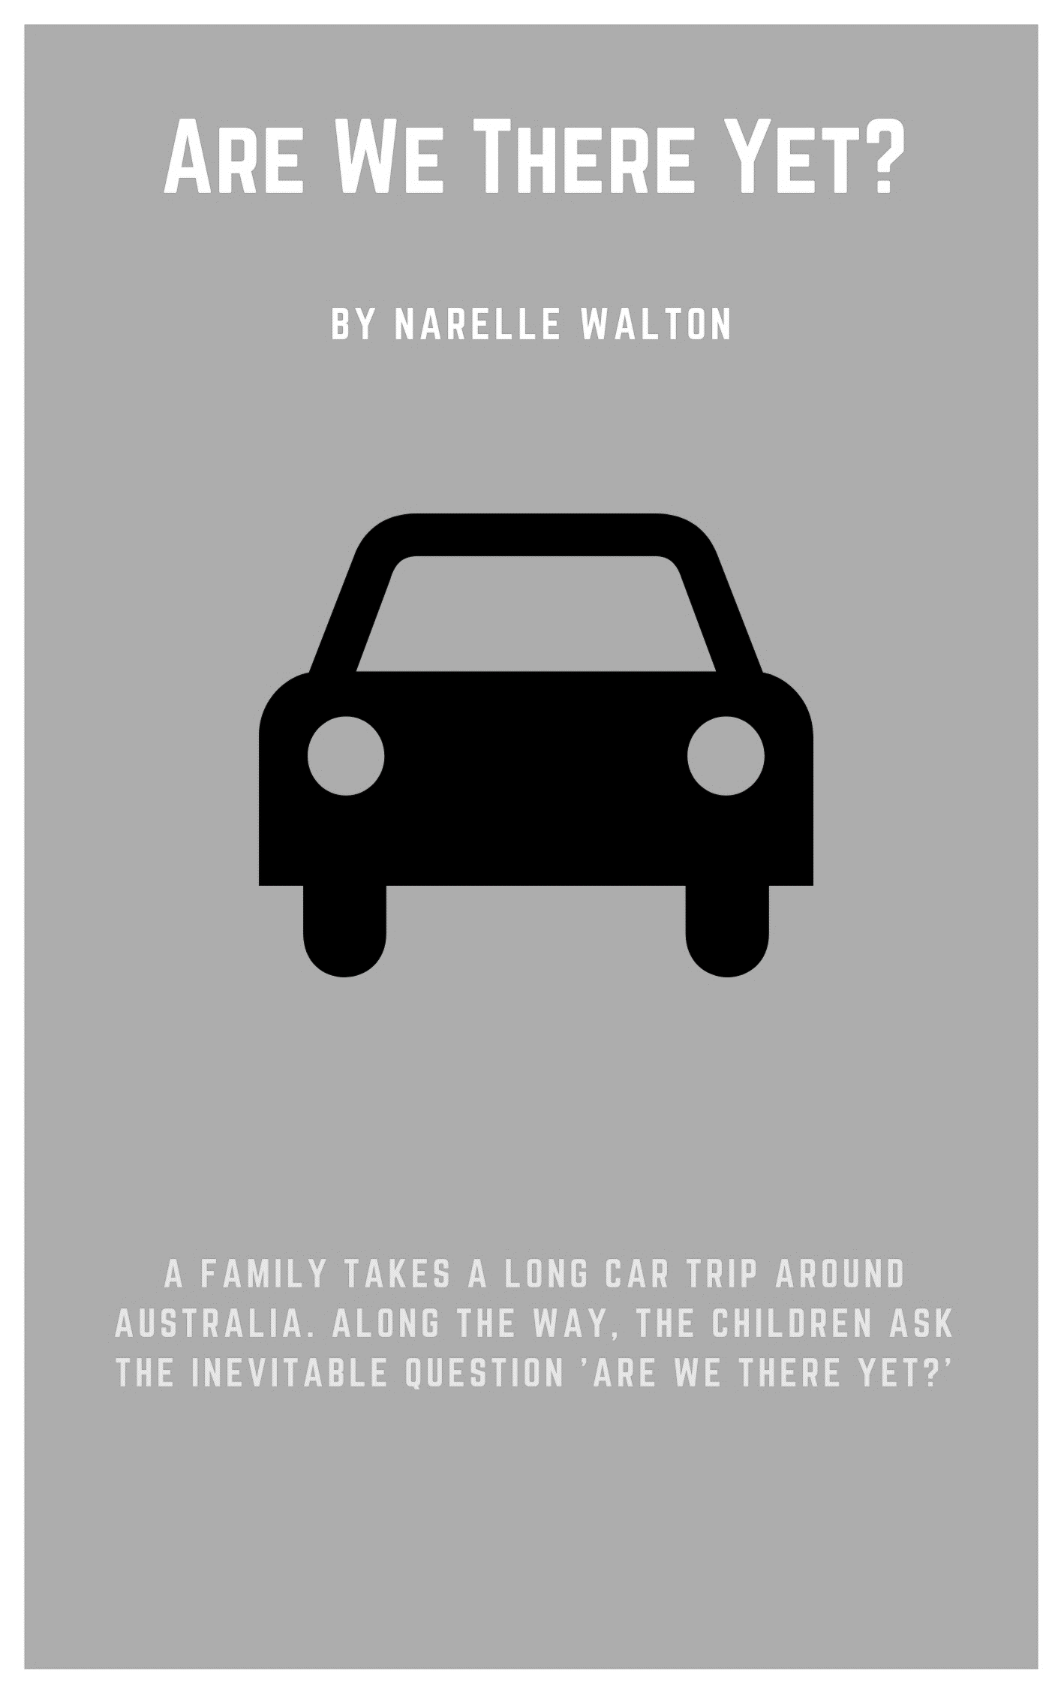
Are We There Yet?
By Narelle Walton

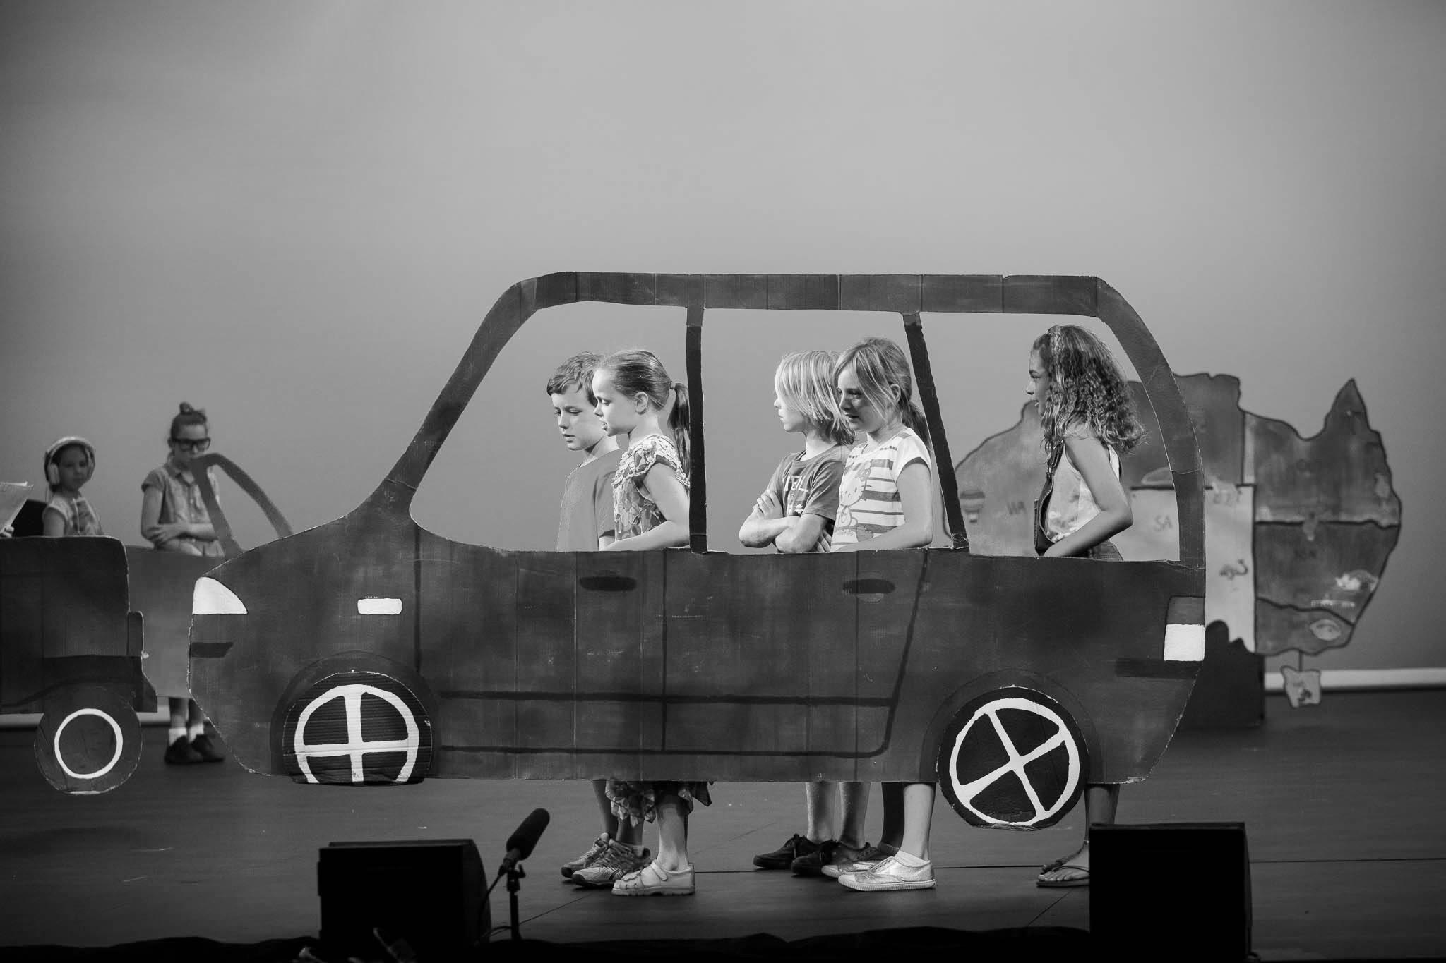

Synopsis
This play was written to support Year 3 & 4 Geography and teach the students in a fun way where the States and Territories are. It ran in literacy groups where the students could collaborate together and work on the Elements of Drama; making, performing and appreciating. It is based on long family car trips travelling around Australia with children asking their parents that annoying question, “Are we there yet?” The play was originally performed by a Year 3 class of thirty students and all students had a speaking part.
Cast - in order of appearance

Narrator 1

Narrator 2

Car 1 – Mum, Dad, Child 1, Child 2, Child 3

Western Australia – Miner 1, Miner 2, Miner 3

Car 2 – Dad, Mum, Jason (teenager), Katie (teenager)

Queensland – Surfer 1, Surfer 2, Surfer 3, Surfer 4

Car 3 – Dad, Mum, Lilly

Northern Territory – Tour Guide, Indigenous Australian, Tourist

Car 4 – Mum, Daughter (aged 16-17)

Melbourne – Worker 1, Worker 2, Worker 3

NOTE: If you don’t have enough students to fill the parts or have students missing for any performance it is easy to double parts from the earlier scenes and have them perform twice. Quick and simple costume changes will help the students achieve this. For example: Child 3 from Car 1, played a Worker in Melbourne; a Surfer also played the Tour Guide in Western Australia.

Before you begin
Curriculum Links
The Australian Curriculum: The Arts – Drama
Explore ideas and narrative structures through roles and situations and use empathy in their own improvisations and devised drama (ACADRM031)

Use voice, body, movement and language to sustain role and relationships and create dramatic action with a sense of time and place (ACADRM032)

Shape and perform dramatic action using narrative structures and tension in devised and scripted drama, including exploration of Aboriginal and Torres Strait Islander drama (ACADRM033)

Identify intended purposes and meaning of drama, starting with Australian drama, including drama of Aboriginal and Torres Strait Islander Peoples, using the elements of drama to make comparisons (ACADRR034)

The Australian Curriculum: The Arts – Visual Arts
Use materials, techniques and processes to explore visual conventions when making artworks (ACAVAM111)

The Australian Curriculum: Geography
The representation of Australia as states and territories and as Countries / Places of Aboriginal and Torres Strait Islander Peoples; and major paces in Australia, both natural and human (ACHASS066)

© Australian Curriculum, Assessment and Reporting Authority (ACARA) 2010 to present, unless otherwise indicated. This material was downloaded from the Australian Curriculum website (www.australiancurriculum.edu.au) (Website) (accessed 21August 2018) and was not modified. The material is licensed under CC BY 4.0 (https://creativecommons.org/licenses/by/4.0). Version updates are tracked on the ‘Curriculum version history’ page (www.australiancurriculum.edu.au/Home/CurriculumHistory) of the Australian Curriculum website.
ACARA does not endorse any product that uses the Australian Curriculum or make any representations as to the quality of such products. Any product that uses material published on this website should not be taken to be affiliated with ACARA or have the sponsorship or approval of ACARA. It is up to each person to make their own assessment of the product, taking into account matters including, but not limited to, the version number and the degree to which the materials align with the content descriptions and achievement standards (where relevant). Where there is a claim of alignment, it is important to check that the materials align with the content descriptions and achievement standards (endorsed by all education Ministers), not the elaborations (examples provided by ACARA).

Getting started
Character development exercises
For this play, character development exercises can be completed as a whole class. As a class, students research the roles in the play to find out:
- What the role wears,
- What the role does,
- What equipment the role needs,
- Any other important information.
Using this information, the students improvised the voice, mannerisms, stance and movement of the character. Students were encouraged to evaluate each other’s representations in a positive and supportive manner.

Set, costuming and props
Students created their props by worked in their performing groups. For example, all students in Car 1 decided on the props that they needed and choose the car that would best suit the family.

Four can be made out of large recycled pieces of cardboard. Ours were sourced from a local boat manufacturer. Students choose templates of four different cars including a station wagon, jeep, beetle and a convertible. Large windows need to be cut out so the student’s faces are visible. A ‘design and make’ day was held at our school with parents and caregivers assisting the students to draw and cut out the cars and wheels. The cars are painted in primary colours with the details in black and white.

A large map of Australia is used as a prop on stage throughout the whole play. Each state is labelled and painted in different colours.
Four surfboards can be cut out from a large sheet of cardboard. The students who play the surfers can design and paint their boards.

Short pieces of music are used for each State and Territory when actors are walking on to the stage. Each song only needs to be played for approximately 8 seconds. Songs used included:
Working Class Man by Jimmy Barnes
Surfin’ Safari by The Beach Boys
Indigenous Instrumental music (non-specific, this can be tailored to the local area)
9 to 5 by Dolly Parton
Down Under by Men at Work.

Costumes and props
Car 1 car, old cassette tape
Miners overalls, hard hats, head torches on hat, dirty faces
Car 2 car, map, head phones on kids
Surfers wet suits, board shorts, cardboard surfboards
Car 3 car
Northern Territory Tour guide (boots, hat), tourist (camera around the neck a bright shirt).
Car 4 car, mobile phone with earphones
Melbourne brief case, clipboard, mobile phones, dressed in work clothes suit and dress or
skirt and top.

Are We There Yet?
By Narelle Walton

SCENE ONE: Setting the scene

Narrators are to start on stage and they are situated down stage right throughout the play. You could have them standing behind the map.

Narrator 1: Australia is a pretty amazing place with wonderful places to visit especially if you’re flying and not driving. Have you ever been on a car trip that never seems to end?

Narrator 2: It’s school holidays and dad says “we are going to see Aunty Trudy”. Let me tell you Aunty Trudy is not that bad. She is old and smells a little, but the worst part is she lives a long, long, long way away and dad says we are DRIVING.

Narrator 1: Not driving! All I can say is thank god for electronics imagine the days when you didn’t have them. Imagine listening to this for 12 hours.

SCENE TWO: Car 1

Entering stage left.

Child 1: Move over you’re on my side, you’re so annoying.

Child 2: No I’m not! Don’t touch me. You move over.

Child 3: Do we have to listen to this music it is so bad. Why would anyone
choose to listen to that? Here play my tape it’s much better.
Child 1: Move over… MUM!

Child 2: I’m not even touching her she’s on my side.

Mum: Come on you two be nice to each other, keep your hands to yourself.

Child 3: Mum! I’m so sick of them.

Dad: If you kids don’t stop it right now I’ll pull over then you’ll all be in big trouble.

Mum: Oh I know! Let’s play I spy with my little eye something beginning with “L”.

Kids: MUM not again. Are we there yet?

Dad: Nope not even close, it’s a long way to Western Australia.

SCENE THREE: Western Australia

Enter stage right. Miners enter to ‘Working Class Man’.

Miner 1: It is so hot I hope we get some rain soon. It’s been a long day today I’m wrecked let’s get out of here and get a drink.

Miner 2: I have been working 10 days straight I’m buggered. I’m looking forward to getting home I’ve got the next 5 days off.

Miner 3: Lucky you! I have just started my 10 day shift I wish I was having the next 5 days off. Let’s go and get that drink I really need it.

SCENE FOUR: Narrators

Narrator 2: Going to Queensland was always fun but only once you got there.

Narrator 1: Those long car rides only got better when you didn’t have to listen to Mum and Dad SINGING or ARGUING.

SCENE FIVE: Car 2

Entering from stage right.

Dad: Are you sure it’s this way, it doesn’t look right to me?

Mum: Well that’s what the map says.

Dad: You don’t even have it up the right way, give it to Jason.

Mum: Jason, Jason take those things out of your ears. I hope you haven’t got that awful music too loud it will damage your hearing.

Jason: Huh! Katie has got hers on how come you’re not yelling at her?

Jason: Katie, Katie, KATIE!

Katie: WHAT!

Jason: Mum and dad want us.

Dad: Can either of you read a map? It seems you mother had us going the wrong way.
Katie: Are you for real?! More time in this car. Why did I even have to come on this trip? I could have stayed at Sarah’s house.

Jason: How long is this trip going to take. I really want a surf.

Jason & Katie Are we there yet?

SCENE SIX: Queensland

Entering from stage left. Surfers run on stage to the music ‘Everybody Surfing Now’.

Surfer 1: What a great morning for a surf, come on guys grab your boards the surf is pumping.

Surfer 2: Look at those waves out the back they’re huge, and there’s not many people out there.

Surfer 3: I think I will be getting to work late today that’s too good to miss. You’ve got to make the most of it when the waves are this good. They’re awesome!

Surfer 4: I’ve got the day off and I know where I’ll be spending the day. Come on guys let’s get out there.

SCENE SEVEN: Narrators

Narrator 1: Then there’s those car rides that last for days when mum says it’s just as much about the journey as it is the destination.

Narrator 2: They are so painful. You never have enough DVD’s to get you through that trip, especially one all the way to the Northern Territory.

SCENE 8: Car 3

Entering from stage left.

Dad: Love, did you remember to pack my shaving kit?

Mum: Yes, dear.

Dad: What about my favourite pyjamas? the blue striped ones?

Mum: Yes, dear.

Mum: This really is God’s country look at those beautiful trees. Lilly, Lilly wake up you’re missing all this, how can you be sleeping when there is all this to look at? It’s just so beautiful!

Lilly: MUM are you for real? You woke me up to show me some trees, they are the same trees that we saw yesterday and the day before, this is so boring.

Dad: Lilly don’t speak to your mother like that, you know how much she loves the scenery plus she has been looking forward to this trip for years.

Lilly: How much further? I just can’t stand it. Are we there yet?

SCENE NINE: Northern Territory

Enter from stage right. Enter to music of an Indigenous Australian origin.

Tour guide: This way, follow me. This is Uluru, isn’t it spectacular!

Indigenous Australian: Welcome to our land this is a very sacred place for our people. Please respect our wishes and do not climb the rock. Remember to take only memories and just leave your footprints.

Tourist 1: It’s amazing! I had no idea it was this big, look at all the colours. How long would it take to walk around it?

Indigenous Australian: It will take you about three and half hours to walk all the way around. I recommend you do it while you are here.

SCENE TEN: Narrators

Narrator 2: Then there’s the car trip that is last minute not planned very well but Mum has to get to Melbourne for work. She decides you haven’t seen Granny and Grandpa for a while and that it would be a great idea to spend quality time with her in the car.

Narrator 1: And quality time with the grandparents. Has she forgotten that when you’re sixteen your friends are the most important people to you and that’s who you want to spend all your time with?

SCENE ELEVEN: Car 4

Enter from stage right.
Mum: Isn’t this nice darling just you and me and all this time together. We have the next 11 hours to catch up. I’m sorry I have been so busy at work. Tell me how is school going? How is your boyfriend? What’s his name again?

Mum: Sally, Sally!

Daughter: Huh! Sorry were you talking to me? Far out Mum! I’m chatting with everyone. Do you know how much I’m missing out on by being on this stupid trip? Brandon is having the best party at his house this weekend. I can’t believe I’m not going. How long is this trip going to take? / Are we there yet?

SCENE TWELVE: Melbourne

Enter from stage left. Workers enter to ‘9 to 5’.

Worker 1: Hi Phoenix are you going to be at the meeting today? The big boss is down from Sydney I’m not looking forward to it.

Worker 2: Yah, I will be there I’m not sure what he is here for. I hope its good news. Last time he fired someone. Let’s just grab a coffee first I think we are going to need it.

Worker 3: (On their phone) Look I’m nearly at the office I will have the paperwork on your desk by 11am. Don’t worry it won’t take long to fix. Ok. Ok see you soon. Bye.

SCENE THIRTEEN: Land Down Under

Half the cast enter from stage left and the other half enter from stage right. All cast members enter to the song ‘Land Down Under’.

SCENE FOURTEEN: Narrators

Narrator 2: Australia it’s a great place. Whether you’re visiting Burke, Broome or Byron Bay you would have to agree there’s no place quite like it.

Narrator 1: Car trips, road trips, work-trips, family-trips whatever the reason when the kids are in the car they are always going to ask

Everyone: Are we there yet?

END

Concluding
Reflection
After the students have engaged with the text, use the following questions to hold a reflective class discussion:
- How do you feel the audience responded to the play?
- What part of the play did the audience find entertaining the most? How do you know this?
- What parts / lines of the play would you change and why?
- How can you use this play to remember certain States and Territories of Australia?
- Choose one landmark you would associate with each state.

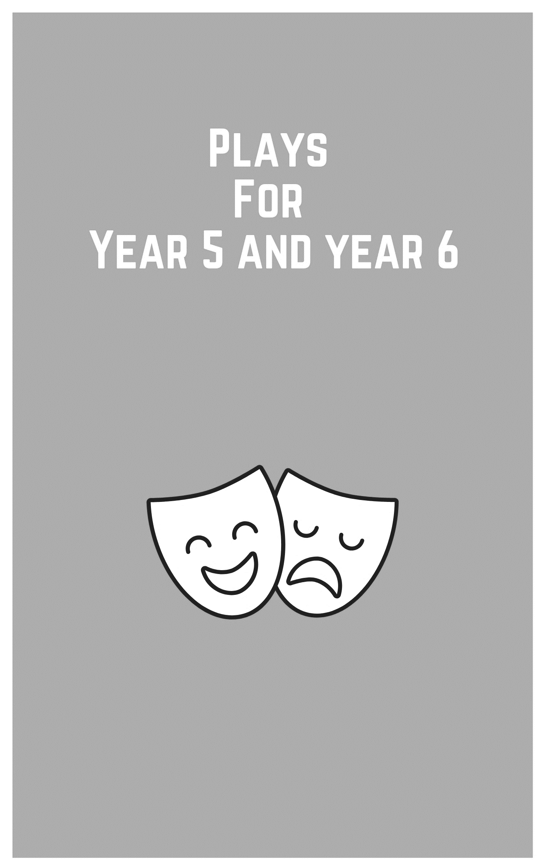
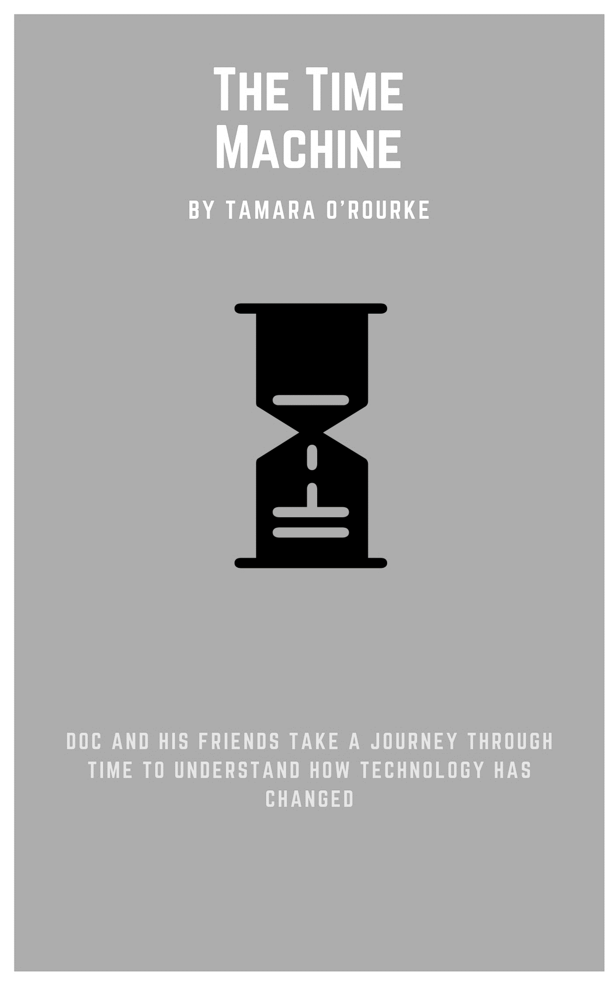
The Time Machine
By Tamara O’Rourke
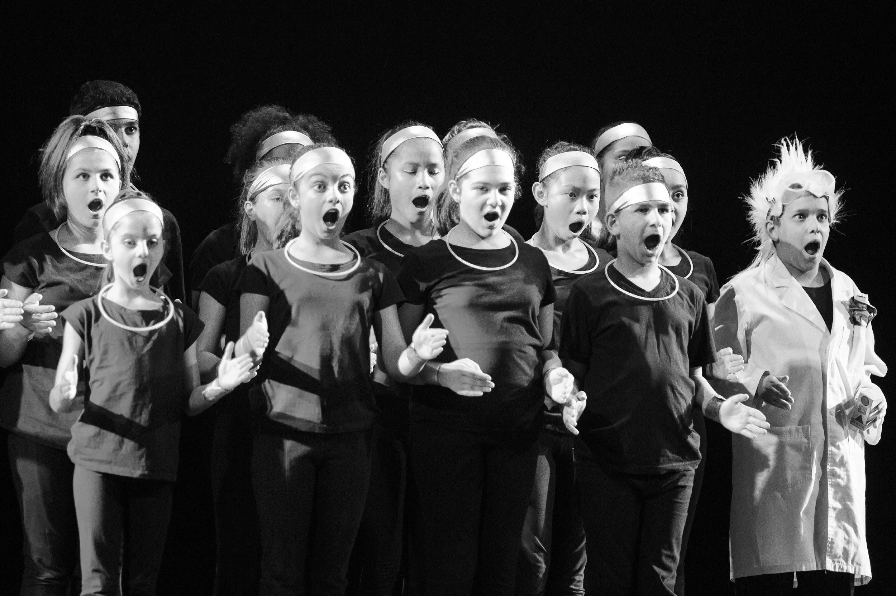

Synopsis
This play follows a scientist named Doc and his friends as they travel back in time to try to understand how technology has changed throughout the years. Doc and the gang travel back to 1967 when television first arrived in NSW schools, to the introduction of the fax machine, the telephone, Google, the interactive whiteboards, Siri and into the future where it all gets a bit too weird for Doc and the gang. The audience travels along with everyone as they explore the monumental technological improvements that have occurred throughout the 20th and 21st centuries and how they have influenced and transformed teaching and learning in the current age.

Cast - in order of appearance
There is one central character in this play and his name is Doc. Doc is the scientist who has developed a time machine that is going to take him and his friends back to the past. The rest of the ensemble cast begins as the time machine then transforms into the rest of the cast.

Doc: Central character that moves the story from one scene to the next.

Mother: Whines about daughter always being on the computer.

Daughter: Always wants to be on her computer.

Grandpa: Does not know why a pen (for an interactive whiteboard) does not have any ink.

School Girl 1 and 2: Complains about how heavy books are.

Teacher in 1967: Introduces the television to the class.

Teacher 1 and 2: Teachers talking over the telephone in class.

Siri: Helps the ensemble cast fix their technology.

Teacher in the future: Teaches a class in 2067.

Actors 1-20 are members of the ensemble cast–anywhere between 10 - 30 students. They do not have specific names.

Before you begin
Curriculum links
The Australian Curriculum: Drama
Explore dramatic action, empathy and space in improvisations, playbuilding and scripted drama to develop characters and situations (ACADRM035)

Develop skills and techniques of voice and movement to create character, mood and atmosphere and focus dramatic action (ACADRM036)

Rehearse and perform devised and scripted drama that develops narrative, drives dramatic tension, and uses dramatic symbol, performance styles and design elements to share community and cultural stories and engage an audience (ACADRM037)

Explain how the elements of drama and production elements communicate meaning by comparing drama from different social, cultural and historical contexts, including Aboriginal and Torres Strait Islander drama (ACADRR038)

The Australian Curriculum: Dance
Explore movement and choreographic devices using the elements of dance to choreograph dances that communicate meaning (ACADAM009)

The Australian Curriculum: Music
Explore dynamics and expression, using aural skills to identify and perform rhythm and pitch patterns (ACAMUM088)

© Australian Curriculum, Assessment and Reporting Authority (ACARA) 2010 to present, unless otherwise indicated. This material was downloaded from the Australian Curriculum website (www.australiancurriculum.edu.au) (Website) (accessed 21August 2018) and was not modified. The material is licensed under CC BY 4.0 (https://creativecommons.org/licenses/by/4.0). Version updates are tracked on the ‘Curriculum version history’ page (www.australiancurriculum.edu.au/Home/CurriculumHistory) of the Australian Curriculum website.
ACARA does not endorse any product that uses the Australian Curriculum or make any representations as to the quality of such products. Any product that uses material published on this website should not be taken to be affiliated with ACARA or have the sponsorship or approval of ACARA. It is up to each person to make their own assessment of the product, taking into account matters including, but not limited to, the version number and the degree to which the materials align with the content descriptions and achievement standards (where relevant). Where there is a claim of alignment, it is important to check that the materials align with the content descriptions and achievement standards (endorsed by all education Ministers), not the elaborations (examples provided by ACARA).

Getting started
Warm up
The Time Machine has a focus on working effectively as an ensemble cast. As such, the warm ups are centered around building trust, stage craft, and ensemble techniques.

The Machine
In this warm up, the students work together to make a machine.
- One student enters the space.
- The student makes a noise and a gesture.
- A second student enters the space. They make a complimentary noise and gesture. (The second person needs to find a way to fit with the sound and gesture of the first person so that the machine is cohesive).
- One by one, each student enters the space and adds their own noise and gesture.
- Once all of the students have entered the space and added to the machine, the teacher becomes the conductor. As the conductor, the teacher can make the machine change the pace and rhythm (slow down, speed up) or even pitch and dynamics of the sound (louder, softer, higher pitch, lower pitch).
Extension: Repeat the activity but increase the difficulty by asking the students to create a machine that has to solve a problem.

Pass the clap
This warm up helps to focus the student’s attention. The activity also helps students to anticipate the movement of other members of the class as well as work as a group.
- The students sit in a circle,
- One student claps their hands towards the person on their left,
- The next student repeats this, clapping their hands towards the person on their left,
- This is repeated around the circle until the clap returns to the first person,
- Repeat activity again, this time setting a time limit for the students, for example, they have to pass the clap within three seconds of receiving it,
- With each pass around the circle, encourage the students to improve on their time.
Extension: add a sound whilst passing the clap, for example ‘whoosh’

Count Up, Count Down
This warm up encourages the students to practice patience and turn taking skills. The warm up also helps the students to develop focus.
Begin the activity by standing or sitting in a circle:
- As a group, the students have to count sequentially, up, from 1 – 10 and then sequentially, down, from 10 – 1,
- The numbers can be said by any student,
- If a number is said by more than one person, the game starts again,
- If a number is said out of sequence, the game starts again.
Extension: if the class is learning a language other than English, the activity can be played by counting in that language.

Zip, Zap, Zop
Begin by standing in a circle.
- Choose a student to start the game,
- The chosen student points across the circle, makes eye contact with another student, makes eye contact, and says, ‘Zip’,
- This student then looks across the circle, makes eye contact with another student and says ‘Zap’,
- This student then looks across the circle, makes eye contact with another student and says ‘Zop’.
The game continues with the words passed in this order ‘Zip’, ‘Zap’, ‘Zop’. Players should try to pass the word smoothly and clearly.
Extension: Play this as an elimination game. If a student speaks incorrectly, doesn’t make eye contact, says the wrong word, then they are eliminated.

Moving through space
Begin by asking the students to move around the room.
- The teacher, as facilitator, calls out different ways to travel (locomotion), and the students respond:
  - Become heavy,
  - Become lighter,
  - Make the movements larger,
  - Make the movements smaller,
  - Travel smoothly,
  - Travel jerkily,
  - Travel on a different level,
  - Travel as if you are moving through a cloud,
  - Travel as if you are moving through mud.

Stillness to speed
Begin with the students moving around the space, becoming aware of, but not communicating with each other.
- On a signal from the teacher, the students move as quickly as they can (in a safe manner),
- On a signal from the teacher, the students freeze, becoming absolutely still and silent,
- On a signal from the teacher, the students move as quickly as they can (in a safe manner),
- On a signal from the teacher, the students freeze, becoming absolutely still and silent.
Extension: Play this as an elimination game. If a student does not freeze straight away, or moves when frozen, then they are eliminated. The last student to freeze or the last student to start moving again may be eliminated.

Tempo changes
Divide the students into groups of five to six. Allocate each group a clearly defined space in the room.
- The teacher, as facilitator, calls out different tempos (speeds) with 1 being almost still as a statue and 10 being as fast as safely possible in the space,
- The students, as a group, must find a way to move to the allocated tempo,
- The challenge for the students is to find the subtle difference between each tempo.

Voice Warm up
Eewy chewy toffee
This activity helps the students develop an awareness of how they can move their mouth, tongue and face.
- Begin by telling the students that you all have an imaginary toffee in your pocket,
  - Ask the students to follow the movements that the teacher makes:
  - Take the toffee out of your mouth,
  - Unwrap the toffee,
  - Put the toffee in your mouth,
  - Start to chew the toffee on the left side of your mouth,
  - Chew the toffee on the right side of your mouth,
  - Move your mouth side to side as you chew,
  - Move your chin in and out as your chew,
  - Imagine the toffee is stuck at the front of your mouth,
  - Imagine the toffee is stuck at the back of your teeth,
  - Imagine the toffee starts off very large and slowly becomes small,
  - Imagine the toffee is very small but becomes large as you chew it.

Story Telling
This warm up encourages the students to engage with their imaginations. It also encourages the students to focus on how they deliver their lines (vocal qualities), even when their line is only one word.
- Stand in a circle (standing encourages better vocal quality than sitting),
- The teacher, as facilitator, calls out a title for a story,
- The students tell the story, one word at a time,
- As the students deliver their word, they should create a cohesive story.
Extension: The game begins with the teacher, as facilitator calling out a title for a story. This time, the first student delivers several words or sentences. On a signal from the teacher as facilitator, the student to the right of the first student continues the story.
Extension: The game begins with the teacher, as facilitator, calling out a title for a story. This time, the first student delivers several words or sentences in gibberish. On a signal from the facilitator, the student to the right of the first student continues the story.

Character development exercises
The clay game
Invite six students to stand in the space. The remaining students become the audience.
- Ask the six students to divide into pairs,
- One member of the pair becomes the sculptor and the other member of the pair becomes the clay,
- The sculptor creates a character by sculpting the face and body of the ‘clay’ into a new position,
- After a few minutes, the teacher, as facilitator, asks the clay to come to ‘life’ creating a character.

Set, costuming and props
The set, costume and props that were used for the play was very minimalistic. I wanted to ensure the focus was on the student’s acting abilities and not on elaborate costume and set design.

Set
- 1 metre by 50 centimeter box

Props
- Roll of paper with the words GOOGLE written in large block letters
- Remote control that Doc uses to work the time machine
- Small box acting as a television for television scene
- Large box on stage which stores the television box and time machine remote
- Piece of newspaper stored in actor’s pockets

Costume
Doc
- Black pants, shoes and t-shirt
- White science lab coat
- White/grey Mohawk wig
- Safety goggles

Ensemble Cast
- Black pants, t shirt and shoes
- Silver material used for wrist and ankle cuffs and headband
- Glow stick necklaces around their necks

The Time Machine
By Tamara O’Rourke

ACT 1 Scene One

Ensemble cast begin centre stage - three rows in a group.

One row kneeling, next row kneeling with body upright, next row standing.

The Ensemble cast is acting as the Time Machine in this scene.

The play begins by Doc running from downstage stage left to downstage right, then from downstage right to downstage left. Doc stops, slowly looks at the audience and then begins to speak.

Doc: What? What are you looking at? Stop looking at me! What’s this? (Doc points to the ensemble cast in the middle of the stage)

Doc: That’s top secret! (Doc speaks to the audience)

Doc: Oh, don’t give me that look. Alright, fine, can you keep a secret?

Ensemble cast lift their heads to speak and then lower their heads after speaking.

Ensemble: Yes, they can keep a secret!

Doc: Shh. (Doc points to ensemble cast) I don’t know if I can trust them.

Ensemble: Just tell them, Doc.

Again, Ensemble cast lift their heads to speak.

Doc: Alright, fine. I have been developing… wait for it… wait for it. (pause) A time machine!

Ensemble: A time machine!

Doc: I want to know how technology has developed throughout the ages.

SCENE TWO: Flashback

A flash back of things people would say as new technology comes into popular culture.

During this scene, the ensemble cast disperses from their group and take on the roles of different people in society.

Mother: Hey Missy, get off your computer.

Daughter: Stop it mum!

Mother: You know, back in my day we didn’t have any of these “computers”.

Grandpa: Hey sonny, what kind of a pen is this? It doesn’t have any ink!

School Girl 1: Gee books are so heavy.

School Girl 2: How did they learn without the Internet?

Daughter: Mum, what was school like when you were there?

Mother: Well…

SCENE THREE: The Present
Actors come back to reality.

Doc: Quickly, everything is ready.

Ensemble cast gets back into the time machine format the same as they were at the beginning.

Doc: Wish me luck.

Ensemble: Luck

Doc: And I’ll see you in the past. (Doc presses the button on the time machine remote)

Ensemble: Back… Back… BACK!

SCENE FOUR: Classroom Scene

Transition.

As the ensemble move into their next positions, they say the following rhyme.

Ensemble: One, two, three, four are your feet flat on the floor? Five, six, seven, eight try to keep your back straight!

Teacher in 1967: Good morning boys and girls.

Ensemble: Good morning, Miss A.

Teacher in 1967: Now who can tell me what today’s date is?

Points to school Girl/Boy.

Teacher in 1967: You!
School Girl steps forward to answer the question.

School Girl: Today’s date is the 10th June 19…

Ensemble whispers to the School Girl.

Ensemble: (Whisper) 67.

School Girl: 67!

Teacher in 1967: That’s right kids and have I got a treat for you.

School Boy: What is it?

Teacher in 1967: Move back kids, because this is big, this is massive and this has never been seen before at school.

Teacher moves over and rummages through the big box on the stage.

Teacher in 1967: It’s in here somewhere.

Teacher pulls out a small box.

Teacher in 1967: Ta da.

All classroom kids: It’s so square. It’s so small. It’s got buttons. What is it?

Teacher in 1967: It’s a television!

Ensemble: A television? (everyone looks confused)

Ensemble: Ah, a television.
Teacher in 1967: A television is a system that converts visual images onto a screen.

School Boy: Can I touch it?

Teacher in 1967: Absolutely not, this is the only one and if this breaks there will be no more television and how would we watch the moon landing in 69?

School Girl: Gee 1969, now that was a different time!

SCENE FIVE: Telephone Scene

Transition.

Ensemble cast moves like robots as they repeat the word “time” three times.

Ensemble: Time… Time… TIME! It’s telephone time. Hello? You have dialed 1800 phone help.

Telephone operator 1: Sorry we can’t get to the phone right now/

Telephone operator 2: But if you leave your name and number after the beep, we’ll get back to you as soon as possible.

Ensemble: Beep!

Doc: (Doc speaks to the audience) Telephones have been connecting teachers for over 40 years.

Teacher 1: Hey ____________ (insert name of student).

Teacher 2: Hey _____________ (insert name of another student).

Teacher 1 and 2: Have you seen Pitch Perfect 3? Hahahahahah (teachers laugh).

Doc: Ahem. (Doc pretends to cough)

Teacher 1: Do you have the MAB blocks?

Teacher 2: Can I borrow some ahhhhh CHALK?

Ensemble: You have been disconnected!

Ensemble cast bends over as if they were broken.

SCENE SIX: Fax Machine

Doc walks around the space pushing the button on his remote control.

Doc: Why isn’t it working? Oh, look reboot. Beep.

Ensemble cast repeat the word “beep” as they move into a formation of a fax machine.

Ensemble: Beep. Beep. Beep. Beep. Beep…

Ensemble cast say the following numbers acting as if they were the numbers being pushed on a fax machine.

Ensemble cast one at a time: 9, 7, 5, 0, 2, 2, 3, 6.

Actor 1: Cue fax machine noise.

Actor 2: (Actor makes the noise of a fax machine.) Beep bop bo bop ba bing!

Actor 3: Send.

Actor 4: Receive.
Doc: Look Guys! It’s a fax!

Ensemble: It’s a fax? (repeats 4 x)

Ensemble pulls out a roll of paper from the side the fax machine and ensemble begin to look at it to try to decipher what it says.

Actor 5: What does it say?

Actor 6: G…O… O… G... L... E?

Actor 7: (Pronounces Google as “googlay”) What’s googlay?

Ensemble: No silly, Google. Your one stop shop for all your knowledge!

SCENE SEVEN: Google

Actors walk around the stage and pull out a piece of newspaper from their pockets.

Ensemble: Knowledge, knowledge, knowledge, knowledge, knowledge.

Actor 8: I wonder how many stars are in the solar system?

Ensemble: Google it.

Actor 9: I wonder; how long the average human can hold their breath?

Ensemble: Google it!

Actor 10: How do I make paper origami?

Ensemble: Just Google it?

The following lines act as a segue into the next scene and allows the actors to fold up their newspapers and put them back in their pockets.

Doc: How to make a paper swan! First, you take your piece of paper and fold it in half. Then you fold it in half again. Then you roll it up and put it in your back pocket. You walk downstage for your next scene.

Actors walk downstage whilst putting their newspaper in their back pocket.

Ensemble: Huh?

SCENE EIGHT: Interactive Whiteboard

Actor 11: (Actors are all facing the audience in one line) In 1999, the interactive whiteboard was invented.

Ensemble: Did you say interactive?

Actors touch the space in front of them as if they were touching an interactive whiteboard.

Ensemble: Touch, touch, touch, drag and drop.

Actors all drop and bend over at the waist.

Actor 12: Wake up you sleepy heads.

Ensemble actors pop up out of their slumber.

Actor 12: We’re in 2015! So arm yourselves!

Members of the ensemble all say different names of technologies that they use, as if they were arming themselves, with them, one at a time.

Ensemble: Yay!

Actor 13: Agh…It’s not working (referring to the actor’s device).

Ensemble: What are we going to do?

Ensemble members are all in despair because their devices do not work.

Actor 14: My pics are all blurry.

Doc: I’m lost.

Actor 15: My music has gone!

Actor 16: Does anyone have a charger?

Ensemble: Siri, can you help us?

Siri looks very unhappy.

Siri: On one condition. Stop mistreating me! Do you know how tiring it is to find all of this information for you? Where’s George Street? What’s the football score? How do I make a stir-fry? It’s really hard. And sometimes I get overwhelmed.

All: We’re sorry, Siri.

Siri: Ok, fine, I’ll help you. Are you ready? (looks to the audience)

SCENE NINE: Classroom scene in the future

The ensemble cast uses the following rhyme to move into their classroom positions.

Ensemble: One, two, three, four are your feet flat on the floor? Five, six, seven, eight try to keep you back straight.

Teacher: Good morning boys and girls.

Ensemble: Good morning Miss A.

Teacher: Now who can tell me what today’s date is?

School Girl: Today’s date is the 10th June 2067!

Teacher: That’s right kids, and do I have a treat for you. Wait, is number 14 here?

Ensemble move their heads around trying to find number 14.

Teacher: I said is number 14 here? Is Luke here?

Actor 16: Has anybody spoken to Luke?

Actor 17: He tweeted last night at 8:30 pm.

Actor 18: He checked in at McDonald’s yesterday.

Actor 16: In person?

Ensemble: Huh?

Teacher: We do not speak to people in 2067… in person.
Actor 19: I don’t like it here.

Actor 20: I wanna go home.

Ensemble: Doc, take us home!

Doc: You know what to do.

Ensemble begin clicking their heels together. (Like Dorothy in the Wizard of Oz)

Ensemble: There’s no place like home, there’s no place like home, there’s no place like home! (Ensemble cast fall to the floor)

BLACK OUT

SCENE TEN: Where are we?

Ensemble: Doc? Where are we? Where have you taken us?

END

Concluding
Reflection
After the students have engaged with the text, use the following questions to hold a reflective class discussion:
- What do you think are the most important things to practice when working as an ensemble?
- What are the different ways you can transition between scenes?
- List five important aspects of performance, for example: voice, acting within the space provided, movement, listening, rehearsal etc.
- Why was it important that the script does not answer the last question in the play?
- How important is timing and pace in a performance? How can you improve this during rehearsal?

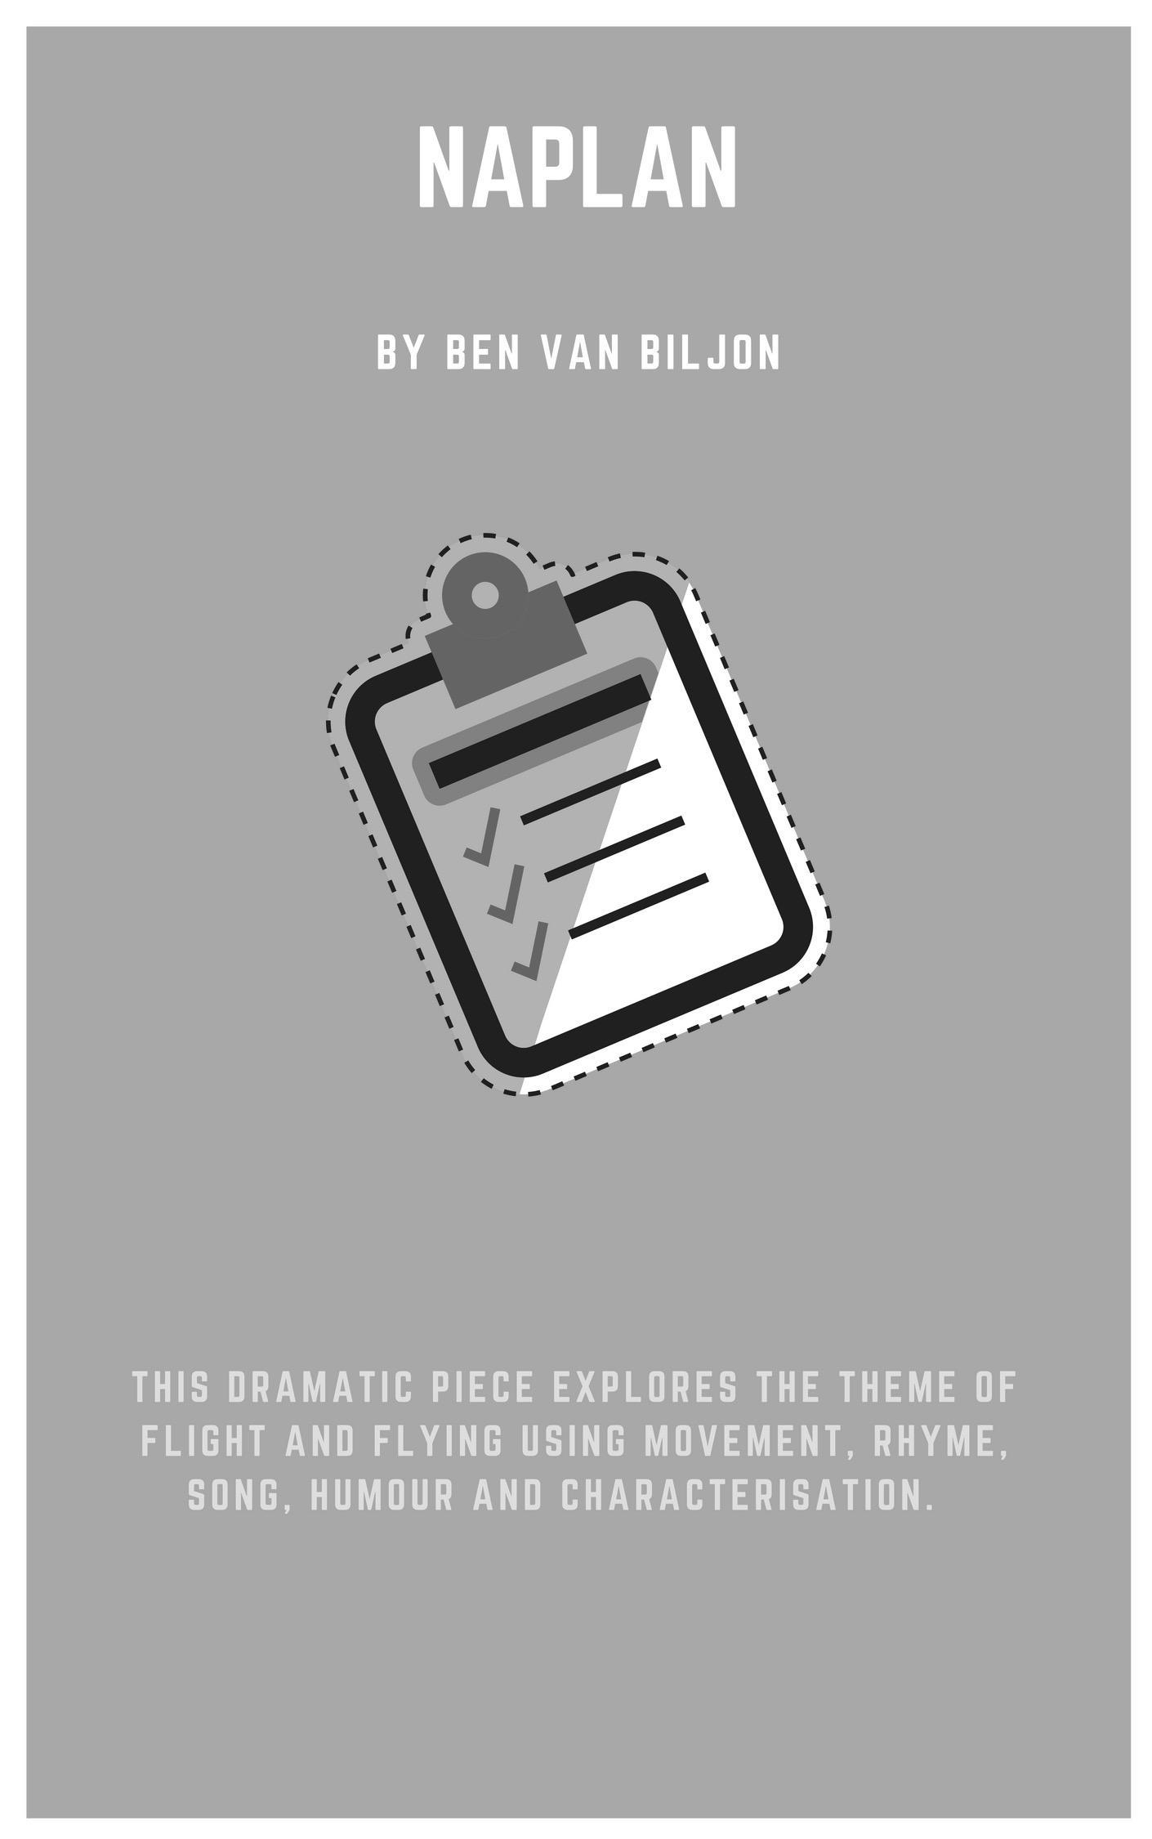
Negative Anti Purposeful Learning and Needs
NAPLAN
By Ben Van Biljon
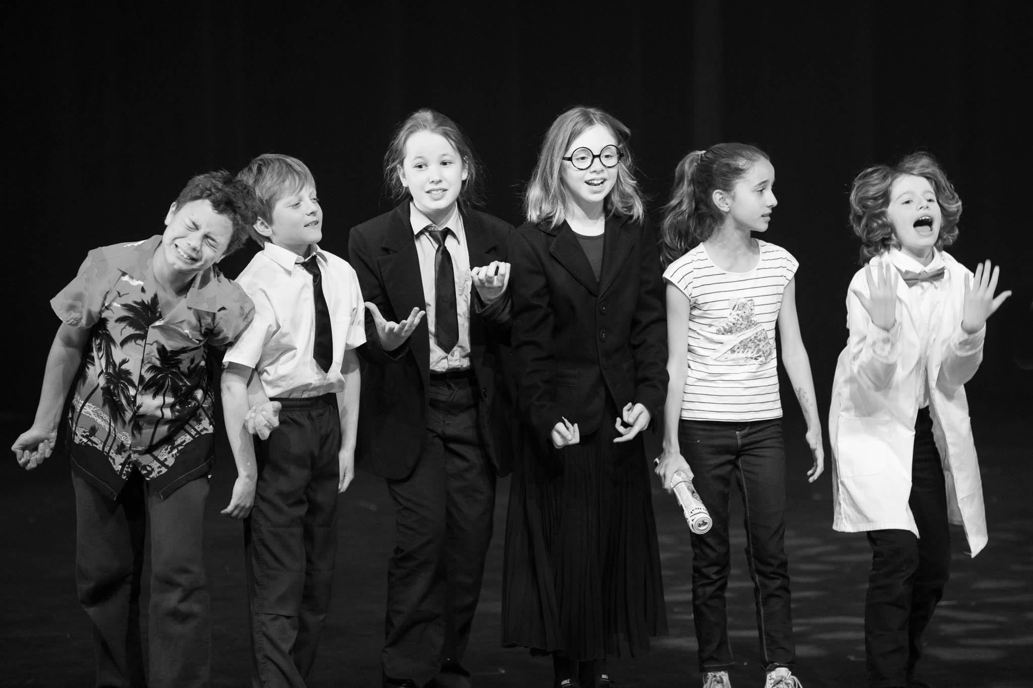

Synopsis
The NAPLAN test can be an extremely nerve-racking experience for many students. But what about the teachers? This satirical piece explores the purpose and value of the NAPLAN assessment from the teacher’s perspective. The themes of the play involve student assessment, personal stress and the pressures of assessment results.

Cast - in order of appearance
There are 14 characters all of whom are teachers. Throughout the piece, they play other roles as well.

Mrs. L: English teacher

Mrs. M: Drama teacher

Mrs. O: Mathematics teacher

Mrs. T: History teacher

Mr. D: Science teacher

Mrs. A: Librarian

Mr. O: IT teacher

Mr. A: Art teacher

Mrs. L: Kindergarten teacher

Mr. L: Mathematics teacher (regimented and hard-lined)

Mrs. H: Primary teacher

Mrs. F: Sports teacher

Mrs. B: Dance teacher

Mrs. R: Music teacher

Before you begin
Prior knowledge
An understanding of what the NAPLAN is. A discussion about what effects and stresses the NAPLAN assessment can have on everyone involved would be highly beneficial. Students must have a general understanding of basic drama techniques that include voice, body, movement and space.

Curriculum links
The Australian Curriculum: Drama
Explore dramatic action, empathy and space in improvisations, playbuilding and scripted drama to develop characters and situations (ACADRM035)

Develop skills and techniques of voice and movement to create character, mood and atmosphere and focus dramatic action (ACADRM036)

Rehearse and perform devised and scripted drama that develops narrative, drives dramatic tension, and uses dramatic symbol, performance styles and design elements to share community and cultural stories and engage an audience (ACADRM037)

Explain how the elements of drama and production elements communicate meaning by comparing drama from different social, cultural and historical contexts, including Aboriginal and Torres Strait Islander drama (ACADRR038)

© Australian Curriculum, Assessment and Reporting Authority (ACARA) 2010 to present, unless otherwise indicated. This material was downloaded from the Australian Curriculum website (www.australiancurriculum.edu.au) (Website) (accessed 21August 2018) and was not modified. The material is licensed under CC BY 4.0 (https://creativecommons.org/licenses/by/4.0). Version updates are tracked on the ‘Curriculum version history’ page (www.australiancurriculum.edu.au/Home/CurriculumHistory) of the Australian Curriculum website.
ACARA does not endorse any product that uses the Australian Curriculum or make any representations as to the quality of such products. Any product that uses material published on this website should not be taken to be affiliated with ACARA or have the sponsorship or approval of ACARA. It is up to each person to make their own assessment of the product, taking into account matters including, but not limited to, the version number and the degree to which the materials align with the content descriptions and achievement standards (where relevant). Where there is a claim of alignment, it is important to check that the materials align with the content descriptions and achievement standards (endorsed by all education Ministers), not the elaborations (examples provided by ACARA).
Getting started
Warm up
Follow the Director
In this warm up, the students lean to follow direction, focus and develop skills in character and role.
- Ask the students to scatter around the space,
- Remind the students that they must complete the activity without talking or bumping into each other,
- The students locate any point in the room, they then walk to that point,
- After reaching the point, the students turn sharply and move to the next point,
- After a short period of time, the teacher, as facilitator, calls out adverbs and students respond accordingly, for example “walk happily”,
- Once the students are demonstrating confidence, the teacher, as facilitator, adds a character to the adjective, for example, “walk happily like a 2-year-old child”.
- Once the students are demonstrating confidence, the teacher, as facilitator, adds a descriptive setting, for example, “walk happily like a 2-year-old child in a candy store”.

Steal the nectar
The aim of this activity is for the ‘civilians’ to work together to steal the nectar from the ‘keeper’ and get it back to their village. Students will develop improvisation skills, freeze frame, energy, imagination and collaboration.
- The ‘civilians’ (students) stand at one end of the room against the wall,
- The ‘keeper’ (played by the teacher or a student) stands on a drama block/chair at the opposite end of the room,
- Below the ‘keeper’ is an any object which is the ‘nectar’,
- When the ‘keeper’ faces away from the rest of the group, the ‘civilians’ are able to move towards the ‘nectar’ to steal it,
- When the ‘keeper’ turns back around, the ‘civilians’ need to freeze and stay in that position,
- If the ‘keeper’ sees anyone moving, they have the right to ‘banish’ them back to the start,
- The ‘keeper’ will ask three people “What are you doing?” each time they turn around,
- The ‘civilians’ that the question is directed to, have to use their frozen body shape to come up with an action and act it out, for example doing a dance, playing tennis, making a milkshake.
- If a ‘civilian’ acts out an idea that has been previously done, they will be ‘banished’ back to the start,
- Eventually, the ‘civilians’ will steal the ‘nectar’,
- Once the nectar is missing, the ‘keeper’ can no longer ask what they are doing,
- The ‘civilians’ cannot, be seen with the nectar in their hands,
- The ‘civilians’ work as a team, hiding the ‘nectar’ behind their backs, until they get it all the way back to the start,
- If a ‘civilian’ is caught with the ‘nectar’ in their hands, the ‘nectar’ is returned and that person is ‘banished’,
- If a ‘civilian’ is seen moving and they have the ‘nectar’, the ‘nectar’ is returned and they are banished.
- The ‘keeper’ has one chance each round to guess who may have the ‘nectar’ if they are correct, the ‘nectar’ is returned and that ‘civilian’ is banished.

Character development exercises
Reader’s Theatre (with a twist)
In this warm up, students work on characterisation, accents and creative thinking.
- Divide the students into groups,
- Allocate each group a Reader’s Theatre script at their reading ability,
- Each student is allocated a character,
- Students will start reading and acting out the scene as their character,
- On the sound of a bell, the students must continue the scene but completely change their character’s voice, movement and actions,
- The bell may be rung multiple times throughout the scene.

Set, costuming and props
Set
There is no specific setting for this piece.

Props
No props required.

Costumes
Suggestion for:
- Mrs L: English teacher—long skirt, buttoned shirt, hair in a bun, glasses
- Mrs M: Drama teacher—all blacks, cravat, beret
- Mrs O: Mathematics teacher—smart casual
- Mrs T: History teacher—pants, button shirt, jacket or vest
- Mr D: Science teacher—lab coat, pants, checkered shirt
- Mrs A: Librarian—dark coloured long skirt, white shirt, cardigan, hair in a bun, glasses
- Mr O: IT teacher—pants, long sleeved shirt tucked in, glasses, hair slicked to one side
- Mr A: Art teacher—mambo shirt, jeans, wild hair
- Mrs L: Kindergarten teacher—colourful dress
- Mr L: Mathematics teacher (regimented and hard-lined)—private school shorts at knee level, socks up to knees, leather school shoes, short sleeved button shirt tucked in, tie, hair slicked and parted
- Mrs H: Primary teacher—smart casual
- Mrs F: Sports teacher—athletic sports attire
- Mrs B: Dance teacher—all black, baggy pants, dance top/singlet
- Mrs R: Music teacher—smart casual

Negative Anti Purposeful Learning and Needs
NAPLAN
By Ben Van Biljon

All teachers grouped and huddled together in centre of stage. Spot light on group.

Mrs. L: Is it still there?

Mrs. M: It’s not going away!

Mrs. O: It’s always there!

Mrs. T: Why won’t it go away?

Mr. D: Make it stop! Please! Make it stop!

Creepy evil laughter audio.

Everyone screams.

All lights on.

Mrs. A: Alright everyone, let’s hold hands. This year is going to be tough.

Mr. O: She’s right. We have to stick together to get through it.

Mr. A: Get through what man?
Mrs. L: Through what?! Why…the NAPLAN of course!

All: NAPLAN!

All divide into two groups: Lot A and Lot B.

Lot A: Give me an N.

Lot B: N.

Lot A: Give me an A.

Lot B: A.

Lot A: Give me a P. L. A. N.

Lot B: P. L. A. N.

Lot A: What’s it spell?

Lot B: NAPLAN!

Lot A: What’s it spell?

Lot B: NAPLAN

Lot A: What’s it spell?

Mr. L: Stress.

Mrs. H: Anxiety.

Mrs. F: What’s it stand for?

Mr. A & Mrs. O: Negative.

Mr. L & Mrs. H: Anti.

Mr. O, Mrs. F & Mrs. B: Purposeful.

Mr. D, Mrs. A & Mrs. T: Learning.

Mrs. L, Mrs. M & Mrs. R: And.

All: Needs.

Mrs. B: That’s a bit harsh don’t you think?

Mrs. R: The NAPLAN isn’t all that bad is it?

Mrs. L: Isn’t it purely to help the teachers, parents and students know roughly where they sit in terms of their academic ability?

Everyone breaks out in hysterical laughter.

All: No!

Mrs. M: Do you have any idea of the implications that the NAPLAN can have on a student’s life? Well… Samantha Davies…

All: This. Is. Your. Life!

Split into three groups.

Mrs. O: Isn’t it amazing how we all made it to Sydney Uni together.

Mrs. T: We are so lucky to get into this degree.

Mrs. F: It’s like a dream!

Mrs. L: Girls, I think this moment calls for a group selfie.

All girls: Group selfie! Click.

Mrs. B: Wow. And to think, I only got one band above the state average in writing in my Year 5 NAPLAN test.

Person puts phone down and everyone moves away slowly.

Mrs. O: Awkwaaaaard.

All girls: Ew.

All: Beth Childs. This. Is. Your. Life!

Mr. D: Everyone, welcome to Google. Here, you will be working for the best company in the world. Only a select few are ever lucky enough to be selected each year to work here. I would like to individually welcome to our staff Melissa Snowden (clap), Sally Clarke (clap) and Beth Ch… hang on… is that… this can’t be right… Beth Childs… did you do poorly in your Year 3 math NAPLAN test?

Mrs. A: Well, yes I did. But I had an off day. My Grandmother had just…

Mr. D: Sorry Beth. But I’m afraid we no longer have a spot at Google for you. I am honestly very sorry.

Mrs. O: But…

All: Trevor Shields. This. Is. Your. Life!

Mr. A: So now lads, what gets much better than this hey?

All old guys: Yeah.

Mr. A: Sittin’ round the wharf, throwing a line in and having a few laughs with mates. Talking about how we’re going to spend our money while we’re retired.

All old guys: Yeah.

Mr. O: What a life! And to think, I couldn’t even spell the word ‘life’ in my NAPLAN test.

All old guys: What?

Mr. O: Yeah. I thought I told you that?

All old guys: No.

Mr. L: Sorry Trevor, did you just say that you spelled ‘life’ incorrectly in your NAPLAN test.

Mr. O: Yeah? A test that I took over 75 years ago.

They all get up and start packing up to leave.

Mr. A: Sorry Trevor, but I thought you were better than that.

Mr. L: I thought I knew you Trevor. But I was wrong. I don’t know you at all!

Mr. O: But guys!
Mr. L: Goodbye Trevor! Have a good life. L, Y, F, E!

Mr. O: Nooooo!

All: Poor Trevor.

Mr. L: Alright you lot. Listen up! Enough of this gibber gabber. There’s a war out there. And if any of you even dare to THINK that you’re not accounted for, then you are sorely mistaken. Do you hear me comrades?

All: Sir, yes sir!

Mr. L: I’ve been in the game for over 20 years and I have seen fellow teachers fall by the way side. They couldn’t hack it. They choked. They didn’t understand the monster that lies waiting for us in the distance.

Mrs. R: What’s going to happen to us sir?

Mrs. H: Are we going to die sir?

Mr. L: Die? No. It’s worse. Much worse than death.

Loud gasp.

Mr. L: The media will tell the world how poorly your students
performed.

Lot A: No! Not the newspapers!

Lot B: Anything but the media!

All: My School website.
Mrs. L: I can see it now…

Mrs. R: Newspapers. Newspapers. Get your daily news. Sydney schools fail the youth of today.

All: Oh no!

Mrs. T: We’re sorry!

Mrs. A: I’m so sorry little Johnny.

Mrs. H: I’m so sorry little Jill.

Mrs. F: But papa, now that I haven’t done well in the NAPLAN, does that mean I can’t get a job?

All: Yes!

Mrs. O: But mama, because I didn’t get in the top bands of the NAPLAN, does that mean I am no longer intelligent?

Mrs. M: No my darling, you’ll always be a bright spark to me.

Mrs. L: Sorry miss. But according to our results, your little girl is as thick as a post.

Mrs. M: No!

Mrs. L: I’m afraid so. See this…this is the wrong spelling of ‘a lot’. It should be two words. ‘A’ then ‘Lot’. A lot.

Mrs. M: Yes I see. But she does so well at school. I don’t understand?

Mrs. L: I know. It’s tough news. And I’m sorry to be the one that has to break it to you. But according to these results, your daughter has no hope in the future. She might as well stop working as hard as what she has been. It’s hopeless. I’m sorry miss. But it’s all downhill from here.

Mrs. M: What? But we’ve done all that we can at home. And my daughter always does her homework. It must be…

Mrs. O, Mrs. Lucy & Mrs. M: The teacher’s fault.

Everyone looks uncomfortable, tugs at their collar and points indirectly at someone else.

Mrs. T: It’s not my fault.

Mrs. A: It’s not my fault.

Mrs. H: It’s not mine either.

Mrs. F: Then whose is it?

Mr. A: It’s the government’s fault man.

Mr. L: My goodness, the hippy’s right. It is the government’s fault.

Mrs. L: So, what do we do?

Mrs. R: We rise.

All: Rise.

Mr. D: As one.

All: One.

Mrs. O: In unison.

All: (All out of sync with one another) In unison.

Mrs. A: And tell these government bigwigs that we stand for the NAPLAN no more.

Mrs. L: We need to program a set of questions.

Mr. D: What about science?

All: Yeah!

Mrs. F: What about sport?

All: Yeah!

Mr. A: What about the arts?

Mrs. R: Arts? Who cares about the arts?

All: We do!

Mrs. H: Are these poor kids getting a fair…

All: Assessment? No!

Mr. D: So, if we aren’t getting a fair assessment of each child, why should we assess the child in this way?

All: Exactly!
Mrs. B: I tell you what people.

All: What?

Mrs. B: I’m feeling inspired.

All: Yeah? To do what?

Mrs. B: I could…

All: Yeah?

Mrs. B: I could just…

All: Yeah?

Mrs. B: Not care about the NAPLAN. And… teach.

Mrs. L: As in, teach with freedom?

Mrs. A: As in, teach the kids what they want to learn?

Mrs. B: You betcha!

All: (Spoken dreamily) Wow… teach…

Mrs. O: Do we care about the results?

All: No!

Mr. O: Do we care about the NAPLAN?

All: No!

Mrs. L: Alright then, so who’s ready to rise up to the government and give them a piece of our intellectual mind?

All: We are!

Mrs. R: Newspapers. Newspapers. Get your daily news. Results for the NAPLAN are in!

All: (Loud gasp)

END

Concluding
Reflection
After the students have engaged with the text, use the following questions to hold a reflective class discussion:
- What are your personal views of the NAPLAN test?
- If you were to change something about the NAPLAN test, what would you change?
- This piece focuses on the negatives of the NAPLAN test. What do you believe are the benefits of doing the test?

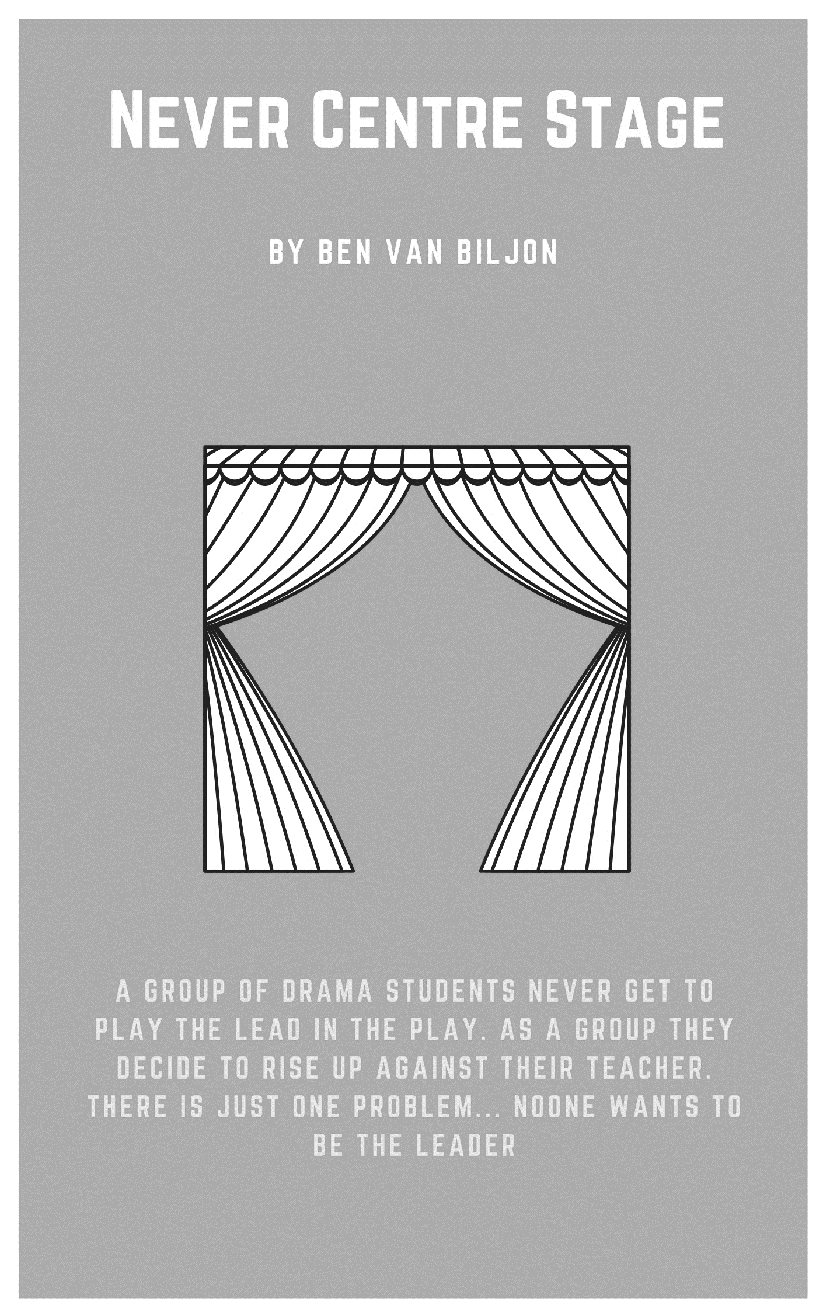
Never Centre Stage
By Ben Van Biljon

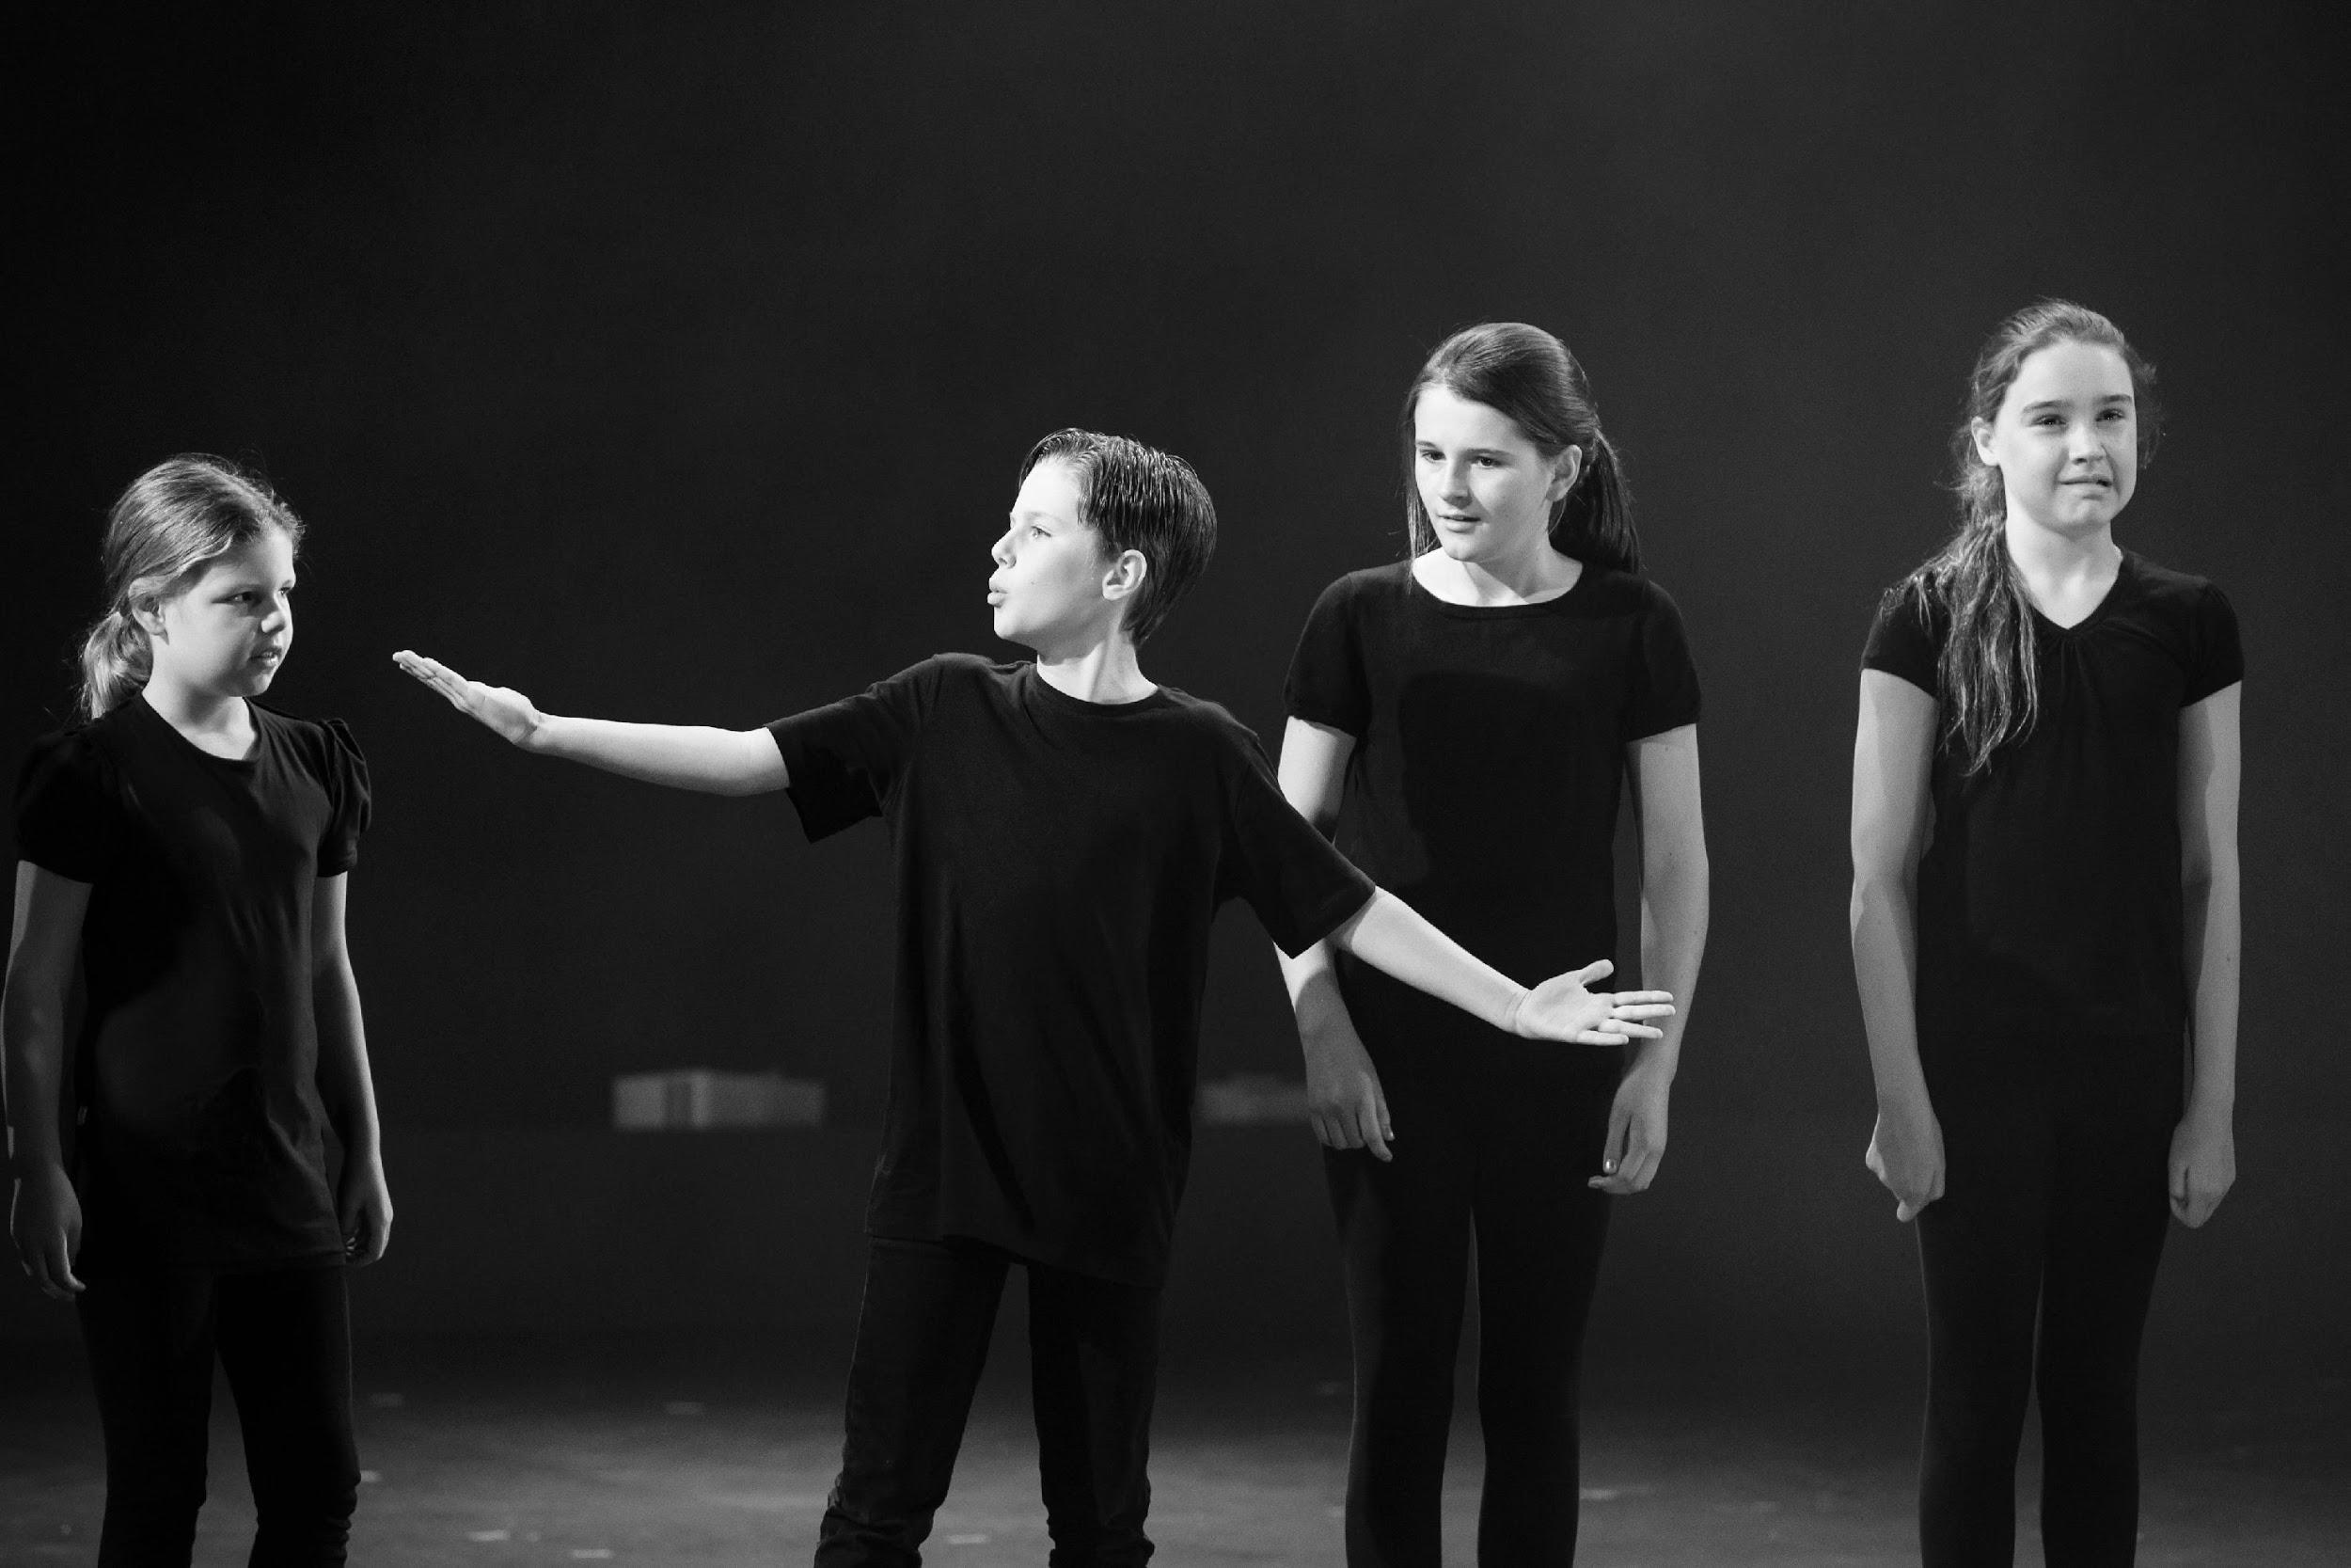

Synopsis
This humorous piece is about a group of drama students who never get the opportunity to play the main character of a play. As a group, they decide to rise up against the teachers who don’t offer these opportunities and demand that they are chosen next to be the lead role. The problem is, is that no one is willing to lead this particular revolution. The themes of the play include leadership, collaboration and teamwork.

Cast - in order of appearance
All characters are school-aged drama students. All of the characters have a love for drama, but are over-actors. They are all passionate, but at their very core, they are scared to take on the responsibility of a lead position. There is no set rule or reason to having certain characters’ boys or girls as written in the script. The script can be altered according to the group of students that’s undergoing this piece.

Alice
Belinda
Cate
Matt
Kim
Laura
David
Eric
Felicity
Greg
Henry
Nathan
Jack

Before you begin
Prior knowledge
Students must have a general understanding of basic drama techniques that include voice, body, movement and space.

Curriculum links
The Australian Curriculum: Drama
Explore dramatic action, empathy and space in improvisations, playbuilding and scripted drama to develop characters and situations (ACADRM035)

Develop skills and techniques of voice and movement to create character, mood and atmosphere and focus dramatic action (ACADRM036)

Rehearse and perform devised and scripted drama that develops narrative, drives dramatic tension, and uses dramatic symbol, performance styles and design elements to share community and cultural stories and engage an audience (ACADRM037)

Explain how the elements of drama and production elements communicate meaning by comparing drama from different social, cultural and historical contexts, including Aboriginal and Torres Strait Islander drama (ACADRR038)

© Australian Curriculum, Assessment and Reporting Authority (ACARA) 2010 to present, unless otherwise indicated. This material was downloaded from the Australian Curriculum website (www.australiancurriculum.edu.au) (Website) (accessed 21August 2018) and was not modified. The material is licensed under CC BY 4.0 (https://creativecommons.org/licenses/by/4.0). Version updates are tracked on the ‘Curriculum version history’ page (www.australiancurriculum.edu.au/Home/CurriculumHistory) of the Australian Curriculum website.
ACARA does not endorse any product that uses the Australian Curriculum or make any representations as to the quality of such products. Any product that uses material published on this website should not be taken to be affiliated with ACARA or have the sponsorship or approval of ACARA. It is up to each person to make their own assessment of the product, taking into account matters including, but not limited to, the version number and the degree to which the materials align with the content descriptions and achievement standards (where relevant). Where there is a claim of alignment, it is important to check that the materials align with the content descriptions and achievement standards (endorsed by all education Ministers), not the elaborations (examples provided by ACARA).

Getting started
Warm up
Follow the director
In this warm up, the students lean to follow direction, focus and develop skills in character and role.
- Ask the students to scatter around the space,
- Remind the students that they must complete the activity without talking or bumping into each other,
- The students locate any point in the room, they then walk to that point,
- After reaching the point, the students turn sharply and move to the next point,
- After a short period of time, the teacher, as facilitator, calls out adverbs and students respond accordingly, for example “walk happily”,
- Once the students are demonstrating confidence, the teacher, as facilitator, adds a character to the adjective, for example, “walk happily like a 2-year-old child”.
- Once the students are demonstrating confidence, the teacher, as facilitator, adds a descriptive setting, for example, “walk happily like a 2-year-old child in a candy store”.

Mirror Mirror
In this warm up, students are given the opportunity to develop their skills in focus and control.
- Ask the students to find a partner and some space around the room,
- Ask the students to label themselves ‘Person A’ and ‘Person B’,
- Person A moves only their hands and arms slowly whilst Person B copies their exact actions,
- After a short time, the roles are then reversed: Person A copies Person B,
- Person A will then moves just their feet and legs slowly whilst Person B copies their exact actions,
- After a short time, the roles are then reversed: Person A copies Person B,
- Person A will then use facial expressions only, Person B copies their exact actions,
- After a short time, the roles are then reversed: Person A copies Person B.
- Person A will then use their whole body to move on the spot, Person B copies their exact actions,
- After a short time, the roles are then reversed: Person A copies Person B.

Crazy Director
In this warm up the students will learn about the areas of the stage and how to follow directions. Skills in improvisation and characterisation are developed as well as raising the student’s energy levels with a fun and competitive activity.
- Introduce to the students to the areas of a stage including:
  - upstage right,
  - upstage centre,
  - upstage left,
  - centre stage right,
  - centre stage,
  - centre stage left,
  - downstage right,
  - downstage centre,
  - downstage left,
  - op side,
  - prompt side.
- The teacher calls out directions for the students to move to, for example, if the teacher calls out downstage right, all the students move to that area as quickly as possible,
- The teacher can also add a specific direction such as, “Move downstage right and act like an angry pirate”,
- If students don’t get to the area quick enough or don’t act out the direction properly, the teacher will tell them that they are ‘fired from the job’,
- If a student has been fired, they can plead for their job back, the better they plead, the better chance they have to being asked to return to the game,
- Each student has only one chance to return.

Character development exercises
Communal Monologue – An ‘Oscar Awards’ speech
In this warm up, the students will develop their skills in improvisation, characterisation, imagination and collaboration. Each student contributes towards the one monologue.
- To begin, the students stand in a circle,
- One student stands in the middle and delivers an improvised ‘Oscar Awards’ speech for 30 seconds,
- The student delivering the speech needs imagine who they are, who they are thanking and why,
- After 30 seconds, the next student takes the place of the person in the middle and takes over from where the last person left off in their speech.
- The student must make the transition as smooth as possible, but can add to and elaborate on the speech.

Set, costuming and props
Set
The setting for this piece is up to the director’s interpretation. Suggestions could be the classroom, a clubhouse or a theatre studio. Drama blocks may be a good use of creating levels and imagery in the set design.

Props
Each student needs to have a piece of paper in their hand and a phone in their pocket.

Costumes
The characters of this piece are all students of drama and theatre. Therefore, the costuming could comprise of wearing stage blacks, over-the-top thespian garments or a school uniform.

Never Centre Stage
By Ben Van Biljon

Everyone stands in a circle on the stage looking down at a script in their hands. All heads slowly lift up and towards the audience.

All: Awwww!

Alice: I…

Belinda: Didn’t…

Cate: Get…

Matt: The lead…

Kim & Laura: Part…

David & Eric: In the…

Felicity & Greg: Play…

All: AGAIN!

Felicity: They never pick me!

Greg: They never choose me!

Henry: I never get the lead part in the play.

All: It’s so unfair!

Nathan: We need to stand up to the teachers who don’t choose us.

Jack: We need to stand up to those who think we are not good enough.

Alice: We need to prove to everyone that we CAN act!

All: We can be dramatic.

Matt: Watch out! We’ve all been theatrically poisoned!

Everyone dies dramatically on stage except for David and Felicity.

David speaks with a corny American accent.

David: Oh Billy Bob no!

Felicity speaks with a corny American accent.

Felicity: Oh Lorna Jane no!

Belinda stands.

Belinda: Did no one see me in our last play? I played a tree. A lousy tree. Do you know how humiliating it is to play a tree? My only line was ‘woosh’. (Pause) Woosh! That’s it! I thought I would ad lib on performance night by adding a second woosh to my dialogue.

Everyone takes a deep breath—loud gasp.

Belinda: Well… I didn’t exactly get it perfectly right.

Everyone moves into a semicircle and Belinda moves to centre stage.

Belinda: I was standing there, looking the part and it was my line. I was going to say it. I was going for it. I was about to announce to the world that a tree can have two wooshes. But, it all went horribly wrong.

Cate: What happened? Did you choke?

David: Vomit?

Eric: Stutter?

Felicity: Splutter?

Greg: Lose a branch?

Henry: Did you break a leg?

Nathan: Did you fall over?

Matt: Was it all of the above?

All: What happened?

Belinda: I… I forgot my line. (cries dramatically)

All: Oh no!

Jack: That’s happened to me before! I forgot my line. And so… I just froze.

Everyone freezes in position for an extended period of time.

Everyone looks off stage and coughs with their hand on their mouth.

All: What’s my next line?

Kim: I only ever get one line.

Belinda: Well at least it’s more than one single word.

Kim: Yeah but I deserve to get more than one line. I deserve to get at least… well my mum says I should be the main part of any play I’m in.

Laura: You are a great actor.

All: A great actor.

Kim: I’m a fantastic actor.

All: A fantastic actor.

Kim: And all I’ve ever wanted was to…

All: All she’s ever wanted was to…

Kim: Win an Oscar!

All: To win an Oscar!

Matt: And to know that someone loves me. That they really love me!

Alice: I would like to thank…

Belinda: I would like to thank…
Cate: I would like to thank…

David: My mum.

Eric: My dad.

Felicity: Myself.

Greg: I would like to say thanks for nothing to…

Matt: The drama teachers who never pick us…

All: To be the lead part in the play!

Henry: And so it must be said again. We should stand up to these people.

Nathan: We must revolt!

Jack: We must start a revolution!

Kim: We should…

Laura: He should…

Alice: Someone should…

Belinda: Stand up and lead us to battle.

All: But how?

Cate: With extreme violence!

All in fighting poses.

David: With peaceful demonstrations.

Make peace signs.

All: Groovy.

Eric: What do we want?

All: A lead role.

Eric: When do we want it?

Felicity: Let me check my calendar.

They all get a phone out of their pocket and check their calendar.

Greg: I should be right to have a lead role after week 8 this term I think?

Henry: I’ve actually got dance group practice every Monday, Tuesday and every
second Thursday, so I’m not sure if I will have time to practice for a lead role until next term at least.

Nathan: And I’ve got…

All: Stop!

Jack: Guys! If we are going to start a revolution we need to act now. We all need to stand tall.

Everyone stands in a line and starts marching on the spot.

All: Left. Left. Left. Right. Left. Left. Left. Left. Right. Left.

Kim: I don’t know what they’ve been told?

All: I don’t know what they’ve been told?

Laura: Our acting talent’s pure gold.

All: Our acting talent’s pure gold.

Alice: We deserve our centre stage.

All: We deserve our centre stage.

Belinda: We’ve got more talent than Nicholas Cage.

All: We’ve got more talent than Nicholas Cage.

Cate: So are we gonna stand up to these teachers?

All: Yeah!

David: Are we gonna demand better roles?

All: Yeah!

Eric: Do we wanna be a tree?

All: No!

Felicity: Do we wanna be the narrator?

All: No!

Greg: What do we wanna be?

All: The lead role!

Henry: So, who’s gonna lead us into battle? Who wants to stand up and tell the teachers what we deserve? Who?

All: Ummmm (Everyone point at someone else on stage.) He/She can!

END

Concluding
Reflection
After the students have engaged with the text, use the following questions to hold a reflective class discussion:
- What personality traits are prominent with all the characters in this piece?
- How would you approach the teacher about getting the lead role in the next play? What would you say?
- What skills or qualities does someone need to take on the lead role?

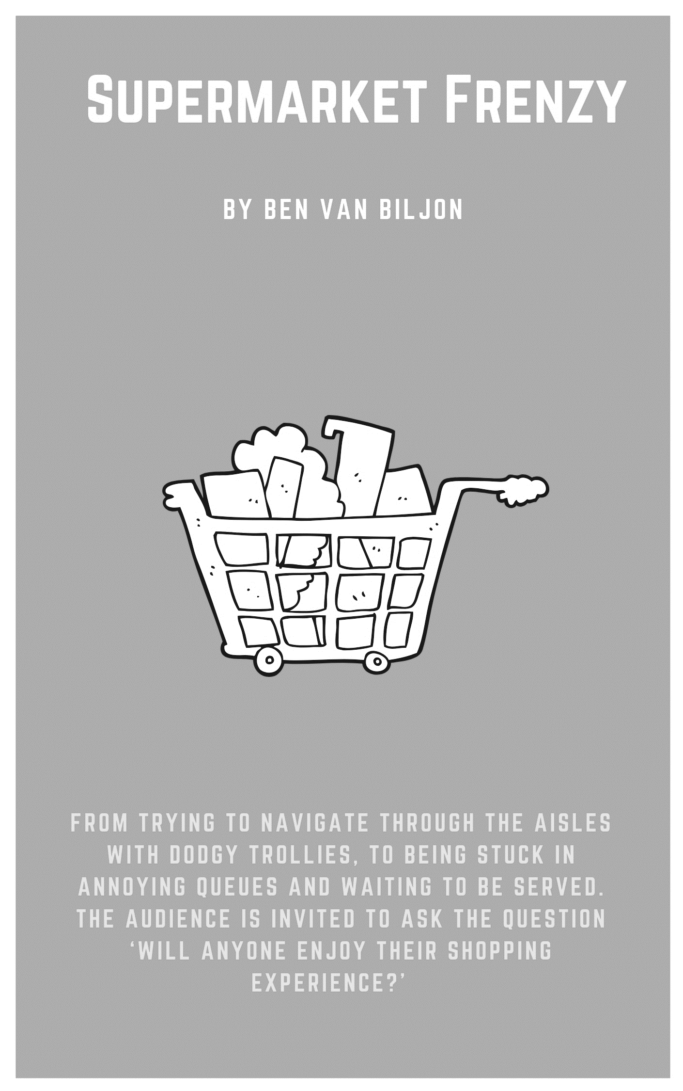
Supermarket Frenzy
By Ben Van Biljon

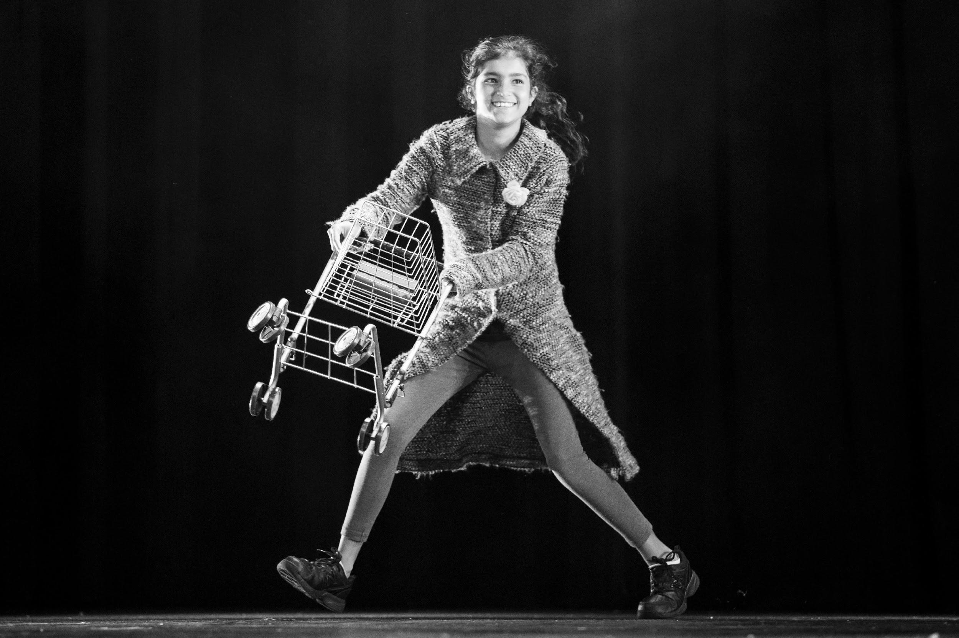

Synopsis
Supermarket Frenzy is a humorous play-built piece of theatre that takes the actors and the audience through the everyday, frustrating situations, experienced when doing the simple task of buying groceries from the supermarket. From trying to navigate through the aisles with dodgy trollies, to being stuck in annoying queues and waiting to be served. The audience is invited to ask the question ‘will anyone enjoy their shopping experience?’ The themes of the play involve shopping, dealing with everyday problems and buying and selling goods and services.
Cast - in order of appearance
15 characters

Staff member 1-4: Young adults/teenagers. Little care for work, monotonous with their speech and low in effort.

Customer 1: Young adult. Adventurous.

Customer 2: Young adult. Impatient business type.

Customer 3: Young Adult. Easily flustered.

Customer 4 & Child: Young primary aged child.

Customer 5 & Parent: Parent of child. Highly stressed.

Customer 6: Adult.

Customer 7: Adult.

Customer 8 & Old person: Old lady who needs help with most things.

Customer 9 & Young teenager: Young female teenager who is always on her phone.

Customer 10: Adult.

Store Manager: Confident businessperson.

Before you begin
Prior knowledge required
Students must have a general understanding of basic drama techniques that include voice, body, movement and space.

Curriculum links
The Australian Curriculum: Drama
Explore dramatic action, empathy and space in improvisations, playbuilding and scripted drama to develop characters and situations (ACADRM035)

Develop skills and techniques of voice and movement to create character, mood and atmosphere and focus dramatic action (ACADRM036)

Rehearse and perform devised and scripted drama that develops narrative, drives dramatic tension, and uses dramatic symbol, performance styles and design elements to share community and cultural stories and engage an audience (ACADRM037)

Explain how the elements of drama and production elements communicate meaning by comparing drama from different social, cultural and historical contexts, including Aboriginal and Torres Strait Islander drama (ACADRR038)

© Australian Curriculum, Assessment and Reporting Authority (ACARA) 2010 to present, unless otherwise indicated. This material was downloaded from the Australian Curriculum website (www.australiancurriculum.edu.au) (Website) (accessed 21August 2018) and was not modified. The material is licensed under CC BY 4.0 (https://creativecommons.org/licenses/by/4.0). Version updates are tracked on the ‘Curriculum version history’ page (www.australiancurriculum.edu.au/Home/CurriculumHistory) of the Australian Curriculum website.
ACARA does not endorse any product that uses the Australian Curriculum or make any representations as to the quality of such products. Any product that uses material published on this website should not be taken to be affiliated with ACARA or have the sponsorship or approval of ACARA. It is up to each person to make their own assessment of the product, taking into account matters including, but not limited to, the version number and the degree to which the materials align with the content descriptions and achievement standards (where relevant). Where there is a claim of alignment, it is important to check that the materials align with the content descriptions and achievement standards (endorsed by all education Ministers), not the elaborations (examples provided by ACARA).

Getting started
Warm up
What is it? / What is it not?
Students develop skills in improvisation and character building.
Ask the students to:
- Walk around the room and use one word to label what they see. Students point at the object while they label it. For example desk, carpet, boy etc.
- Add one adjective before each thing they label. For example large desk, dirty carpet, happy boy etc.
- Add additional detail to each item labeled. For example: large brown wooden desk top that is nailed to four metal legs that are shaped at 90 degrees and have a small plastic black cap at the bottom of each leg.
- Label what they see in detail, but speak with a different character voice each time. For example, they could use the voice of an investigator, documentarian, someone British etc.
- Label what they see but say what it is not. For example, if the students see a desk, they could label it as a carrot or something else that is completely unrelated.
- Work through the previous steps but keeping it to what it is not. For example, a large carrot, a large, rotting, smelly, moulding carrot.

What is it? (pairs)
Students develop skills in improvisation, character building and teamwork.
Ask the students to:
- Walk around the room in pairs. Use one word each, at a time, to label what they see. Point at the object while they are speaking. “This” “Is” “A” “Waterbottle” “And” “It” “Has” “A” “Black” “Nozzle”.
- Continue labeling objects around the room. Add in different accents or character voices. Whoever starts the dialogue, ultimately chooses what style of voice both students are to use.
- Start conversations with other pairs around the room. The conversations are still spoken one person at a time, one word at a time. For example, couple A speaks one word at a time followed by couple B then speaking one word at a time.

Hi _______, it’s ________. Say hi to _________ for me.
The aim of this activity is to speak to people at the other ends of the room by using clear voice projection and without having to scream. By completing this activity the students develop skills in voice projection.
- Students stand in a circle that covers as much of the space as possible. The further everyone is away from each other the better.
- The first student looks at someone on the opposite side of the room and says, “Hi (peer’s name), it’s (their own name). Say hi to (chooses another peer in the classroom) for me”.
- The student who was spoken to, repeats what the other person said, but change the names.
- The activity continues until everyone has spoken. If someone was not heard or if the receiver didn’t hear the name of the person that they chose for them, then the speaker must repeat the entire thing again with a louder and clearer voice.

Character development exercises
Waiting in a queue
Students develop improvisation and characterisation skills.
- Three students stand in a queue waiting to be served. All three students will become a character of their own and interact with the other characters while they are waiting to be served.
- After a suitable amount of time, the student at the front of the queue leaves (gets served) and another student joins on at the back of the queue.
Extension: have a selection of costume items and props for the students to select from before they join the queue.

Set, costuming and props
Set
The setting for this piece is the supermarket.

Costume
Suggestion for costumes include:
- teenagers or young adults as staff workers is to have a basic uniform,
- store manager is a basic suit or jeans with jacket,
- old lady customer is powdered hair or wig, glasses, floral dress and cardigan,
- all other customers are to wear a variety of casual clothes that lends itself to their particular character type.

Props
Each customer will have a trolley. Toy trollies if available or chairs as an alternative are possible options.

Supermarket Frenzy
By Ben Van Biljon

Trollies are all in a line across the back of the stage. The staff is standing at the front of the stage as teenagers in supermarket work clothes.

Staff: Supermarket’s open. Come in and buy stuff. Or don’t. Whatever?

Customers from off stage walk on stage in a line. Each person takes a trolley and swerves in different directions of the stage. Last ‘lucky’ person takes trolley and walks easily with it to a point on the stage.

Half of the customers stand on one side of the stage with trollies, while the others stand on the other side of the stage. Both sides are facing each other. They start crossing past each other to the other side of the stage. As they walk towards each other to get past, they awkwardly step to the same side.

Step left.

All: Sorry.

Step right.

All: Sorry.

Step left again.

Left half: Ha! How funny.

Step right again.
Right half: Would you just get out of the way? Urgh!

Left half: Sor-ry!

They all walk towards the front of the stage and stand in a line. Everyone is choosing an item. Customer 1 is in the middle of the line.

All: We’re here to buy things.

Cust 1: So many things.

Everyone leans in towards the middle of the line to look in at the middle person’s trolley. The middle person looks left and everyone on the left quickly looks away. The middle person then looks quickly to their right and everyone on the right looks away sheepishly.

Store manager: Welcome to Uncle Frank’s Supermarket. Where there’s plenty of things to buy! Freshest produce in all of Australia. All the brands that you love, but just spelt slightly different. And the friendliest staff who are ready to help you in any situation.

Staff: (Unenthusiastically) Welcome to Uncle Franks…

Store manager: We guarantee you a hassle-free experience at Uncle Frank’s. And those of you who don’t enjoy their shopping experience, please, we’re always open to suggestions to how we can improve.

Staff: It’s your lucky day shoppers! There’s items on sale everywhere.

All: Sales! Everywhere! Sales, sales, sales, sales…

Customers all go into lanes and start shopping. People at front of stage (1-5) turn the corner into the same lane as people at back of stage (6-10). Everyone reacts awkwardly.

Cust 1-5: Oh no/

Cust 6-10: /not them.

Customers meet up and act surprised.

Cust 1-5: Oh hey!

Cust 6-10: Hey!

Cust 1-5: It’s so funny seeing you here.

Cust 6-10: Yeah!

Cust 1-5: Yeah…

Awkward pause.

Cust 6-10: Do you live around here?

Cust 1-5: Yeah.

Cust 1: I’m

Cust 2: Just

Cust 3: Down

Cust 4: The

Cust 5: Road.

Cust 6-10: Oh yeah.

Cust 1-5: Yeah.

Everyone sighs.

Cust 6: Well

Cust 7: I

Cust 8: Might

Cust 9: Keep

Cust 10: Shopping.

Cust 1-5: Sure. Well it was great seeing you.

Cust 6-10: Yeah you too.

All walk past each other just a few steps.

All: Ugh. That was so awkward.

Everyone continues walking up and down aisles and seeing each other.

All: (Continually) Hi.

Everyone freezes except for parent with child.

Child: Mum can I have one of these?

Parent: No.

Child: Mum can I have one of those?

Parent: No!

Child: Mum…

All: Stop!

All customers freeze.

Store manager: As you can see, the poor parent here is going through something that I like to call, LWBS.

Staff: Little Whining Baby Syndrome.

Store manager: Here you will see the child continually ask for things that the parent can’t afford or want to purchase. One of three things will happen. Will it be A?

Staff: Parent will buy something to keep the child happy.

Customers: Here! Just have it!

Store manager: B?

Staff: Parent will threaten to take child home if they continue to ask for things.

Customers: If I hear one more word from you, we’ll go straight back to the car and we’ll go right back home!

Store manager: Or C?
Staff 1-2: Parent will forget that they are surrounded by people in a public place…

Staff 3-4: And let loose on the poor unsuspecting child.

Child: Mum, can I have another one of those?

Parent: You know what? I’ll tell you what you can have. YOU CAN HAVE A…

All Customers: (Coughing into hand) Ahem.

Cust 1: Hey everyone!

All: Yeah?

Cust 1: Guess what I’m gonna do!

All: What?

Cust 1: I’m gonna walk into the supermarket and buy just a couple of things and walk out.

All: And?

Cust 1: And I’m going to do it… without a basket!

All: (Gasp)

Everyone walks into a straight line and customer 1 walks in front. Customer 1 looks confident and cocky.

Cust 2: Good luck.

Cust 3: Good luck.
Cust 4: Good luck.

Cust 5: Good luck.

Cust 1: I don’t need luck. I’m just needing a couple of things. Like an onion.

All: And…

Cust 1: Some cheese.

All: And…

Cust 1: Oh I need some milk.

All: And…

Cust 1: Oh yeah I need some batteries.

All: And…

Cust 1: Gee, watermelon is cheap at the moment; I might get some of that.

All: And…

Cust 1: And some of that.

All: And…

Cust 1: Some of those.

All: And…

Cust 1: Oh and just one of those.

Customer 1 struggles to get to the register.

Cust 6: Do you need some help?

Cust 1: Oh yes please. That would be great.

Cust 6: Yeah no worries. I’ve just got to get something from the deli.

All: The deli!

Cust 6: I’ll be back in a tic.

Cust 7: The deli. To get a number or not to get a number? That is the question.

Cust 1-5: Get a number!

Staff: Next.

Cust 1-3: Then just stand back.

Cust 4-5: And wait for your number to come up.

Staff: Next.

Cust 7-10: Don’t get a number!

Staff: Next.

Cust 7-8: Just make your way up to the front.

Cust 9-10: Surely, they’ll serve you when they see you.

Staff: Next.

Cust 6: Hi. Could I please have…

Staff: Do you have a number?

Cust 6: No, but I just thought…

Staff: Who’s next?

Cust 6: Ugh forget it! I’m going to the check out.

People in the aisle with trollies parked across the way. Customer 6 finds it hard to get through or around.

Cust 6: Excuse me I need to get to the

All: Checkout.

Everyone stands in one line in front of 1st staff member. Customer 8 acts like an old person at the front of the line.

Cust 8: Sorry lovey. But I didn’t bring my glasses. What does that say?

Staff: Milk.

Cust 8: And how much is the milk pet?

Staff: $2.20.

Cust 8: Okay. So that’s 20 cents, 30 cents, 40 cents…

All Customers: Ugh!

Move to next checkout. Customer 9 is at the front of the line with a phone in his/her hand.

Cust 9: (On the phone) No I know! He was totes inapropes. OMG! But you know what I say, YOLO!

All customers: Ugh!

Move to next checkout.

Staff: So that’s $82 altogether.

Cust 10: Okay. Can I pay half with my card and the other half with cash? Oh sorry, I haven’t got enough cash to go halves, so can I go $60 on my card and the rest in cash? But I’m not sure if that leaves me with enough cash in my wallet? Can I give you my rewards card and do you have any more of those stickers for my kid’s school?

All customers: Ugh!

Move to next checkout.

Staff: That comes to $26.50.

Cust 3: Oh really. I don’t have enough on my card. Can I remove the ice cream?

Tries to pay with the card.

All: Bom bom.

Cust 3: Can I remove the lettuce?

Tries to pay with the card.

All: Bom, bom.

Cust 3: Can you just give me a second? I’m just going to check to see how much is in my account.

All customers: Ugh!

Move to next checkout. Customer 2 is on the phone to someone waiting behind someone being served.

Cust 2: Yeah, I should be there soon. I’ve just been standing in line at the checkout for ages.

Staff member on next checkout directs question to customer standing behind Customer 2.

Staff member: Hi. Would you like to come to this checkout?

Cust 2: Are you kidding me? I said…

All: Are you kidding me?

Store manager: I’m sorry, is everything alright?

Everyone comes towards the store manager, surrounds him with their trollies and starts yelling over the top of one another.

Store manager: Woah, woah, woah! Everyone needs to calm down. Now, who’s got the first complaint?

All hands go straight up simultaneously. Store manager looks straight ahead to audience and takes a huge gulp.

Sudden black out.

END

Concluding
Reflection
As a class, discuss the question ‘how does this piece relate to the audience?’
Ask the students to consider the following:
- In your opinion, what was the most enjoyable part of the entire piece to act out? Why? Write the answer in a drama journal.
- What personal stories or incidents have you had in the supermarket that could be used as another scene in this play? Write a short script that uses one of these stories or incidents in a drama journal.

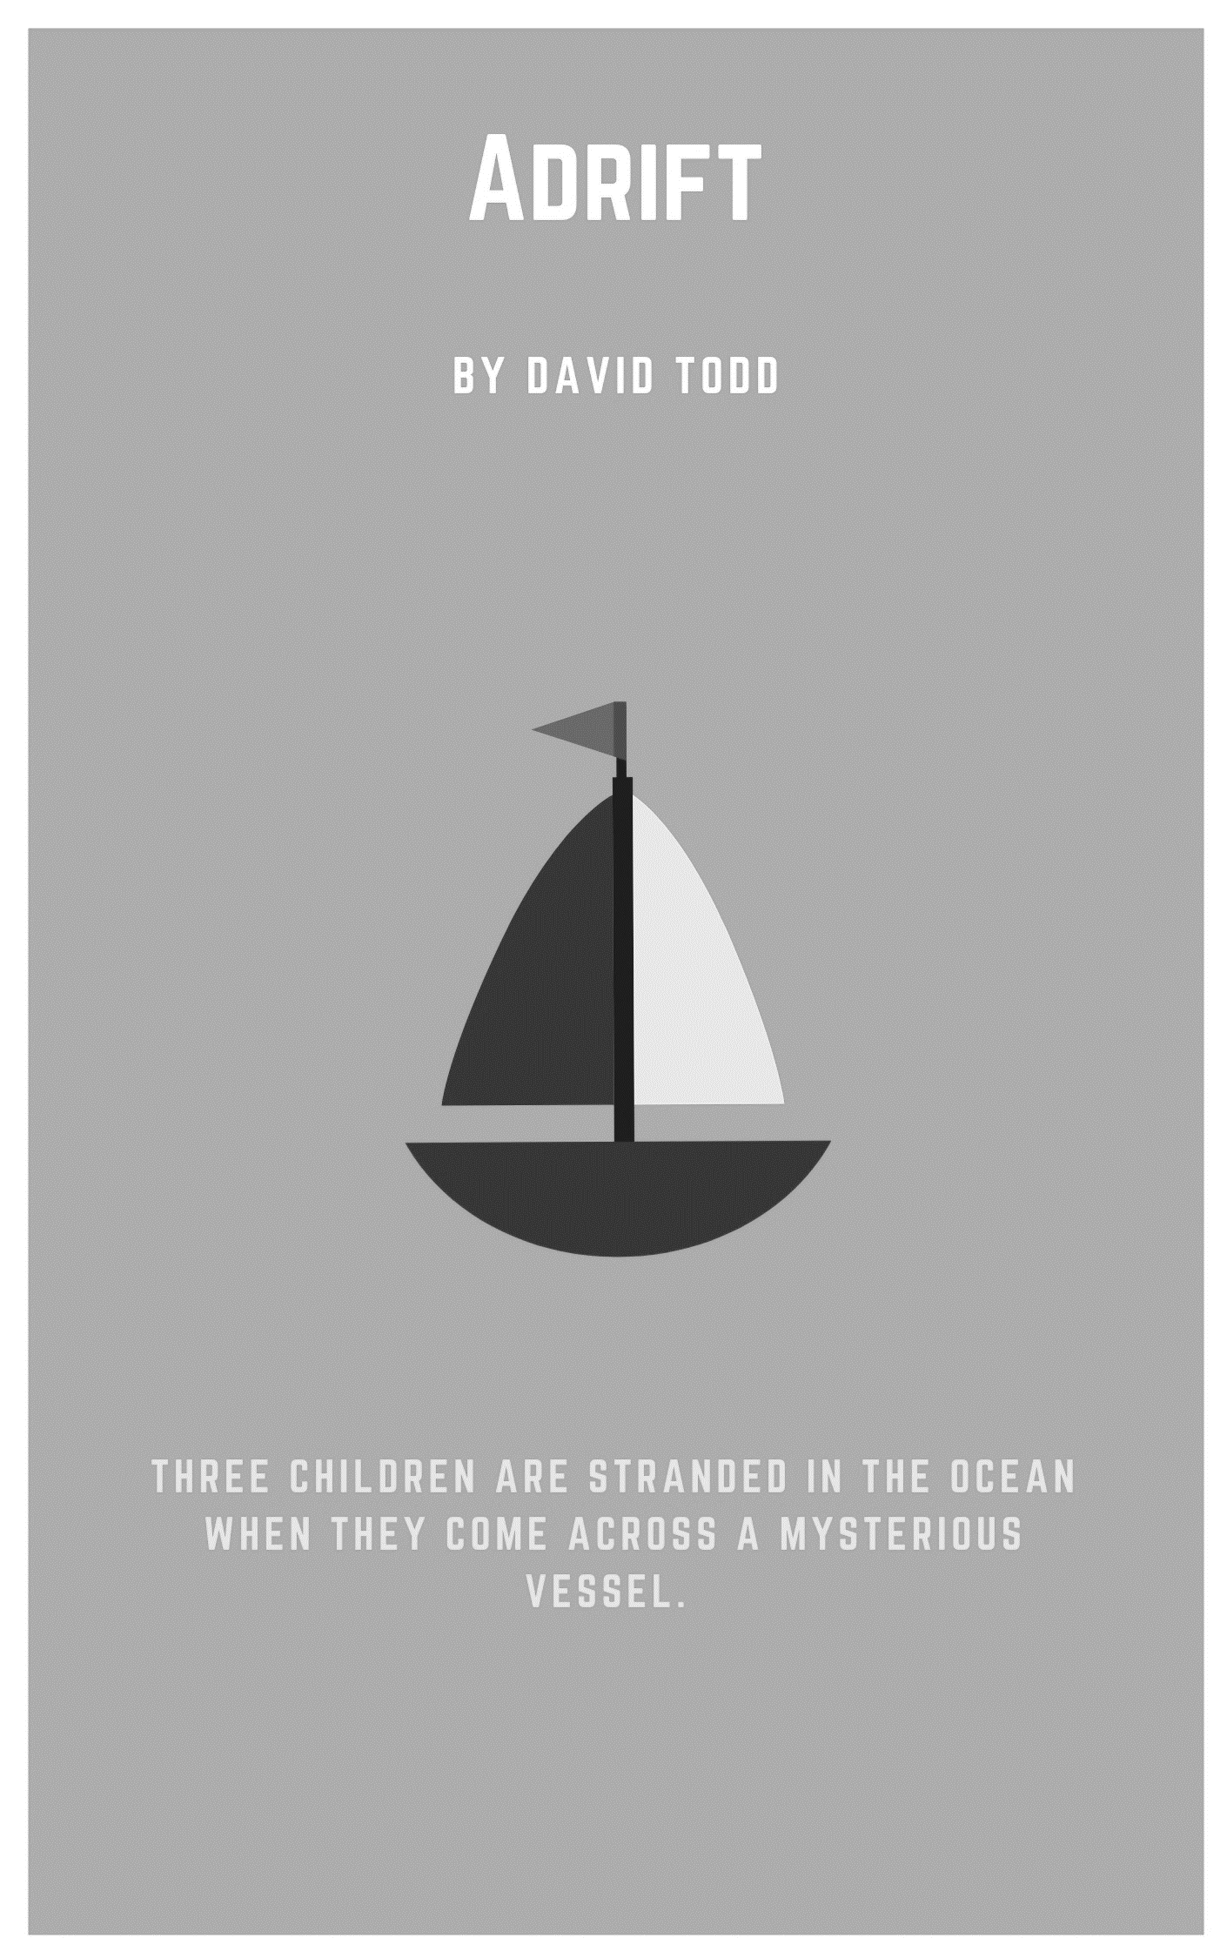
Adrift
By David Todd

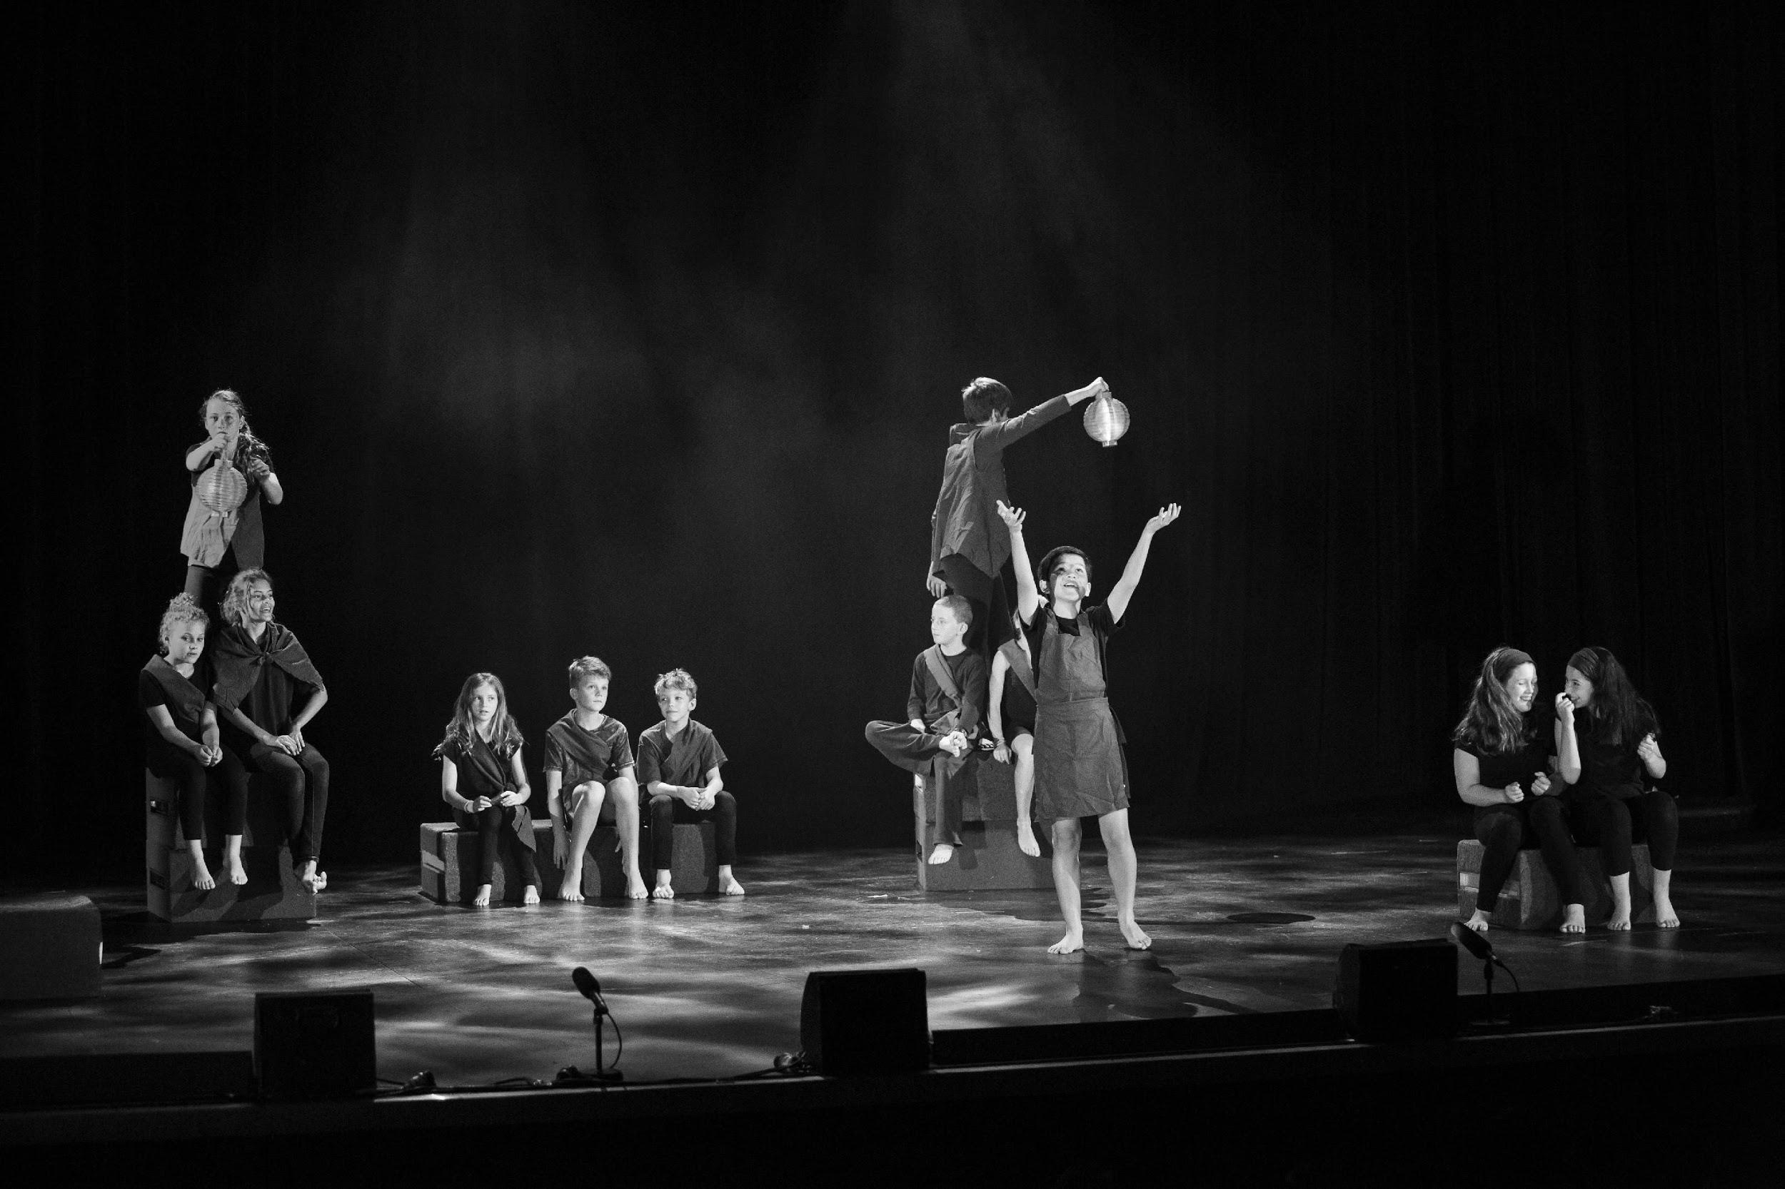

Synopsis
Three children are stranded in the ocean. The children are on a tiny boat and are becoming desperate when they come across a mysterious vessel. The encounter with the mysterious vessel brings hope. The interaction with the occupants also brings uncertainty as the children aren’t sure what to make of those they encounter, who at first they don’t understand.

Cast - in order of appearance

Older Girl: female, year 5 / 6, responsible

Older Boy: male, year 5 / 6, adventurous

Young Child: year 3-6, naïve

Mother/Inspector 1: female, year 5 / 6, authoritative

Father/Inspector 2: male, year 5 / 6, distractible

Boat Mother: female, year 5 / 6, nurturing

Trade Girl: female, year 3-6

Trade Boy: male, year 3-6

Captain: year 5 / 6, responsible

Old Woman: female, year 5 / 6, wise

Expert Fisherman: year 5 / 6, experienced

Trainee Fisherman: year 3-6, novice

Cook: year 3-6, kind

Navigator: year 3-6, professional

Grumpy Kid: year 3-6, grumpy

Game Kid 1: year 3-6

Game Kid 2: year 3-6

Game Kid 3: year 3-6

Cast of 18 with doubling: Mother and Father from Scene Two double as the Inspectors in Scene Five.

Before you begin
Prior knowledge
The production of the play ‘Adrift’ and associated activities offer substantial learning across the curriculum for students. It addresses general capabilities including: Ethical understanding, Intercultural understanding, Civic and citizenship and Difference and diversity.

This play raises many questions of a sensitive nature including refugees, human rights and the part we all play in understanding what impact we can have as global citizens. As a prior learning experience, studying one of the texts below and/or whole classroom discussions on the topic of refugees would be beneficial to ascertain if the content of this play is appropriate for your class / ensemble. Any students who are refugees, have family who are refugees or students who have relocated from a nation struggling with conflict may find this content confronting.

Recommended literary texts for study and prior learning are:
The Little Refugee by Anh Do,
Boy Overboard by Morris Gleitzman,
The Journey by Francesca Sanna
The Bone Sparrow by Zana Fraillon

Curriculum links
The Australian Curriculum: The Arts – Drama
Explore ideas and narrative structures through roles and situations and use empathy in their own improvisations and devised drama (ACADRM031)

Use voice, body, movement and language to sustain role and relationships and create dramatic action with a sense of time and place (ACADRM032)

Shape and perform dramatic action using narrative structures and tension in devised and scripted drama, including exploration of Aboriginal and Torres Strait Islander drama (ACADRM033)

Identify intended purposes and meaning of drama, starting with Australian drama, including drama of Aboriginal and Torres Strait Islander Peoples, using the elements of drama to make comparisons (ACADRR034)

© Australian Curriculum, Assessment and Reporting Authority (ACARA) 2010 to present, unless otherwise indicated. This material was downloaded from the Australian Curriculum website (www.australiancurriculum.edu.au) (Website) (accessed 21August 2018) and was not modified. The material is licensed under CC BY 4.0 (https://creativecommons.org/licenses/by/4.0). Version updates are tracked on the ‘Curriculum version history’ page (www.australiancurriculum.edu.au/Home/CurriculumHistory) of the Australian Curriculum website.
ACARA does not endorse any product that uses the Australian Curriculum or make any representations as to the quality of such products. Any product that uses material published on this website should not be taken to be affiliated with ACARA or have the sponsorship or approval of ACARA. It is up to each person to make their own assessment of the product, taking into account matters including, but not limited to, the version number and the degree to which the materials align with the content descriptions and achievement standards (where relevant). Where there is a claim of alignment, it is important to check that the materials align with the content descriptions and achievement standards (endorsed by all education Ministers), not the elaborations (examples provided by ACARA).

Getting started
Warm up
Zip, Zap, Boing
This popular activity is excellent for student focus, listening on stage and timing. Adrift is an ensemble piece with a lot of rapid-fire dialogue between the characters, which this activity caters for effectively.
- Students stand in a circle and start the activity by passing a clap around the circle. The clap is accompanied with a body movement in the direction of the clap, eye contact with the recipient of the clap and vocally making a ‘zip’ sound. The activity starts by sending the clap in one direction with increasing speed. One clap at a time is passed around the circle
- The next level of variation is that the clap can be passed in either direction around the circle. Voicing ‘zip’, body direction and movement and eye contact with recipient are essential.
- In the next stage of this warm up the clap can be sent across the circle with the word ’zap’. Students must retain body direction and eye contact when they send their clap. The only people that can’t be zapped are those who are one person either side of the student with the clap.
- A zip or zap can be rejected with a ‘boing’. To reject a zip or zap the student must lift their arms up inwards to their head from the elbow and say ‘boing.’
As the difficulty of the game increases, it’s very important to ensure that only one clap is being sent around the circle. As the direction of the clap changes more wildly the students’ focus becomes more important in order to follow the action.

Energy Focus
This activity is a great one to use immediately before a rehearsal or performance. The aim of this warm up is to focus on all cast members and respond to the energy in the room.
- The students stand in a circle in silence focusing on each other.
- The goal is for all students to stomp with one foot into the circle, while clapping their hands together and saying a one syllable word eg. ‘Bah’ at the same time with no prompt.
- Once the students have attempted their first simultaneous movement & sound, the teacher is to encourage a more harmonious and tight sound. Arrhythmic patterns are better because it’s harder to go against the body’s natural rhythm and more beneficial to purely focus on the ensemble’s intention.
- As an alternative, once the ensemble are focused and the timing is tight, the activity can be altered to incorporate a sequence of one syllable words i.e. a different word each time and then repeating back to the start of the sequence.
The collective movement / sound burst needs to happen without rhythm or patterns. This activity is about watching cast members and feeling when the time is right to make the commitment to stomp, clap and vocalize.

Character development exercises
Character Reactions
One student is selected to be the announcer. Their job is to call out a word in the language of ‘Adrift.’ (see Glossary for key terms).
The students stand in the rehearsal space and react to the word or phrase that the announcer calls out with a movement.
The announcer is then changed and the focus for the students is to respond with dialogue to a word i.e. Calata (fish) > Lemete (thank you). They can respond in the language of the play or in English. The purpose of this activity is to consolidate the meaning of the language and to respond in character is a way that is meaningful for an audience who don’t have subtitles.

Glossary of Terms
Bah – Me/Attention
Calata – Fish
Hafiz – Mother
Hasa – Her
Hata - Quiet
Jasa – Him
Kah Fenna – Boat
Lemete – Thank you
Makenta – Safely
Motto – Now
Pem Duck – Everyone
Pretta – Please
Soto – Ball
Yek – Yes

Set, costuming and props
Set
The set for this play should be minimal, created with drama blocks and theatricality. The main variation in staging is from the first small boat, to the bigger refugee boat, to the final border patrol boat. Students don’t need to be physically on the blocks to create the illusion of a boat, however it does work well in Scenes 1 and 3 on the first boat to create extra tension and danger.

Costume
The costuming for this play needs to differentiate the three distinct groups of characters:
- The three children who made the boat,
- The refugees on the large boat,
- The parents / inspectors.
This can be achieved with a basic black costume with a simple feature colour fabric to denote the characters i.e. a sash, head scarf, skirt, apron, vest.
A student workshop to conceptualise the design for the fabric and then create the costumes is a great way for the students to have ownership of their characters.

Props
The only props needed for this play are two torches and two lanterns. These work well with a dim lighting state for example a blue wash and a fog machine.

Adrift
By David Todd

ONE: LOST

Older Girl is standing on top of three pre-set drama blocks shining a torch out into the beyond as Older Boy and Young Child lie sleeping by her feet. It is foggy.

SFX – Ocean storm Sounds.

Older Girl: Hello! (beat) Hello!

Older Boy: (Waking up, to girl) Is there someone out there?

Older Girl: (She shakes her head) Hello! Hello!

Young Child: (Standing to join them) Please, somebody! We’re lost.

Older Boy: (Pointing into distance) What’s that?

Older Girl: What?

Older Boy: That light.

Young Child: I see it! I think it’s another boat!

Older Girl: Hello! Hello!

All: (Waving) Over here!

SFX - Ocean noises stop.

TWO: FLASHBACK

Older Girl, Older Boy & Young Child move forward off the blocks and start miming passing bits of wood and hammering into them. Mother enters stage right.

Mother: What is all this noise out here?

Older Boy: Nothing.

Mother: Your father’s doing his crossword.

Father enters stage right.

Father: What is going on out here? I’m trying to do my crossword.

Older Boy: We’re just making a go cart.

Mother: That’s a big go cart!

Father: Never seen one like that before.

Older Boy: It’s a new prototype.

Older Girl: Sorry Mr and Mrs Border, we’ll keep it down.

Mother: Please do.

Father: Can’t hear myself thinking with that racquet.

Mother and Father exit stage right.
Young Child: You shouldn’t have made it so big!

Boat Mother, Trade Boy & Trade Girl enter stage left. They have snuck out to listen.

Older Boy: It has to be big if we’re taking it out to sea.

Older Girl: Hey shhhh, look (indicating the three onlookers)

Older Boy: Don’t worry about them, they can’t understand us.

Young Child: Who are they?

Older Boy: They just moved in next door, from overseas.

Older Girl: Are you sure they can’t understand?

Young Child: I don’t think this is a good idea.

Older Boy: You don’t have to. If you don’t like it don’t come.

Boat Mother, Trade Girl & Trade Boy exit stage left

THREE: SAVED

The three children walk back onto the three drama blocks and start waving their hands above their heads.

SFX – Ocean storm sounds. Play until the end of the piece

Older Girl: Over here!

Young Child: We’re saved!
Older Boy: Maybe.

Older Girl: What do you mean maybe?

Older Boy: They look different.

Young Child: What do you mean?

Captain: (off stage) Tee hat pot kah fenna!

Young Child: I told you this was a bad idea.

Older Boy: We have to turn around.

Older Girl: It’s too late.

Old Woman enters.

Old Woman: Please, may I board your vessel?

The children are silent.

Old Woman: We mean no harm. There are mothers and children on our boat. (Beat) We are here to help.

Older Girl: Thank you! Please.

Older Boy: What are you doing?

Older Girl: We have to.

Older Boy: This is crazy; they could be pirates or something!
Old Woman: (Stands on blocks) Where are your parents?

Young Child: They don’t know we’re out here.

Old Woman: It is very dangerous out here. Please let us help.

Older Girl: Thank you!

Old Woman: Come on board with us and we’ll take you as far as we can. My friends don’t speak much English but they are good people.

Older Boy: We’ll be fine thanks. We’ll just sail home.

Older Girl: No we won’t, we’re completely lost. If we don’t go with this nice lady we may never get home. (To Old Woman) Thank you!

All exit stage left.

FOUR: FRIENDS

The remainder of the ensemble enter stage left and bring on the five remaining drama blocks to create a bigger boat.

The boat cast take their places on the boat and continue with what they’re doing.

Navigator & Captain hold lanterns that they bring on.

Expert Fisherman: (Showing trainee how to fish.) No, no, no. Hep, suuuuuuuup. Who!

Trainee Fisherman: Ahhhhhhh. Hep, suuuuuuuup. Whoooooooo!

Expert Fisherman: No, no, no. Who! (catches fish) Oh! Calata! (pulls in fish very excitedly)
Trainee Fisherman: (Is given fish by Expert) Calata!! (to everyone) Calata! (gives it to Cook)

Cook: Ah calata! lah pat he may ah (Goes to back of boat with Fish)

All: Calata! Calata! Calata!

Navigator: Bah! (everyone stops) Tee Hat! (everyone turns)

Older Girl, Older Boy and Young Child from the other boat board with the Old Woman entering from stage left.

Old Woman: Please step aboard. You are most welcome on our boat.

They all join the boat.

Grumpy Kid: (Points at the three) Calata?

Old Woman: Yek. Calata doe pem duck.

Boat Mother: (Admonishing Grumpy kid) Kiri! (gestures for everyone) Pem duck.

Older Boy: I don’t like this. These people/

Older Girl: Are saving us!

Game Kid 1: (Gives Young Child a ball) Soto.

Young Child: Ball.

Game Kid 2: (Gesturing to Young Child to throw) Soto?

Young Child: Soto! (throws it)
Game Kid 3: Soto? (They pass the ball to each other in a circle)

Game Kid 1: (Singing) Soto aya baha (clap clap)

All: (Singing) Soto aya baha (x 3)

Young Child: This is fun! (to Old Woman) Thank you for saving us!

Old Woman: Our Navigator spotted you. (to Navigator) Ba heesy mofu.

Older Girl: Thank you. How do you say thank you?

Old Woman: Lemete.

Older Girl: Lemete.

Navigator: Sah me jasa!

Captain: No pretta bin hasa.

Old Woman: This is the captain of our boat. The navigator is praising him.

Cook: (Comes on with the fish) Calata! Pem duck!

Boat Mum: (Takes some from the cook and offers it to the children) Please. Calata.

Older Girl: Are you sure? We can’t take all of your food.

Young Child: Mmmmm I love fish!

Older Girl: That’s rude!

Old Woman: Our fisherman is very proud. It is customary to offer our guests food. Please enjoy.

Older Girl: Thank you so much! (to Older Boy) Take some you’ll offend them.

Older Boy: It does look pretty good. Who caught this?

Old Woman: Sabata he foso?

Trainee Fisherman: Bah!

Expert Fisherman: No, no, no. de bah!

Trainee Fisherman: Yek, ha see.

Older Boy: Lemete Fisherman.

Boat Mum: Ah lemete! Very good! Please sit.

The children sit with Boat Mum as Cook hands out fish

Grumpy Kid: Jet meh sah calata?

Boat Mum: (To Grumpy Kid, who sits and waits) Spilt naheese.

Game Kid 2: Soto?

Boat Mum: Calata.

The Game Kids, Trade Boy, Trade Girl and Grumpy Kid sit with the Older Girl / Boy and Young Child. Old Woman and Boat Mum watch them enjoy.

Older Girl: This tastes amazing! Are you going to join us?

Old Woman: We will eat ours when we catch our next supply. In our country Calata is plentiful, but out here it’s not as easy to catch. Our fishermen are very tired.

Older Girl: Why did you have to leave?

Old Woman: We were afraid for our lives. There is much fighting. It is not safe for our children.

Older Boy: You are family?

Boat Mum: Yes, family. (beat) We dream of our children laughing and playing makenta.

Old Woman: Makenta means safely. This long trip is to ensure that. For the children and their future. We can only dream that your country might be able to help us.

Navigator: (Pointing at approaching boat urgently) Mah bret kah fenna!

Captain: (Calls Old Woman) Sahana! Kah fenna!

Old Woman: Oh no!

Captain: (Pointing at kids) Bah heesie mah jotta leh fasiti!

Older Boy: What is it?

Older Girl: There’s a boat coming!

Old Woman: Our captain needs your help.

Captain: Motto! Motto!

Older Girl: What is it?
Older Boy: Looks like a police boat.

Old Woman: It is border patrol; they are here to detain us. We need your help. They will take us away.

Older Girl: What can we do?

Older Woman: We need you to get back into your boat and distract them while we push away.

Older Boy: Of course.

Navigator: Motto! Motto!

Older Woman: You need to go now! They will take you back to your family.

Young Child: Goodbye! Soto!

Game Kid 3: Soto.

Throws him the ball. She throws it back.

The children move off.

Boat Mum: Pretta ma colo! (she pushes forward trade girl and trade boy) Please, take them with you.

Old Woman: Sa lata jee hafiz?

Older Girl: Of course.

Old Woman: Jee hafiz!

Boat Mum: Okay.

Old Woman: And their mother.

Captain: MOTTO!!!

Boat Mum, Trade Boy, Trade Girl, Older Boy, Older Girl & Young Child all exit.

Navigator: Pem Duck. (Gesture for quiet) La see hata!

The other boat people take off the other five drama blocks and exit silently stage right.

FIVE: FLEE

Boat Mum, Trade Boy, Trade Girl, Older Boy, Older Girl & Young Child all enter stage left and stand on the small boat.

Inspectors enter stage right, shining a torch.

Inspector 1: Stop immediately!

Inspector 2: You are in breach of our border patrol.

Inspector 1: We are boarding your vessel.

Inspector 2: Cooperate and no harm will come to you.

Older Girl: Please we are lost. Please help us.

Inspector 1: You are Australian?

Older Boy: Yes.
Inspector 2: What are you doing all the way out here?

Young Child: It was his idea. (points to Older Boy)

Boat Mum: It was my fault. I am the crazy aunty. I thought it would be fun.

Inspector 1: Okay then, let’s get you home.

Trade Girl: Thank you.

Inspector 2: Just don’t do it again!

Trade Boy: Okay.

Inspector 2: Can you drive the boat? (to Inspector 1) I really want to finish this crossword.

Inspector 1: (Starts to leave) Okay, but hold on it’s going to be a fast ride. We’ve got guests for dinner tonight.

Inspector 2: Who?

Inspector 1: The new neighbours. I’m cooking a …

Inspector 2: (Stops, sees something in the distance) Did you see that? (pause, while they both look into the distance)

Inspector 1: What?

Inspector 2: (Confused) I don’t know.

Inspector 1: C’mon this fish isn’t going to cook itself.

Older Girl: Calata!

Black out

END

Concluding
Reflection
After the students have engaged with the text, use the following questions to hold a reflective class discussion:
- How did being part of the process of staging this play affect how you thought about new Australians who come to this country as refugees?
- Which characters’ journey did you connect with and relate to? Why?
- What challenges arose with the use of a foreign language without subtitles? Was this important to the story?
- How did the audience respond to the performance? Was their experience one that you expected? Why?

Glossary
Stage Areas
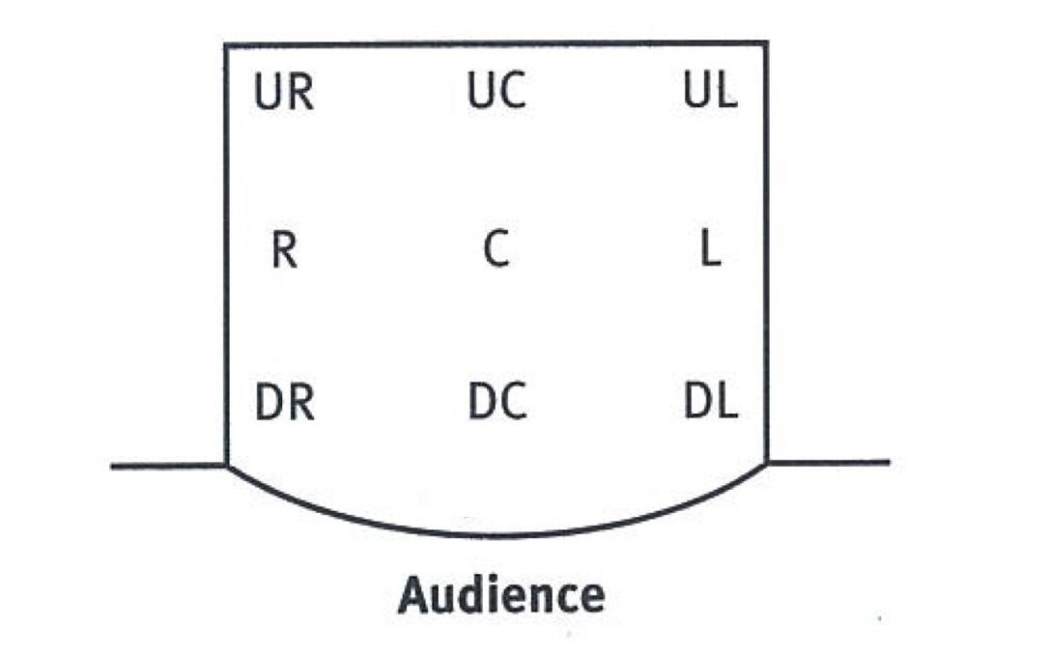
The terms were created by actors and directors working on proscenium or “end on” stages. The perspective is that of an actor facing the audience from the stage.

UR Upstage Right (your right as you face the audience, away from the audience)
UC Upstage Centre (centre, away from the audience)
UL Upstage Left (your left as you face the audience, away from the audience)
R Stageright
C Centrestage (the middle of the acting area)
L Stageleft
DR Downstage Right (your right as you face the audience, towards the audience)
DC Downstage Centre
DL Donwstage Left (your left as you face the audience, towards the audience)

Other

/ Slash. Indicates overlapping dialogue or where one character jumps in upon another
Character’s line. As developed by playwright Caryl Churchill

Beat A moment or breath

LX Lighting effects

SFX Sound effects

Segue An uninterrupted transition from one scene to another

