NSW Public Schools Secondary Aboriginal Dance Workshop 2022

Workshop Information Package

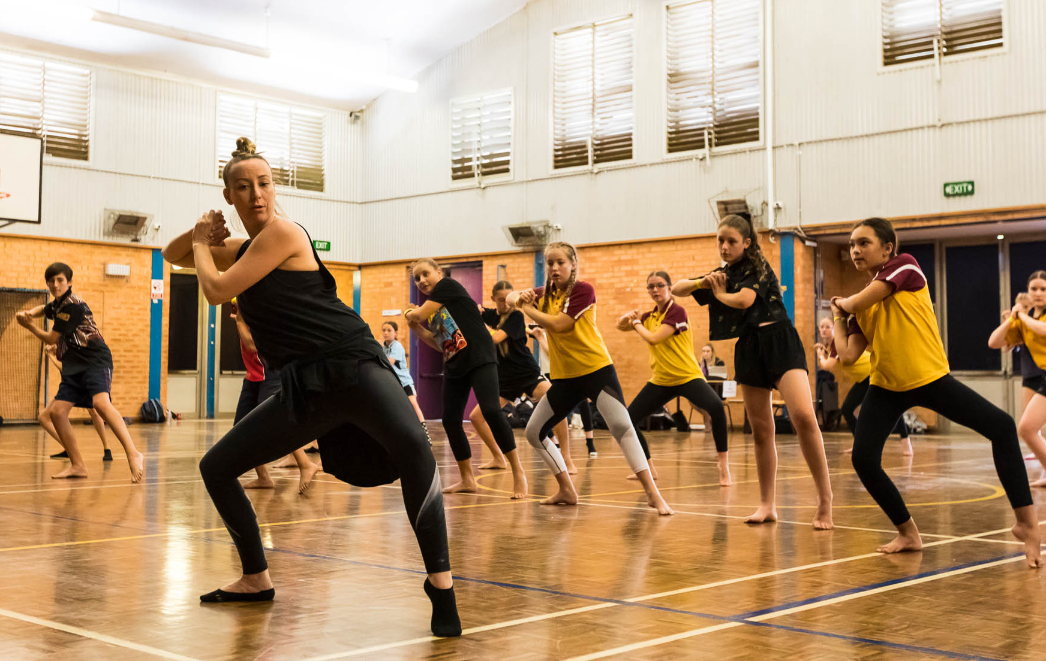

For further information or enquiries please contact the Arts Initiatives team
via email artsinitiatives@det.nsw.edu.au or phone (02) 8512 1170
The Arts Unit, Corner of Toothill Street & The Boulevard, Lewisham NSW 2049.
Locked Bag 1500, Petersham NSW 2049.
Program Coordinator – Catherine Gilholme, Arts Initiatives and Events Officer
Ph (02) 8512 1190 | Mob 0411 030 530

Secondary Aboriginal Dance Program 2022
- About the program
- Key information
- Program dates
- Workshop Schedule
- Professional learning – teaching standards
- Workshops etiquette
- Organising teacher checklist
- Payment Advice form

About the program

The Secondary Aboriginal Dance Workshop is run by the NSW Department of Education Arts Unit in collaboration with the internationally renowned Bangarra Dance Theatre. This program has been designed to engage and educate students in contemporary Indigenous dance.

The Secondary Aboriginal Dance Workshops are for NSW Public School groups of Indigenous students and their teachers. This program is open to all students from NSW Public Schools in Years 7-12.

Throughout the workshop, tutors from Bangarra Dance Theatre will provide students and teachers with a contemporary repertoire, with opportunities for schools to incorporate their local cultural dance styles and stories.

The program will begin with a 1-hour teacher information session for participating teachers and support staff which will include protocols to assist with cultural dance delivery, the connection to culture and the significance of the stories and movement to the land. The session will also cover how to support students as they develop their final dance work.
Students will then participate in a one-day workshop from 9:15am – 2:30pm. This engaging and high energy dance program will cater for experienced and inexperienced dancers. Resources will be provided to support the ongoing use of repertoire for school celebrations.

Key information
Program dates: Term 1, 2022
Mode: This program will be held face-to-face at various locations across NSW.
Attendees: The teachers information session can be attended by up to 4 teachers per school.
The workshops are open to students and teachers from Indigenous backgrounds from NSW Public Schools. Students must be in Years 7-12 and attend a NSW Public School. Workshops must be actively supervised by a teacher from the school and it is expected that student behaviour is appropriate to that of any school activity.
Program inclusions:
- 1-hour teachers information session.
- 5-hour student workshop.
Fees: Schools will be charged $30 per participating student:
Fee | Program element | Inclusions
$30.00pp | Student workshops | Up to 20 students per school

Aboriginal Dance Company selection
If you have students who you think have talent and ability in Indigenous dance, please nominate them for consideration for the 2022 Aboriginal Dance Company. This elite ensemble rehearses at Bangarra Dance Studios and performs at the State Dance Festival, The Schools Spectacular and other high-profile Department of Education events. Previous Aboriginal Dance Company members have gone on to pursue their passion for dance at some of Australia’s leading dance organisations.
As part of their application, students will be required to submit a video audition performing contemporary Indigenous dance repertoire, as well as a 1-minute filmed viva voce discussing points such as their Indigenous background, dance experience and interest in the NSW Public Schools Aboriginal Dance Company.
Applications for the 2022 Aboriginal Dance Company close Friday 8 April, 2022.

Program dates for 2022
Week | Date | Location | Venue
6 | Tuesday 1 March | Newcastle | Maitland Grossmann High School
 | Wednesday 2 March | Central Coast | Tuggerah Lakes Secondary College Berkley Vale Campus
 | Friday 4 March | Queanbeyan | Karabar High School
7 | Tuesday 8 March | Grafton | South Grafton High School
 | Wednesday 9 March | Inverell | Inverell High School
 | Thursday 10 March | Narrabri | Narrabri High School
 | Friday 11 March | Dubbo | Dubbo College South Campus
9 | Tuesday 22 March | Cowra | Cowra High School
 | Wednesday 23 March | Blue Mountains | Lithgow High School
 | Thursday 24 March | Illawarra | Wollongong High School of the Performing Arts
 | Friday 25 March | Western Sydney | Rooty Hill High School

Workshop Schedule
9:15am | Schools arrive and sign on
9:30am | Warm up
9:45am | Choreography
10:50am | Break (15 mins)
11:05am | Workshop continues
12:30pm | Lunch Break (30 mins)
1:00pm | Workshop continues
2:15pm | Cool Down
2:30pm | Workshop Ends

Professional learning – teaching standards
These workshops address the following Teacher Identified Professional Development for the following teaching standards:
1.4.2 Design and implement effective teaching strategies that are responsive to the local community and cultural setting, linguistic background and histories of Aboriginal and Torres Strait Islander students.
2.4.2 Provide opportunities for students to develop understanding of and respect for Aboriginal and Torres Strait Islander histories, cultures and languages.
6.2.2 Participate in learning to update knowledge and practice targeted to professional needs and school and/or system priorities.

Workshop etiquette
The following guidelines will help everyone get the most out of their Secondary Aboriginal Dance Workshops.
- It is expected that all students attending the workshop will actively participate in the workshop activities. Teachers are asked to actively supervise the workshop and ensure that student behaviour is respectful and focussed on the learning.
- Please note that you will need to request permission from Bangarra to use this music if you are performing this choreography for an audience, including assemblies and NAIDOC celebrations etc. You can however use the choreography with different music without asking for permission.
- Please notify Catherine Gilholme in advance of your workshop if there are any issues that might need to be addressed 0411 030 530 or email artsinitiatives@det.nsw.edu.au

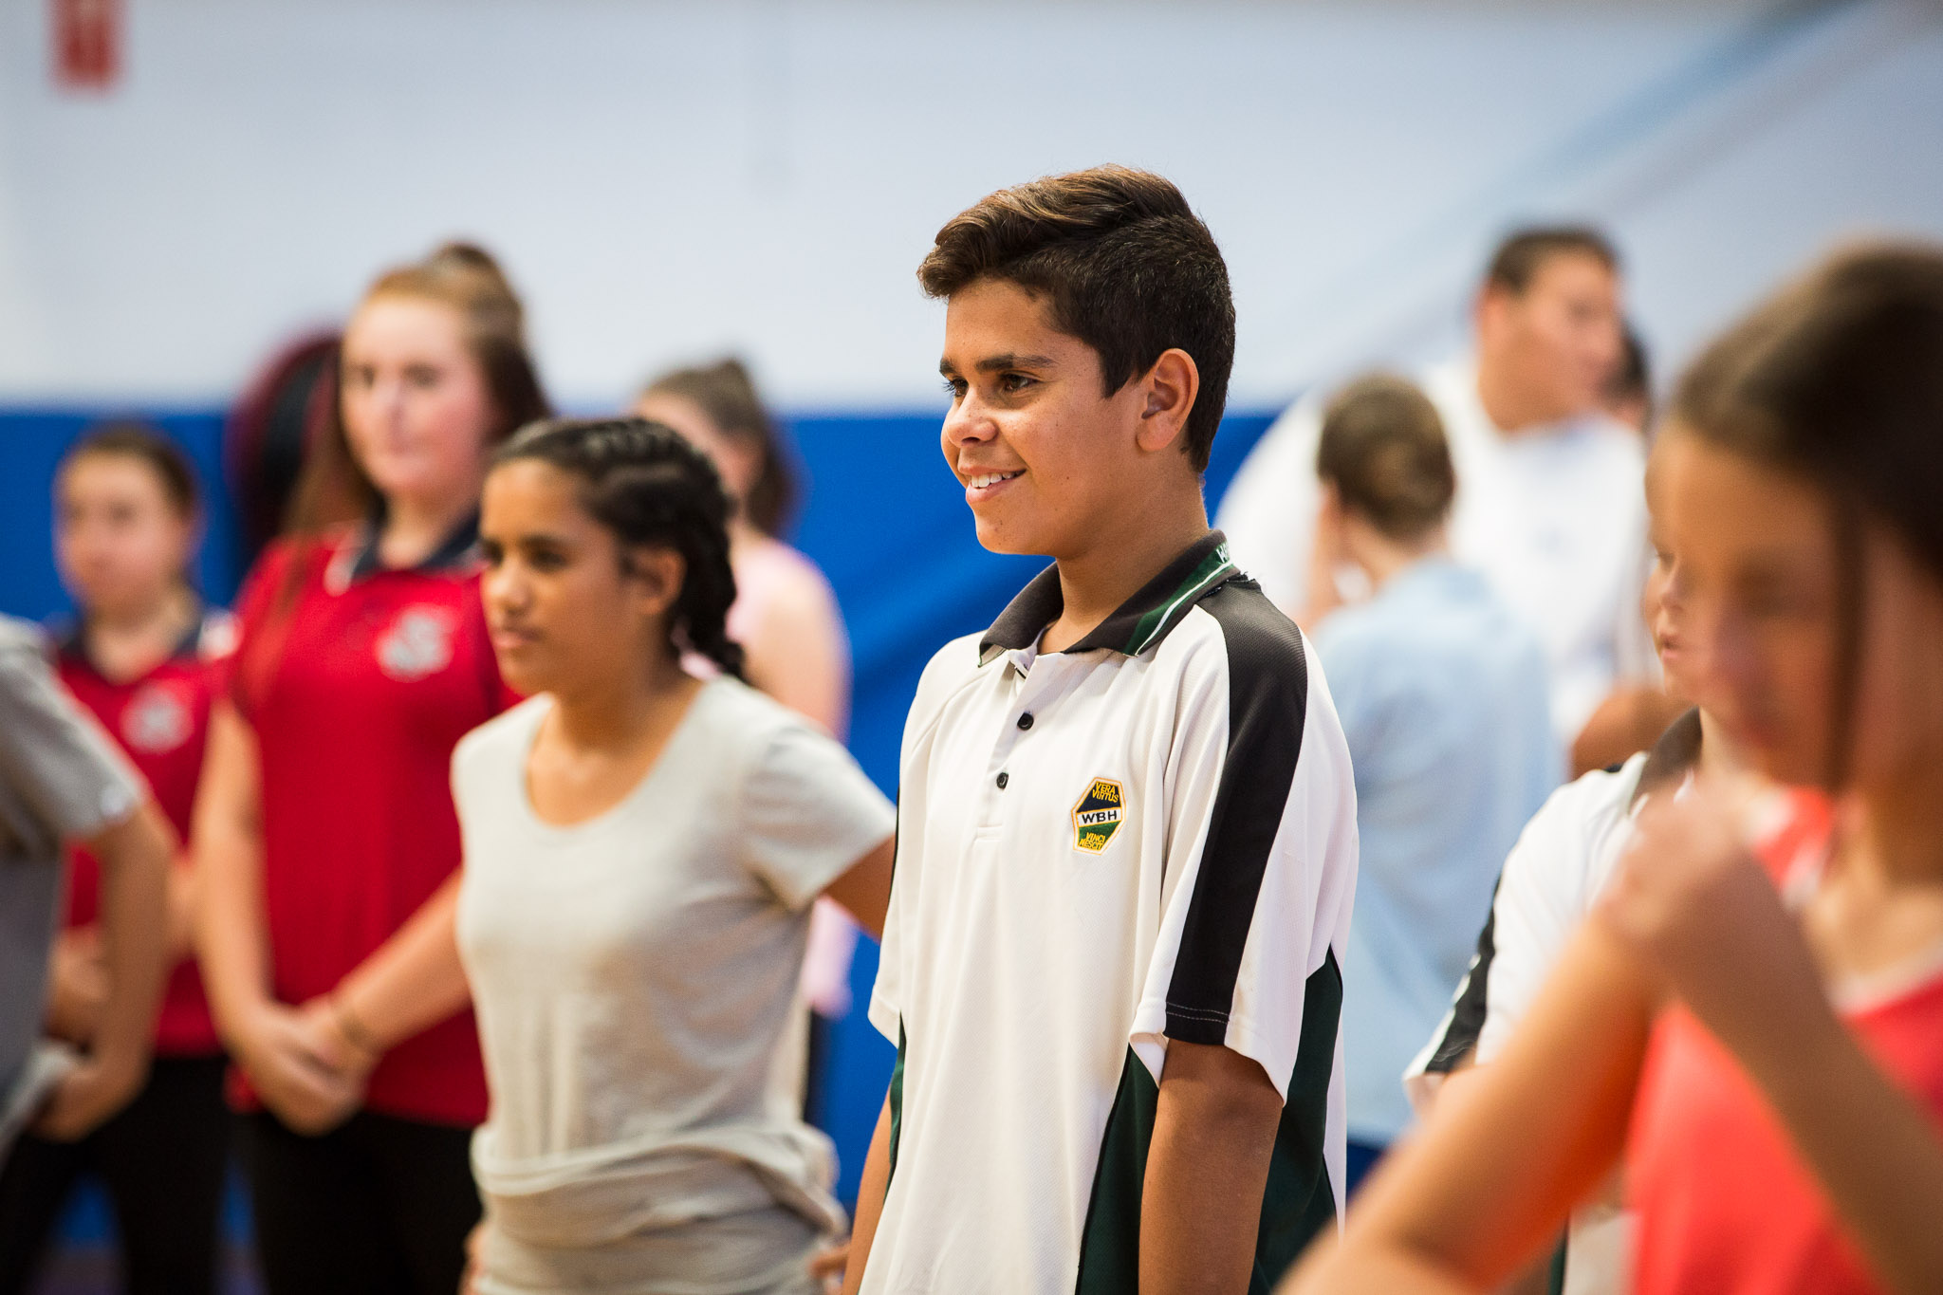

Organising teacher – checklist
- Finalise your registration by completing and returning the Payment Advice form (final page of document). Scan and send to the Arts Initiatives team via email artsinitiatives@det.nsw.edu.au
- Ensure you have received a Zoom invitation link and email for the correct teacher information session.
- Student Health Care Plans and a first aid kit with an Epipen are required for all schools attending workshops
- Students should be dressed in comfortable clothing that allows free movement and bare feet are preferable.

- Students should have water available as they will be expected to actively participate in the workshops.

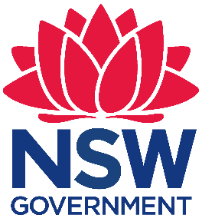
Payment Advice form

Secondary Aboriginal Dance Program 2022
The Arts Unit, NSW Department of Education
The 2022 Secondary Aboriginal Dance Workshop fees are $30 per participating student:
Fee | Attending Students (max 20) | Total ($30 x number of students)
$30.00  (no GST) | Enter number of students: _____

…………………………………………………………………………………………………….…..
Once complete, please email this form to the Arts Initiatives team artsinitiatives@det.nsw.edu.au

School name: ____________________________________ School code: __________
I understand that the school will be charged a fee of $30.00* per student participating in the 2022 NSW Public Schools Secondary Aboriginal Dance Workshop. Fees are processed as a direct debit via an Intercompany Journal (previously Sundry Tax) after the workshop.

Organising teacher
Name: __________________________
Signature: _______________________
Date: _______________

Principal
Name: ___________________________
Signature: _______________________
Date: _____

