NSW Public Schools Secondary Aboriginal Dance Workshop 2022

Online Workshop Information Package
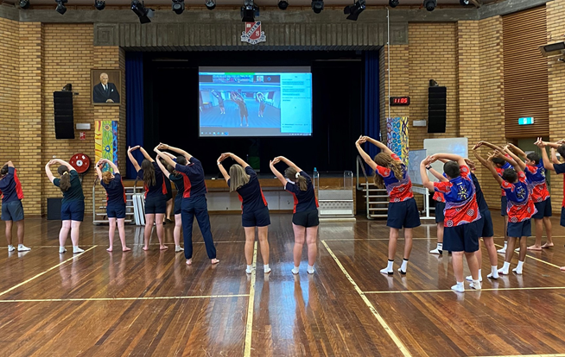

For further information or enquiries please contact the Arts Initiatives team
via email artsinitiatives@det.nsw.edu.au
The Arts Unit, Corner of Toothill Street & The Boulevard, Lewisham NSW 2049.
Locked Bag 1500, Petersham NSW 2049.
Program Coordinator – Catherine Gilholme, Arts Initiatives and Events Officer
Ph (02) 8512 1190

Secondary Aboriginal Dance Program 2022
- About the program
- Key information
- Acceptance information
- Program dates
- Accessing the sessions
- Workshop schedule
- Professional learning – teaching standards
- Workshops and Zoom etiquette
- Organising teacher checklist
- Payment Advice form

About the program

The online Secondary Aboriginal Dance Workshops are run by the NSW Department of Education Arts Unit in collaboration with the internationally renowned Bangarra Dance Theatre. This program has been designed to engage and educate students in contemporary Indigenous dance.

The online Secondary Aboriginal Dance Workshops are for NSW Public School groups of Indigenous and non-Indigenous students and their teachers. The online workshops are open to all NSW Public Schools.

Over 3 online workshops, tutors from Bangarra Dance Youth Theatre will provide students and teachers with a contemporary repertoire, with opportunities for schools to incorporate their local cultural dance styles and stories.

The program will begin with a teacher information briefing for participating teachers and support staff which will include protocols to assist with cultural dance delivery, the connection to culture and the significance of the stories and movement to the land. The session will also cover how to support students as they develop their final dance work.
Students will participate in a total of 3 online workshop sessions. The first 2 sessions will be held in Term 1 weeks 6 and 7 and a final workshop, in Term 1 week 9. The final session will include a showcase performance of the finished work from each school.
Workshops must be actively supervised by a teacher from the school and it is expected that student behaviour is appropriate to that of any school activity. Groups will be expected to work on choreography between each session.
Please note there are limited places for the online workshops and your application does not guarantee your schools entry into the program.

Key information
Program dates: Term 1, week 6, 7 and 9 2022.
Mode: This program will be conducted live online (via Zoom).
Attendees: All schools must have at least 1 teacher in attendance for the teacher information briefing and for each workshop. Inviting community members to the workshops is strongly recommended.
Program inclusions:
- 1-hour teachers information briefing.
- 4.5 hours of student workshops and an online showcase.
Fees: Schools will be charged a flat rate of $300 per school (no GST). This is made up of:
Fee | Program element | Inclusions
$300.00 | Student workshops | Up to 20 students per school
 | Total: | $300.00 (no GST)

Acceptance information
Schools will be notified of their acceptance by reply email prior to the commencement of the program.
Applications close Friday 18 February 2022.

Program dates for 2022
Workshop | Week | Date
Workshop #1 | Term 1, Week 6 | Monday 28 February, 2022
Workshop #1 | Week 6 | Tuesday 1 March, 2022
Workshop #1 | Week 6 | Wednesday 2 March, 2022
Workshop #1 | Week 6 | Thursday 3 March, 2022
Workshop #1 | Week 6 | Friday 4 March, 2022
Workshop #2 | Term 1, Week 7 | Monday 7 March, 2022
Workshop #2 | Week 7 | Tuesday 8 March, 2022
Workshop #2 | Week 7 | Wednesday 9 March, 2022
Workshop #2 | Week 7 | Thursday 10 March, 2022
Workshop #2 | Week 7 | Friday 11 March, 2022
Workshop #3 / Showcase | Term 1, Week 9 | Monday 21 March, 2022
Workshop #3 / Showcase | Week 9 | Tuesday 22 March, 2022
Workshop #3 / Showcase | Week 9 | Wednesday 23 March, 2022
Workshop #3 / Showcase | Week 9 | Thursday 24 March, 2022
Workshop #3 / Showcase | Week 9 | Friday 25 March, 2022
Teachers information briefing
Term 1, week 5: Wednesday 23 February.
Time: 4pm – 5pm.
Student workshops
On each workshop date listed below, there will be 2 time slots:
- 9:15am to 10:45am.
- 11:15am to 12:45pm.
When applying, schools will be given the opportunity to nominate their preferred date and time slot however, this does not guarantee your position. Schools must be available to attend the same session and time slot for the 3 workshops.

Accessing the sessions
This year, the Secondary Aboriginal Dance Workshops will be held online, helping to increase the flexibility of program delivery and facilitate accessibility for schools in rural and remote areas.
The sessions will be held using the virtual Zoom platform. Organising teachers will be sent information via email with a Zoom hyperlink for the teacher information session and the student sessions. Please join us online 15 -10 minutes prior to the start time to allow for any technical difficulties to be addressed. Workshops will commence at the indicated time.
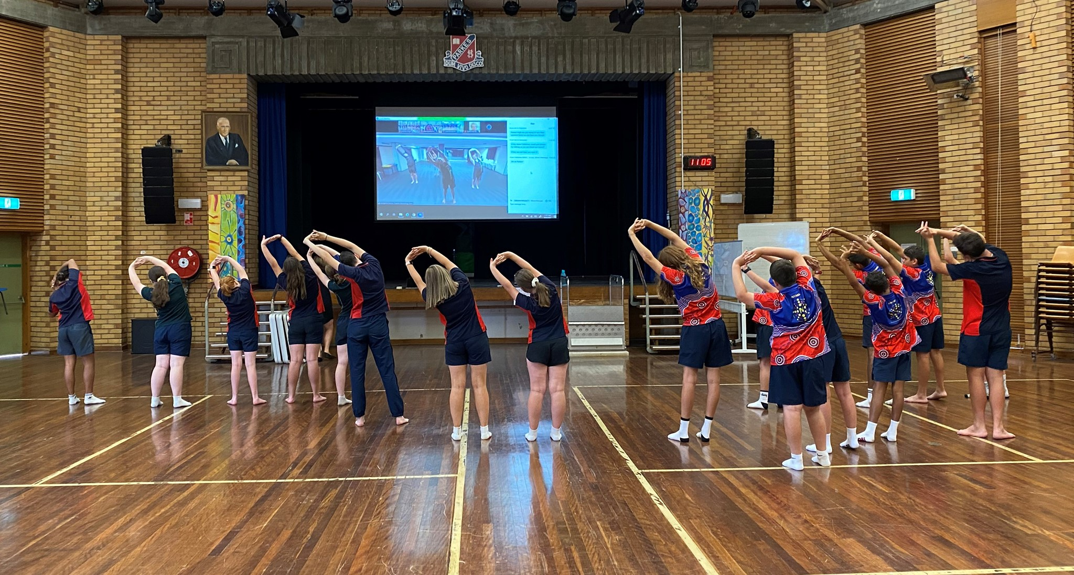
For the student sessions, you will need to have an area in your school available where students are directly facing the camera / screen and can clearly see and hear the tutors on Zoom while they are dancing. A classroom, hall or studio space with video capabilities (e.g. video conferencing or ‘connected classrooms’) works best.

Example of using Zoom and video conferencing technology in the school hall
(credit: Parkes High School)

Workshop schedule
Time | Activity
15min | Warm up
30min | Choreography
10min | Break
30min | Choreography
5min | Wrap up

Professional Teaching Standards
This program addresses the following Professional teaching Standards for Teacher Identified Professional Development
1.4.2 Design and implement effective teaching strategies that are responsive to the local community and cultural setting, linguistic background and histories of Aboriginal and Torres Strait Islander students.
2.4.2 Provide opportunities for students to develop understanding of and respect for Aboriginal and Torres Strait Islander histories, cultures and languages.
6.2.2 Participate in learning to update knowledge and practice targeted to professional needs and school and/or system priorities.

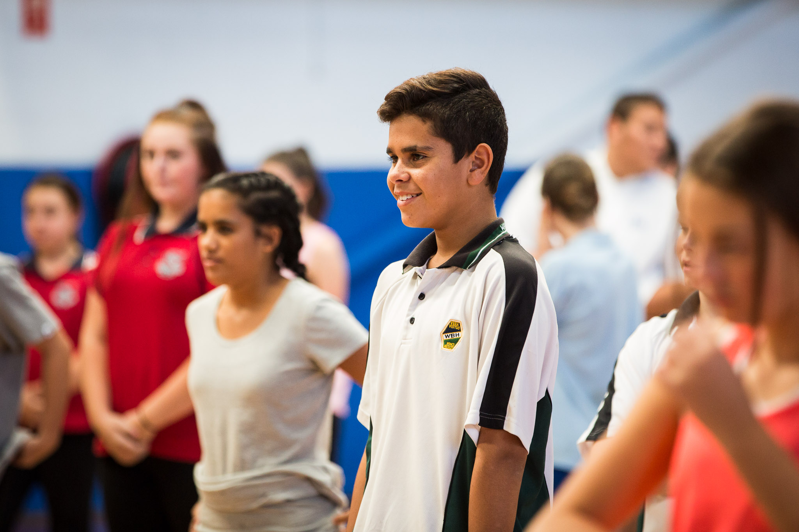

Workshop and Zoom etiquette
The following guidelines will help everyone get the most out of their online Secondary Aboriginal Dance Workshops.
- Please participate in the workshop with your audio on mute and your video on.
- Name on screen should be your school name.
- If students have questions they need to be directed to the teacher who can then ask any questions using either the chat function or the raised hand.
- There will be a TAU staff member monitoring the chat function throughout the workshop to address any concerns or questions you have.
- It is expected that all schools will attend the full program of workshops and have something to present at the final showcase.
- Where possible, it is hoped that schools will be able to have 2 staff members supervising the workshop and ensuring that students are respectful and cooperative.
- It is expected that all students attending the workshop will actively participate in the workshop activities. Teachers are asked to actively supervise the workshop and ensure that student behaviour is respectful and focussed on the learning.
- At the end of each workshop there will be a creative task set for schools to devise their own choreography to add on to the repertoire being taught. Teachers need to ensure that there is time between workshops for students to work as an ensemble to devise and learn work so that it is ready to be shown the following workshop.
- You will be given the music that we are working with as a link prior to the workshop. Please note that you will need to request permission from Bangarra to use this music if you are performing this choreography for an audience, including assemblies and NAIDOC celebrations etc. You can however use the choreography with different music without asking for permission.
- Please notify Catherine Gilholme in advance of your workshop if there are any issues that might need to be addressed or email artsinitiatives@det.nsw.edu.au

Organising teacher – acceptance checklist
- Finalise your registration by completing and returning the Payment Advice form (final page of document). Upload the complete Payment Advice form into your online application or email directly to Arts Initiatives team: artsinitiatives@det.nsw.edu.au
- Ensure you have received a Zoom invitation link and email for the teacher’s information briefing.
- Ensure you have received a Zoom invitation link and email for the student workshop sessions.
- For the student sessions, organise and/or book a space in your school that is suitable for dancing for the size of your group. Students will need to be able to clearly see and hear the tutors on screen (e.g. via a connected classroom or smartboard) and vice versa. A first aid kit on hand is also required.

- Students should be dressed in comfortable clothing that allows free movement and bare feet are preferable. All attending students will be expected to actively participate in the workshops.

- Students should have a water bottle available.

Payment Advice form

Secondary Aboriginal Dance Workshop 2022
The Arts Unit, NSW Department of Education

Name of school: __________________________________________
School Code: __________________________________

Schools will be charged a flat rate of $300 per school (no GST required) for the 2022 Secondary Aboriginal Dance Workshop. This is made up of:
Fee | Program element | Inclusions
$300.00 | Student workshops | Up to 20 students per school
 | Total: | $300.00* (no GST)

…………………………………………………………………………………………………….……………………………………………………………..
Once complete, please upload this form into your application or email to the Arts Initiatives team artsinitiatives@det.nsw.edu.au
I understand that the school will be charged a fee of $300.00 for participating in the 2022 NSW Public Schools Secondary Aboriginal Dance Workshop. Fees are processed as a direct debit via an Intercompany Journal (previously Sundry Tax) after the first session.

Organising teacher
Name: __________________________
Signature: _______________________
Date: ___________________________
Principal
Name: ___________________________
Signature: _______________________
Date: ____________________________

