NSW Public Schools Boys Vocal Program 2022

Workshop Information Package
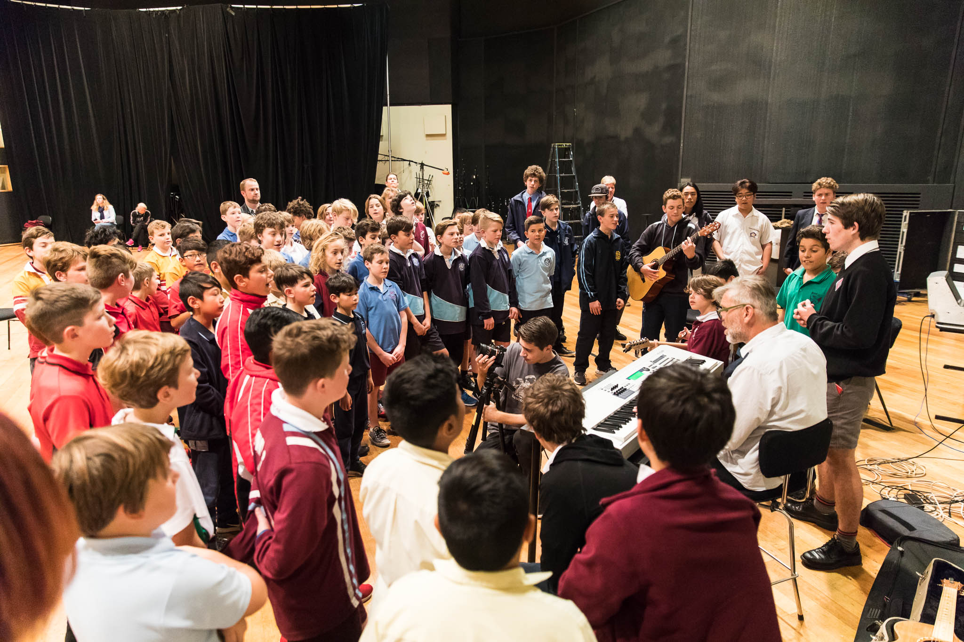

For further information or enquiries please contact the Arts Initiatives team
via email artsinitiatives@det.nsw.edu.au
The Arts Unit, Corner of Toothill Street & The Boulevard, Lewisham NSW 2049.
Locked Bag 1500, Petersham NSW 2049.
Program Coordinator – Catherine Gilholme, Arts Initiatives and Events Officer
Ph (02) 8512 1190

Boys Vocal Program 2022
- About the program
- Key information
- About the tutor
- Workshop Schedule
- Items to bring and wear
- COVID-19 information and processes
- Organising teacher checklist
- How to register
- Workshop location
- Accommodation possibilities
- Payment Advice form
- Permission to Publish – Parent form
- Unaccompanied student medical form
- Student behaviour code

About the program
The three-day Boys Vocal Program is led by vocal tutor Stuart Davis at Trackdown Studios at the Entertainment Quarter in Moore Park. During the first two days of the workshop students and teachers will work on vocal warm-ups, vocal techniques, ensemble singing, filming a film clip and developing an exciting harmonised repertoire. On the second day, we will have a showcase concert for students, groups or individuals, who might like to perform any repertoire that they are working on.
On the third day students will record the track with sound engineers at Trackdown Studios where they will experience the recording, engineering and mixing process. Following the program, the completed music clip and recording will be available to all schools via the Arts Unit website.

Key information
Program dates: Term 2, Week 6 2022
- Tuesday 31 May
- Wednesday 1 June
- Thursday 2 June
Venue: Trackdown Studios, Entertainment Quarter, Moore Park
Attendees: The program is a non-audition program and is open to all boys in NSW Public Schools from Years 5-12 who love to sing.
Students do not need to have any music training or experience they must be willing to participate actively in the workshops. Upon acceptance into the program, teachers will be sent vocal recordings so that the students can learn their part and the lyrics prior to the commencement of the workshop.
Time: 9:00am – 2:30pm, daily
Fees: $90 per participating student.
This student fee is payable directly to schools. The Arts Unit will direct debit the fee from the school after the workshop.

About the tutor
Stuart Davis has been a choir director and arranger for 25 years and currently directs three choirs in Sydney. He has directed many massed choral events including The Choral Sea.
Stuart sings with The Heavenly Light Quartet and the Black Gospel quartet with Tony Backhouse. In addition to this, Stuart has also led tours and 'singing adventures' to Cuba, Spain, Morocco, Tonga and Vanuatu.
Stuart is also the lead singer of the band The Big Merino.

Workshop schedule

DAY 1 – Tuesday 31 May
8:30am | Sign on
9:00am | Program welcome and introductions
9:10am | Warm up and first rehearsal
10:30am | Recess
11:00am | Workshop
12:00pm | Rehearsal
12:30pm | Lunch
1:00pm | Rehearsal
2:30pm | Day 1 concludes

DAY 2 – Wednesday 1 June
8:30am | Sign on
9:00am | Warm up
9:10am | Section rehearsals with Stuart
10:30am | Recess
11:00am | Section rehearsal continue
12:00pm | Showcase – Please register if your students would like to perform.
12:30pm | Lunch
1:00pm | Rehearsal
1:45pm | Performance in the Entertainment Quarter
2:30pm | Day 2 concludes

DAY 3 – Thursday 2 June
8:30am | Sign on
9:00am | Recording session begins
10:00am | Group 1
11:00am | Group 2
12:00pm | Group 3
1:00pm | Lunch
2:00pm | Listen to rough cut of recording and farewell
2:30pm | Day 2 concludes

Items to bring and wear
On the day of the workshop, students should:
- Wear their school uniform
- Bring a water bottle, snacks and a packed lunch each day
- (Note: there are also food outlets nearby such as Subway and Oporto in the Entertainment Quarter)
- Bring relevant protective wear (e.g. hat and/or school jacket)
- Students may also choose to bring items such as handballs, guitars, books or card games to play during break times.
- Boys in Years 5-12 are invited to prepare and perform an item in our Boys Vocal showcase. The item can be a group or solo performance. A keyboard is available at the venue however all other instruments will need to be brought to the venue by the school

COVID-19 information and processes
As your child is participating in an extracurricular off-site activity, it is essential that parents and carers acknowledge and understand the risk of COVID-19 and the risk management processes in place by the program organiser:
I acknowledge that this event/activity is required to be held in accordance with any current NSW Health COVID-19 Public Health Orders and the NSW Department of Education’s policies and procedures. I acknowledge and accept that there is a risk that my child may be exposed to COVID-19 whilst attending and participating at this event. I confirm that my child will not attend if displaying any symptoms of illness, and/or if directed to isolate under public health orders.
If your child presents as unwell (including with mild COVID-19 symptoms) they will be temporarily isolated and the parent/carer will be contacted to collect their child immediately from the venue. Throughout the entirety of this program, staff and students will be strongly encouraged to wear masks where possible and practice social distancing.
Please see the NSW Department of Education COVID-safe advice and COVID-smart measures for further information.

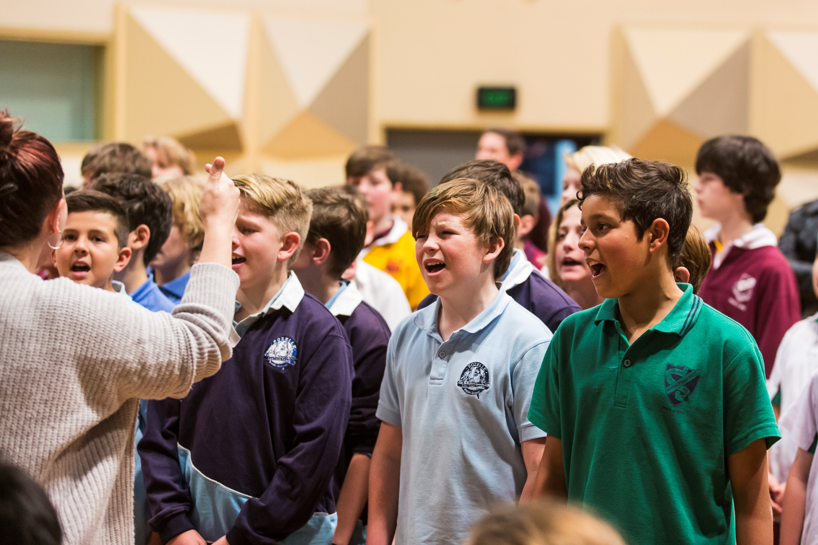

Organising teacher – checklist
Prior to the workshop, organising teachers are required to:
- Register students and ensure all relevant paperwork is complete
- Prior to the workshop, you will receive the learning tracks and lyrics for this year’s song via email. Please allocate parts (alto, tenor baritone, bass) to the students based on their vocal range.
- We suggest you familiarise your students with the lyrics and their vocal part prior to the first day of the workshop.

During the workshop, accompanying teachers are required to:
- Supervise students during the workshop and during breaks.

- Ensure that students with medical needs have their relevant medication and Health Care or ASCIA plans. Please also ensure that dur care has been exercised to accommodate students medical and dietary needs on the day of the workshop.

- Identify any students who suffer from allergies which may lead to anaphylactic shock and inform the coordinator at the workshop.

- As per the NSW Department of Education Excursion Policy, teachers are required to bring a first aid kit (including an EpiPen) to the workshop venue.

- Accompanying teachers are encouraged to actively participate in the workshop activities.

How to register
Accompanied Groups
Three or more students must attend with a supervising teacher. Schools are able to send a maximum of 10 students per school. Please contact the program organiser if you would like to bring more than 10 students.
Step 1 – Ensure each student completes and returns a ‘Permission to Publish – Parent form’ (page 10) to the organising teacher. Scan these forms and upload into application or email to artsinitiatives@det.nsw.edu.au

Step 2 – Teacher to complete the Payment Advice form (page 9) and scan (pdf).

Step 3 – Complete the online application using the following link: https://www.artsunit.nsw.edu.au/form/boys-vocal-program-application-f

Step 4 – Attach relevant paperwork. Submit your online form. You will receive a confirmation email that the registration is complete.

Unaccompanied Students
A maximum of 2 students from a school may attend without a supervising teacher. It is mandatory, that the organising teacher obtains approval from the program organiser for unaccompanied students to attend.

It is the school’s responsibility to ensure the student has sufficient transport to and from the workshop. Unaccompanied students will be supervised by a Department of Education staff member during the workshop. It is crucial that students attending unaccompanied fill out the online form accurately, detailing any medical and dietary requirements.
Step 1 – Ensure the student completes and returns the Permission to Publish – Parent Form (page10) and Unaccompanied Student Medical Form (Page 11,12,13) to the organising teacher. Scan (pdf).

Step 2 – Teacher to complete the Payment Advice form (page 9) and scan (pdf).

Step 3 – Complete the online application using the following link: https://www.artsunit.nsw.edu.au/form/boys-vocal-program-application-f

Step 4 – Attach relevant paperwork to your online application and submit. You will also be required to attach student ASCIA or Health Care Plans (if applicable). The teacher will receive a confirmation email that the registration is complete.

Workshop location
Trackdown Studios Building 125,
The Entertainment Quarter
116 Lang Rd, MOORE PARK NSW 2021
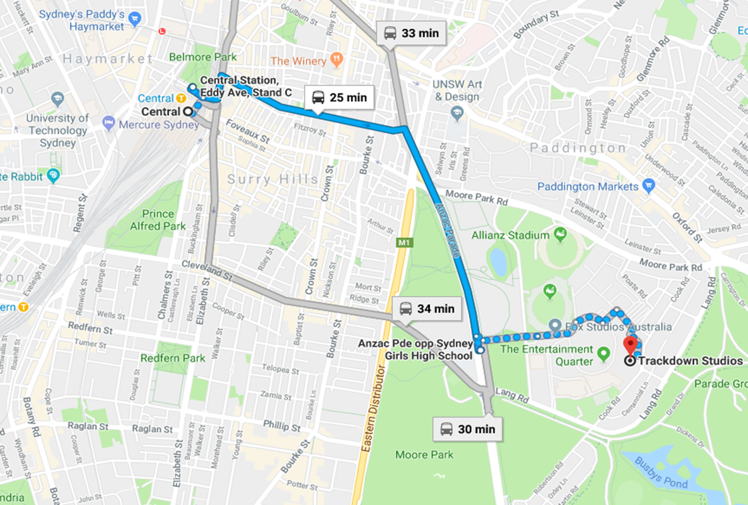
By Bus
Bus Numbers from Central Station to Moore Park: 374, 355
By Light Rail
Board L2 or L3 from Central station and exit the light rail at Moore Park. From Moore Park light rail station, it is approximately a 1km walk to Trackdown studios.
By Car
There is no parking at Trackdown but there is a paid parking station at Fox Studios, Moore Park. Trackdown is a short walk from the parking station.
Trackdown Studios is very close to Sydney Girls High School, the Sydney Showground, Fox Studios and the SCG. The building itself is next to AFTRS (Australian Film, television and Radio School)

Accommodation possibilities
This list is designed to assist teachers with some possibilities should they be planning to use accommodation in the city. Try www.visitnsw.com.au for a more comprehensive listing. Please note that The Arts Unit does not endorse any of the places listed here, these are general suggestions based on the location of the program.
Sydney CBD Location:
Sydney Backpackers- Victoria House  7 Wilmot Street, Sydney NSW 2000  Ph: 9267 7772  www.sydneybackpackers.com | The Y on the Park  5-11 Wentworth Ave,  Sydney NSW 2000  Ph: 9285 6288  www.yhotel.com.au
Aarons Hotel  37 Ultimo Road,  Haymarket NSW, 2000  Ph: 9281 5555  www.aaronshotel.com.au | Y Hotel City South  179 Cleveland Street,  Chippendale NSW 2010  Ph: 8303 1300  www.yhotel.com.au
Sydney Central Youth Hostel  11 Rawson Place, Sydney NSW 2000  Ph: 9218 9000  www.yha.com.au | The Woolbrokers at Darling Harbour  22 Allen Street, Pyrmont NSW 2010  Ph: 9552 4773  www.woolbrokershotel.com.au
Rydges Hotel Camperdown  9 Missenden Road,  Camperdown NSW 2050  Ph: 02 9516 1522  www.rydges.com | Citigate Central Sydney  169-179 Thomas Street,  Sydney NSW 2000  Ph: 1800 252 588  www.mirvachotels.com/citigate-central-sydney
Oaks Goldsbrough Apartments  125/243 Pyrmont St,  Pyrmont NSW 2009  Ph: 9518 5166  www.oakshotelsresorts.com | Wake Up! Sydney Central  509 Pitt Street, Sydney NSW 2000  Ph: 9288 7888  www.wakeup.com.au
Home Backpackers  238 Elizabeth Street,  Sydney NSW 2000  Ph: 1800 444 527 or 9211 9111  www.homebackpackers.com | City Central Budget Accommodation  707a George Street,  Sydney NSW 2000  Ph: 9211 9999  www.ccbackpack.com.au
Other suburbs close to Trackdown Studios Moore Park, Randwick, Surry Hills, Kensington, Paddington, Central, Hay Market and Ultimo.

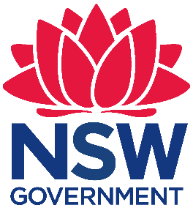
Payment Advice form

Boys Vocal Program 2022
The Arts Unit, NSW Department of Education
The 2022 Boys Vocal Program Workshop fees are $90 per participating student:
Fee | Attending Students (Maximum 10 students) | Total ($90 x number of students)
$90.00  (no GST) | Enter number of students: _____

…………………………………………………………………………………………………….……………………………………………………………..
Once complete, please upload this form into your application or email to the Arts Initiatives team artsinitiatives@det.nsw.edu.au

School name: ____________________________________ School code: __________
I understand that the school will be charged a fee of $90.00 per student participating in the 2022 NSW Public Schools Boys Vocal Program Workshop. Fees are processed as a direct debit via an Intercompany Journal (previously Sundry Tax) after the workshop.

Organising teacher
Name: __________________________
Signature: _______________________
Date: _______________

Principal
Name: ___________________________
Signature: _______________________
Date: _______________

Permission to Publish – Parent Form
Specific Activity
2022 Boys Vocal Program

Explanation of the activity
The NSW Department of Education (the Department) is presenting the 2022 Boys Vocal Program (the Program) through The Arts Unit. The program will run for three days where participating students will take part in vocal workshops, a showcase concert as well as, filming and recording a music video.

Description of the information that will be collected
The NSW Department of Education will collect video and digital images throughout the three-day program to be displayed on the Arts Unit, NSW Department of Education and its associated media channels and websites. The final music video will also list participating students’ first names and schools.

Explanation of how the information will be collected
All footage and images are collected during the three-day program.

Explanation of where the information will be published
The 2022 Boys Vocal Program music video and images will be published publicly on The Arts Unit website and social media channels. The material may also be used on associated Arts Units channels and NSW Department of Education websites, media units and social media channels to promote The Arts Unit’s Boys Vocal Program in perpetuity.

Permission to Publish
I give permission for my child’s video, images, first name and school to be used by the NSW Department of Education for its 2022 Boys Vocal Program.
I give permission for this material to be published in print and electronic media, and in doing so, I understand that the Department may:
- use, re-use, publish, and re-publish that content;
- alter, modify or otherwise change that content in any manner the Department desires to meet compliance such as copyright;
- combine that content with textual matter and/or with other pictures and/or media; and
- use the content for illustration, promotion, art, editorial, advertising, trade, publishing, or any other purpose, for the Project.
Child’s School ……………………………………………………………………
Child’s name (please print): …………………………………………………….
Parent/ Guardian’s Signature: .…………………………………………………
Parent/Guardian’s name (please print): ……………………………………….
Date: …………………….

Unaccompanied student medical form
To be completed for each student who is attending the workshop without a teacher. This information will be given to the supervising Department of Education staff member; please ensure it is written clearly and is accurate.

The information provided is being obtained for the purpose of ascertaining relevant medical information, requirements and other health care related needs about my child who is currently enrolled at the school listed above and who may participate in school excursions, sporting activities or other education or school activities conducted by or in conjunction with their school.

It will be used by officers of the NSW Department of Education to assist planning, to support students, and to minimise risks when conducting all activities related to the 2022 NSW Public Schools Boys Vocal Program.

Other persons or agencies that may be provided with this information include, but are not limited to, volunteers and members of external organisations who join with the school or are otherwise involved in the planning or delivery of the 2022 NSW Public Schools Boys Vocal Program; and persons that may be called upon to provide health care treatment or other assistance during or as a consequence of such activities.

Provision of this information is not required by law. However, a failure to provide the information may mean that your child cannot participate in a particular activity. Provision of this information will significantly assist The Arts Unit in planning a safer educational activity. It will be stored securely. If you have any concerns about provision of this information, please contact Catherine Gilholme on 02 8512 1190. You may correct any personal information provided at any time by contacting Catherine Gilholme.

Student Name:
School:
Date of Birth:
Age: |  | Grade/Year:

Student information

Parent / Carer information
Parent/Carer Name:
Parent/Carer Address:
Parent/Carer  Contact Numbers: | Mobile: Work:
Emergency Contact  (if parent/carer unavailable) | Name: Contact No:
Doctor Name:
Doctor Address:
Doctor Phone Number:

Medical conditions
List existing medical conditions or illnesses (include existing and/or previous injuries, asthma, diabetes, epilepsy, allergies etc). Outline the treatment for each.
Medical Condition/s:
Treatment:
COVID  Vaccination Status (please circle) | Unvaccinated 1 Dose 2 Doses 2 Doses + Booster

Anaphylaxis
Students who suffer from allergies which may lead to anaphylactic shock must have a copy of their ASCIA Action Plan attached to this document.
Students will also be required to see Catherine Gilholme or a nominated DoE Staff member at all workshops & performances with relevant medication, Epipen and a copy of their ASCIA action plan.
Dietary Needs:

Dietary needs:
Outline special dietary needs including possible reaction to inappropriate diet.

Medications:
Medication(s) to be administered during rehearsal/performance times
Name of Medication:
Instructions for administration:
Time of administration:
Any possible reactions:

Confirmation
This information is correct as at the date indicated below. If there are any changes to this information I will contact Catherine Gilholme with any additional information.
Student Name:
Parent/Guardian Signature:
Date:

Behaviour code for students
The Arts Unit is a specialist unit within the New South Wales Department of Education that provides a unique range of opportunities across all of the performing and visual arts, including dance, drama, music, visual arts, public speaking and debating to the students and teachers in NSW Government Schools.

Statement
The Core Rules of Discipline for students participating in arts-based programs, events or activities conducted by The Arts Unit provides a clear statement of the NSW Department of Education expectations of students.

Relevance
The Core Rules of Discipline apply to students enrolled in NSW Government Schools, who are selected or nominate to participate in arts-based programs, events or activities in respect to their conduct whilst participating in such programs, events or activities conducted by or for the Department.

The Core Rules of Discipline have been developed as a means of ensuring the safety of ALL students who participate in arts-based programs. Students must comply with the Core Rules of Discipline at all times whilst participating in the arts-based activity. Participation in arts-based activities is not mandatory for students in government schools, and a student who is unwilling to agree to comply with the Core Rules of Discipline will not be approved to participate in the arts-based activity.

Definition
‘Student’ means any students enrolled in a NSW Government School participating in programs, events or activities coordinated by The Arts Unit.
‘The Department’ means the NSW Department of Education.

Students participating in programs, events or activities conducted by The Arts Unit will adhere to the Core Rules of Discipline in NSW Government Schools. Prior to participation in a program, event or activity all students over 18 must sign an agreement acknowledging the Core Rules of Discipline and the student’s willingness to comply with them. Students under 18 must have a parent or carer sign an agreement on the student’s behalf.
- Comply with instructions given by teachers at all times. Attend every day required, unless they are legally excused, and be at the program, event or activity on time and be prepared to actively participate and learn.
- Maintain a neat appearance, including adhering to the requirements of the program, event or activities uniform, dress or costume requirements.
- Behave safely, considerately and responsibly, including when travelling to and from the program, event or activity.
- Show respect at all times for program, event or activity coordinators, teachers, other school staff, tutors, and helpers, including following rules specific to the program, event or activity, speaking courteously and cooperating with instructions and learning activities.
- Treat other students and adults involved in the activity with dignity and respect.
- Care for property belonging to themselves, the venue and others.
- Respect property belonging to themselves, the venue or others

Note: The department has a duty of care to all students, and provides a safe and secure learning environment for all of its students, including where the student is involved in an approved activity away from his or her school. Behaviour by a student that affects the safety of others, such as harassment, bullying, violence and illegal or anti-social behaviour of any kind will not be tolerated. This includes but is not limited to smoking, consumption of alcohol and possession or use of illegal drugs.
Consequences for student breaches of these core rules of discipline at a program, event or activity conducted by The Arts Unit:
The Manager of The Arts Unit, in consultation with the relevant school Principal, may deal with any breaches of this code by imposing appropriate consequences which may include exclusion from the program, event or activity. Serious breaches of the code may also be subject to discipline in accordance with policies outlined in the document Students Discipline in Government Schools: https://detwww.det.nsw.edu.au/policies/student_serv/discipline/stu_discip_gov/
As a result of a breach of the Core rules of Discipline, a student may face disciplinary action at his or her school. In cases of serious misbehaviour by a student, including but not limited to violence or possession of illegal drugs, this may result in suspension or expulsion.

