2022 Multicultural Playwright Program

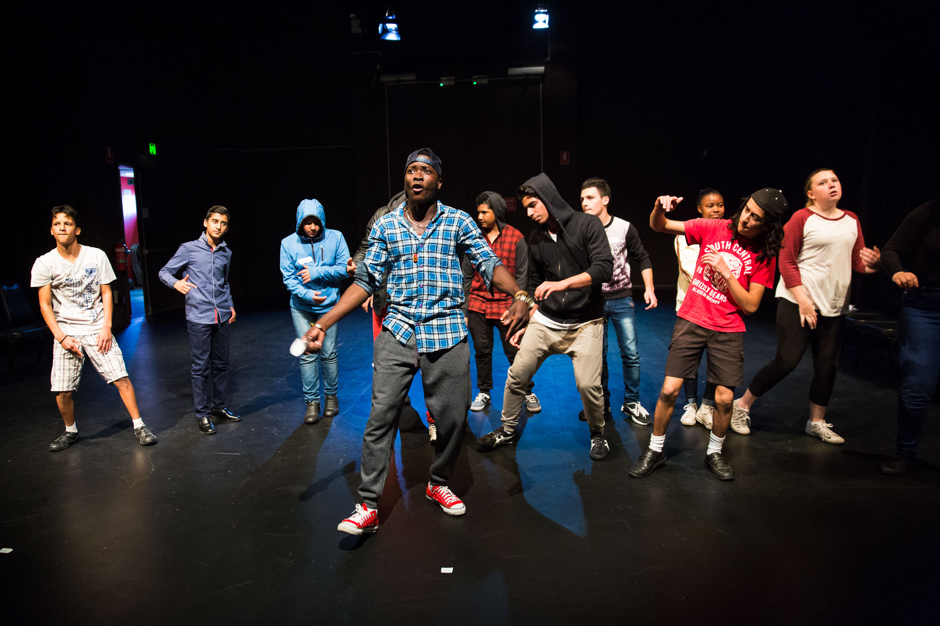
Information package

For further information or enquiries please contact the Arts Initiatives team
via email artsinitiatives@det.nsw.edu.au
The Arts Unit, Corner of Toothill Street & The Boulevard, Lewisham NSW 2049.
Locked Bag 1500, Petersham NSW 2049.
Program Coordinator – Catherine Gilholme, Arts Initiatives and Events Officer
Ph (02) 8512 1190

Multicultural Playwright Program 2022
- About the program
- Who should attend
- Dates and fees
- Program overview
- Tutor information
- Student workshop schedule
- COVID-19 information and processes
- Supervising teacher checklist
- Venue
- Teacher professional learning session
- Register for professional learning
- Payment advice form
- Behaviour code for students

About the program
The Multicultural Playwright Program is designed to give students, Years 7–12, from a refugee or non-English speaking background the opportunity to share their stories through the development of literacy, expressive and performance skills.
This 3-day workshop program will give multicultural and refugee students and their teachers a scriptwriting and performance experience, culminating in a showcase performance which is live streamed back to the student’s home countries.
As part of the preparation for this showcase, teachers will be sent a performance stimulus sheet containing performance starting points and ideas for development.
In 2022, we are also offering a 1-day Professional Learning workshop for teachers of EAL/D students to explore ways of using drama in the EAL/D classroom, to develop student engagement and experiences of performance.
The Multicultural Playwright Program Teacher Professional Learning (TPL) complements the NSW Public Schools Multicultural Playwright Program Student Workshops. The TPL is run prior to the student workshops.
The teacher workshop will help you develop high-level skills in making performance works, engaging in creative practices and exploring dramatic contexts for students with EAL/D and refugee backgrounds.
Following the TPL workshop, you will be invited to select a time for a theatre practitioner mentor to come to your school for 1 x 2hr workshop, to assist with the implementation of strategies and work with you and your students to develop a performance in preparation for the Multicultural Playwright Program Student Workshop.
This program addresses the National Teaching Standards 1.3.2, 2.1.2, 6.3.2
Please contact Catherine Gilholme to discuss any additional support that The Arts Unit can offer to facilitate your school’s involvement in this program.
Email: artsinitiatives@det.nsw.edu.au
Phone: 8512 1190

Who should attend
Teacher professional learning
This workshop is designed for NSW public school secondary teachers (and support staff) who teach students from an EAL/D and/or refugee background.
All participants must register on MyPL - TIPD Course ID: NRG04991
Student Workshop
This workshop is designed for NSW public school students from Years 7–12 who are from a refugee or non-English speaking background. Please be aware that the final performance will be live-streamed, therefore appropriate permission must be sought by the schools for participating students.

Dates
Teacher professional learning
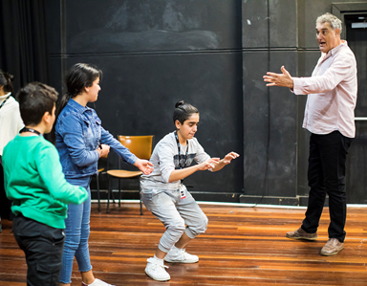
Date: Term 2 Week 4 – Tuesday 17 May 2022.
Time: 9:00 am – 3:00 pm
Venue: Bankstown Arts Centre - Studio 1
5 Olympic Parade, Bankstown, 2200
Student 3-day workshop
Date: Term 2 Week 9 - Tuesday 21, Wednesday 22 and Thursday 23 June, 2022.
Time: 9:00 am – 3:00 pm
Venue: Bankstown Arts Centre - Theatre
5 Olympic Parade, Bankstown, 2200

Program fees
The 3-day workshop fee is $90.00 per participating student.
There is no fee for the teacher professional learning for 1 teacher per school who have students participating in the 3-day program.
A fee of $150 for additional teachers attending the professional learning.
The amount will be direct debited via your school’s Sundry Tax following the workshop.

Program overview
The program will commence with a 1-day teacher professional learning workshop. During this workshop, teachers will work with a theatre practitioner and teacher mentor to develop a program of ideas and teaching strategies to engage and encourage their EAL/D and refugee students to share their experiences and work creatively with each other to express their ideas. Teachers will be given a range performance starting points and ideas for students to work on back at school.
Following this workshop, teachers will have the opportunity to have a theatre practitioner mentor come along to their school to work with their students for 1 x 2hr workshop to assist with the preparation and devising of their performances. The dates will be negotiated to best fit the participating school in the weeks leading up to the 3-day program.
These performances form the basis of the performance to be developed throughout the 3-day workshop under the guidance of Zeal Theatre. The final showcase of the student work is then performed and live streamed to home countries.

Tutor information
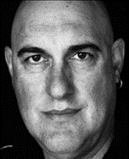
Stefo Nantsou founded Zeal Theatre in 1989. Tom Lycos joined Zeal Theatre co-creating 11 original productions with Stefo. Three of these plays were published as “The Zeal Theatre Collection” by Currency Press in 2011. In 2012 Tom and Stefo wrote “BRAT CAMP” which has since been produced by Kolibri Theatre in Hungary. Their production of “THE STONES” has been performed over 1200 times worldwide including seasons at the National Theatre in London & The Duke Theatre in New York, and has been translated into over 30 languages.
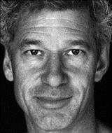
Stefo has directed his plays for companies in Germany, Holland, Wales, Canada, & Denmark. He was resident director at the Sydney Theatre Company from 2009-2013 where he wrote and directed 11 productions including the epic “LEVIATHAN” with a cast of 350 people. Stefo also writes and directs plays with Australian Macedonian Theatre in Sydney, his play “MR BALKAN” toured throughout Australia and the Republic of Macedonia in 2011. Zeal Theatre won the prestigious ASSITEJ International Presidents Award in Montreal, Canada in 2008 for ‘outstanding services to the theatre industry’. Zeal has created over 45 original productions.

Student workshop schedule

DAY 1 |  | DAY 2 |  | DAY 3
9:00am | Schools arrive and sign on | 9:00am | Schools arrive and sign on | 9:00am | Schools arrive and sign on
9:15am | Watch a performance by Zeal Theatre | 9:15am | Student devising workshop | 9:15am | Student devising workshop
11:00am | Recess | 11:00am | Recess | 11:00am | Recess
11:20am | Student performance workshop | 11:20am | Teachers school performance | 11:20am | Student technical rehearsal
1:00pm | Lunch | 1:00pm | Lunch | 1:00pm | Lunch
1:30pm | Student devising workshop | 1:30pm | Student devising workshop | 1:30pm | Student performance of final work
2:30pm | Day 1 concludes | 2:30pm | Day 2 concludes | 2:30pm | Workshop concludes

How to register
Students must attend with a supervising teacher
Step 1: Confirm your student numbers and receive approval from your school principal.
Step 2: Fill out the ‘Payment Advice’ form (below).
Step 3: Complete the online application on The Arts Unit website.
Step 4: Attach the Payment Advice form to your online application.
Step 5: Submit your online form. You will receive a confirmation email that your registration is complete.

Items to bring and wear
On the day of the workshop, students should:

- Wear comfortable clothes or their school sports uniform
- Bring a water bottle, snacks and a packed lunch
- Bring relevant protective wear (e.g. hat and/or school jacket)

COVID-19 information and processes
As your child is participating in an extracurricular off-site activity, it is essential that parents and carers acknowledge and understand the risk of COVID-19 and the risk management processes in place by the program organiser:
I acknowledge that this event/activity is required to be held in accordance with any current NSW Health COVID-19 Public Health Orders and the NSW Department of Education’s policies and procedures. I acknowledge and accept that there is a risk that my child may be exposed to COVID-19 whilst attending and participating at this event. I confirm that my child will not attend if displaying any symptoms of illness, and/or if directed to isolate under public health orders.
If your child presents as unwell (including with mild COVID-19 symptoms) they will be temporarily isolated and the parent/carer will be contacted to collect their child immediately from the venue. Throughout the entirety of this program, staff and students will be strongly encouraged to wear masks where possible and practice social distancing.
Please see the NSW Department of Education COVID-safe advice and COVID-smart measures for further information.

Supervising teachers

Organising and supervising teachers are required to:
- Download and read the risk assessment (this will be provided prior to the student workshop).
- Identify students who do not have permission to publish (please contact the program organisers if this is the case, as the final performance is live-streamed).
- Organise transport and accompany students to/from the workshop.
- Supervise students during the workshop and during breaks. Teachers are also encouraged to actively participate in the workshop activities.
- Ensure that students with medical needs have their relevant medication and Health Care or ASCIA plans.
- Identify any students who suffer from allergies which may lead to anaphylactic shock and inform the coordinator at the workshop.
- As per the NSW Department of Education Excursion Policy, teachers are required to bring a first aid kit (including an Epipen) to the workshop venue.

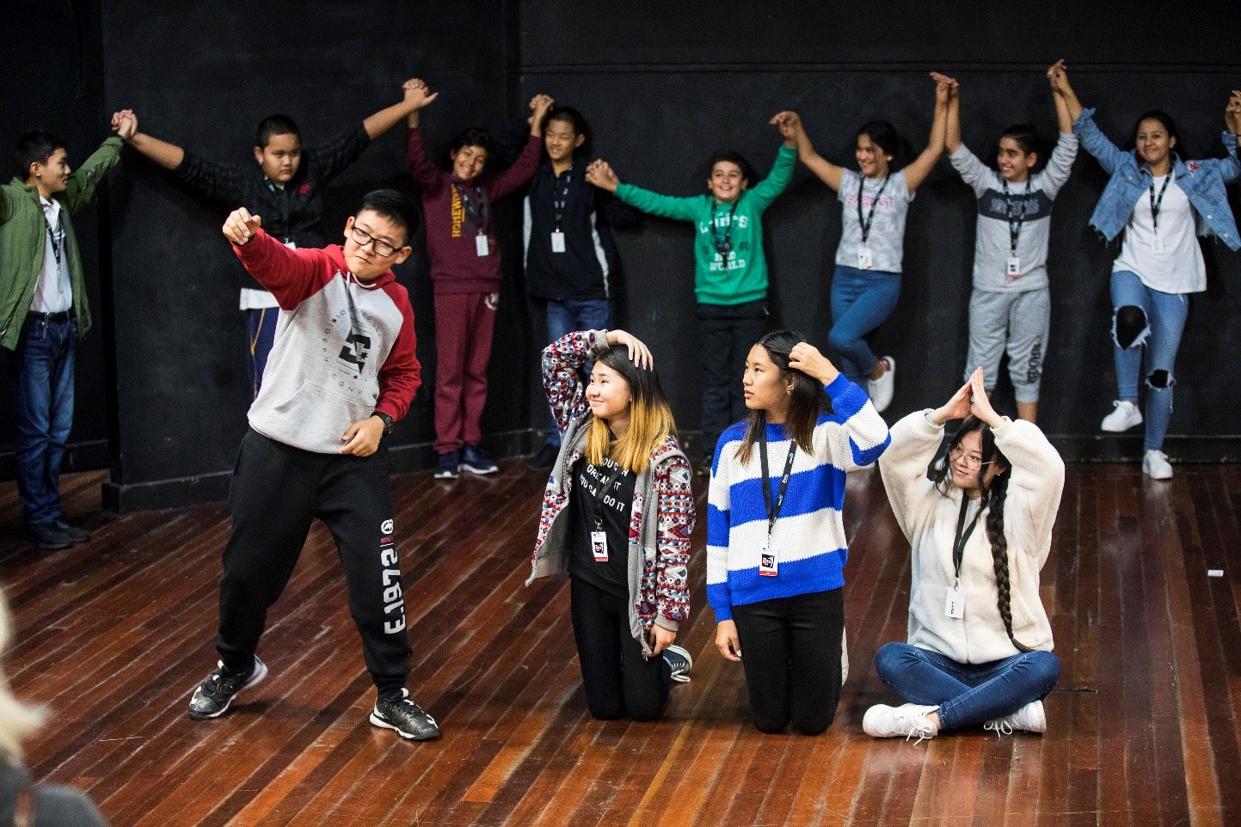

Getting here
The Bankstown Arts Centre is approximately a 3-minute walk from Bankstown train station. There are a number of paid parking lots within walking distance of the Bankstown Arts Centre however, please allow extra time for your arrival, as parking availability is not guaranteed.
- Saigon Place Public Parking – 2-minute walk.
- Greenfield Parade Parking – 3-minute walk.
- Brandon Avenue Public Parking – 2-minute walk.

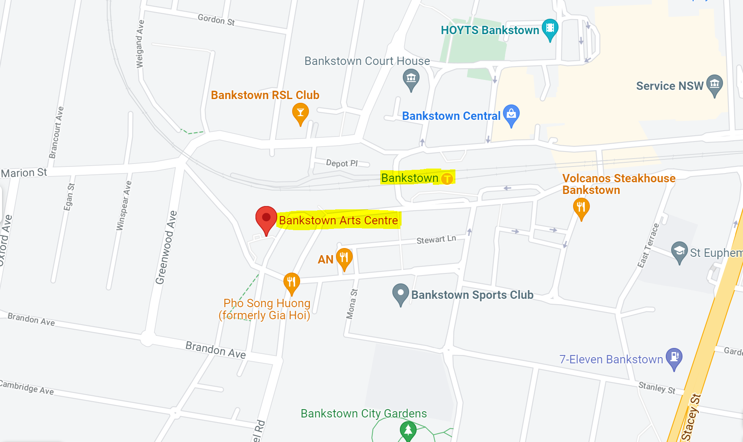

Teacher professional learning
Completion of the program will qualify you for 7 hours of registered professional learning. This program addresses the National Teaching Standards 1.3.2, 2.1.2, 6.3.2. Please ensure you enrol in the course via MyPL Course ID: NRG04991 in order to have the hours added to your professional learning log.

Workshop overview
Sessions are facilitated by industry professionals and Department of Education teachers with specialised skills. Sessions will focus on:
- Engaging students through movement, music and drama
- Creating performances from a range of stimulus material
- Managing collaborative learning experiences and group work
- Using non-verbal communication focusing on empowering and teaching students through performance, movement and gesture
- Play building and characterisation.

Workshop inclusions
The following will be provided for workshop participants:
- 1-day workshop with recognised industry professionals
- 1x 2hr mentoring session at your school, at your selected time
- 7 hours of registered professional learning
- Morning tea and lunch
- Comprehensive resource booklet

Items to bring and wear
On the day of the workshop, teachers should:
- Wear comfortable clothing – we will be moving around a lot!
- Bring a water bottle
- Bring a pen, pencil and highlighter

Registering for teacher professional learning
- Step 1: Receive pre-approval from your school principal.
- Step 2: Enrol via the Staff Portal MyPL website, and search for Course ID NRG04991.
- Step 3: Upload your complete Payment Advice form into your online application or email (signed and scanned, pdf format) to artsinitiatives@det.nsw.edu.au The form is located on page 10 of this document.
Note: You will only be registered once all of the above steps have been completed.

Tutor information
Teacher Workshop Tutor: Kate Worsley
A graduate of Theatre Nepean, Kate Worsley is an actor, teaching-artist and English as a Second Language teacher. She currently works as a teaching-artist for Bell Shakespeare and Sydney Theatre Company and is an Associate Artist at Powerhouse Youth Theatre (PYT). For PYT she recently designed and facilitated PILOTS, a mentor and workshop program and co-directed In This Fairfield: Romeo & Juliet In The West with David Williams.
Kate is also a mentor for Riverside Theatres Sharp, Short Theatre program. Most recently for Riverside education, Kate created and directed The Letters Project, an interactive performance piece that placed letters written by local high school students beside those written by World War One nurses and soldiers.
Kate is based in Western Sydney and is passionate about the availability and accessibility of quality drama programs for young people across the region.

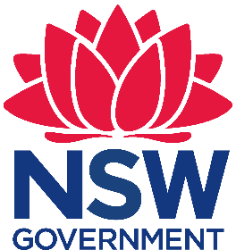
Payment Advice form

Multicultural Playwright Program 2022
The Arts Unit, NSW Department of Education
…………………………………………………………………………………………………….……………………………………………………………..
Total number of students attending workshops: _______
Total number of teachers attending professional learning session: ______
- _____ x students. Registration $90.00 each.
- 1x complimentary teacher (if you have students attending the three-day Multicultural Playwright Program). Registration $0.00
- _____ x additional teacher/s. Registration $150.00 each
- _____ x teacher who do not have students participating in the 3-day student workshop and performance program. (Please note that this will not include the mentoring option). Registration $150.00
…………………………………………………………………………………………………….…..
Once complete, please upload this form into your application or email to the Arts Initiatives team artsinitiatives@det.nsw.edu.au

School name: ____________________________________ School code: __________
I understand that the school will be charged a fee of $90.00 per participating student and $150.00 per participating teacher in the 2022 NSW Public Schools Multicultural Playwright Program. Fees are processed as a direct debit via an Intercompany Journal (previously Sundry Tax) after the workshop.

Organising teacher
Name: __________________________
Signature: _______________________
Date: _______________

Principal
Name: ___________________________
Signature: _______________________
Date: ______________

Behaviour code for students
The Arts Unit is a specialist unit within the New South Wales Department of Education that provides a unique range of opportunities across all of the performing and visual arts, including dance, drama, music, visual arts, public speaking and debating to the students and teachers in NSW Government Schools.

Statement
The Core Rules of Discipline for students participating in arts-based programs, events or activities conducted by The Arts Unit provides a clear statement of the NSW Department of Education expectations of students.

Relevance
The Core Rules of Discipline apply to students enrolled in NSW Government Schools, who are selected or nominate to participate in arts-based programs, events or activities in respect to their conduct whilst participating in such programs, events or activities conducted by or for the Department.

The Core Rules of Discipline have been developed as a means of ensuring the safety of ALL students who participate in arts-based programs. Students must comply with the Core Rules of Discipline at all times whilst participating in the arts-based activity. Participation in arts-based activities is not mandatory for students in government schools, and a student who is unwilling to agree to comply with the Core Rules of Discipline will not be approved to participate in the arts-based activity.

Definition
‘Student’ means any students enrolled in a NSW Government School participating in programs, events or activities coordinated by The Arts Unit.
‘The Department’ means the NSW Department of Education.
Students participating in programs, events or activities conducted by The Arts Unit will adhere to the Core Rules of Discipline in NSW Government Schools.
Prior to participation in a program, event or activity all students over 18 must sign an agreement acknowledging the Core Rules of Discipline and the student’s willingness to comply with them. Students under 18 must have a parent or carer sign an agreement on the student’s behalf.

- Comply with instructions given by teachers at all times. Attend every day required, unless they are legally excused, and be at the program, event or activity on time and be prepared to actively participate and learn.
- Maintain a neat appearance, including adhering to the requirements of the program, event or activities uniform, dress or costume requirements.
- Behave safely, considerately and responsibly, including when travelling to and from the program, event or activity.
- Show respect at all times for program, event or activity coordinators, teachers, other school staff, tutors, and helpers, including following rules specific to the program, event or activity, speaking courteously and cooperating with instructions and learning activities.
- Treat other students and adults involved in the activity with dignity and respect.
- Care for property belonging to themselves, the venue and others.
- Respect property belonging to themselves, the venue or others

Note: The department has a duty of care to all students, and provides a safe and secure learning environment for all of its students, including where the student is involved in an approved activity away from his or her school. Behaviour by a student that affects the safety of others, such as harassment, bullying, violence and illegal or anti-social behaviour of any kind will not be tolerated. This includes but is not limited to smoking, consumption of alcohol and possession or use of illegal drugs.

Consequences for student breaches of these core rules of discipline at a program, event or activity conducted by The Arts Unit.
The Manager of The Arts Unit, in consultation with the relevant school Principal, may deal with any breaches of this code by imposing appropriate consequences which may include exclusion from the program, event or activity. Serious breaches of the code may also be subject to discipline in accordance with the Students Discipline in Government Schools policy.
As a result of a breach of the Core rules of Discipline, a student may face disciplinary action at his or her school. In cases of serious misbehaviour by a student, including but not limited to violence or possession of illegal drugs, this may result in suspension or expulsion.

