KROP – Kids Rapt on Performing

Information package
KROP 2022 is an annual Education Week creative arts production held at the Griffith Regional Theatre as a celebration of public education.

It has provided NSW public school students with performing arts opportunities for over 13 years.

All information will be found in on KROP 2022 - Kids Rapt on Performing webpage

Important dates

Production dates
KROP will be staged on Wednesday 3 August and Thursday 4 August 2022.

There will be a
- full dress rehearsal on Wednesday 3 August.
- matinee on Thursday 4 August.
- evening performances on Wednesday 3 and Thursday 4 2022.

Rehearsal dates
- KROP rehearsals will be Thursday 21 July and Friday 22 July 2022 in the Griffith Regional Theatre.
- You will be allocated a time slot on one of these dates. It is compulsory to attend this rehearsal time slot as there will be NO other rehearsal times available.
- Participation in KROP is free.
- Schools are responsible for the supply of relief, travel, meals and accommodation if required.
- It is mandatory for students to be in costume to assist lighting and staging planning.

COVID-19
The operation of this program is contingent on advice provided by the NSW Department of Education in consultation with NSW Health. All activities will adhere to the DoE COVID-19 guidelines and restrictions. You will be updated as changes occur.

Applications

Nominations
- NSW public schools are invited to apply for KROP by completing the KROP 2022 school nomination form
- Nominations are due 5:00pm, Monday 28 March 2022.

Audition and performance guidelines
- All KROP items are selected by audition. Auditions will be scheduled for Term 2 Week 6.
- We will endeavour to have face to face auditions this year. However, if needed auditions may be held via video audition using YouTube.
- On selection schools will be sent an acceptance and information package.
- Schools may enter more than one audition item but only one performance will be selected per school.
- Audition routines should be as close to performance standard as possible.
- Choreography must be complete and groups must provide a description of costumes and staging.
- Group size must be between 6 and 30 students. At this stage we recommend under 30 students per group but this number may be less due to COVID -19 guidelines at the time of the event.
- Maximum time limit is 5 minutes. This will be strictly adhered to and timed at auditions.
- Suitability of music, lyrics, costume and choreography must be age-appropriate and suitable for a community audience. Costumes, movements or music that are suggestive or use simulated violence will not be selected.
- Props and staging must be quickly and easily set and removed. All props are the responsibility of school groups and must be fireproofed to comply with theatre requirements.
- Stage dimensions of Griffith Regional Theatre stage are 12 metres across (wing to wing) and 9 metres deep (front to back).
- For all performances, students will generally enter Stage Left and MUST exit Stage Right. (Left and right are as seen by the performer, facing the audience). The curtain will not be closed between items.
- Music must be of the highest quality and submitted on a CD or high-quality USB. Editing should also be high-quality. Details of submission will be available in the acceptance.
- Copyright must be consistent with regulations. All licenses must be cleared before the public performance. Refer to Smartcopying for further information.
- It is recommended to avoid use of DISNEY music.
- Supervision of students must be under their teacher’s direct supervision at all times under NSW Department of Education policy. Normal excursion duty of care applies.

Tips for audition video
- Recording from a phone or tablet mounted on a tripod if it is sufficient quality for the audition video.
- Record the performance in one continuous take from a wide angle to ensure all performers are seen. Do not zoom in and out.
- Spend time rehearsing, recording and reviewing your audition video.
- Where possible, minimise external light sources by covering windows to avoid interference with visual contrast.

Tips for uploading to YouTube
- Visit www.youtube.com and create an account or sign in.
- Select upload.
- Follow the instructions onscreen to upload your video.
- Once uploaded, on privacy settings select unlisted (anyone with this link can view) and save changes. This is important because it means the general public cannot view the link.
- When complete, your video will have a URL.
- Send email to robyn.schmetzer@det.nsw.edu.au with the following information
- School name
- Teacher name and contact number
- Item name and artform
- YouTube URL
- Brief description of item including costume
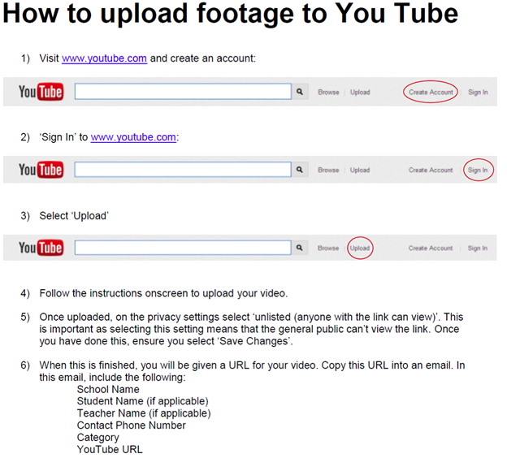

Enquiries
Robyn Schmetzer, KROP producer (Griffith East Public School)
Email: robyn.schmetzer@det.nsw.edu.au
Telephone: 02 6962 1804

