DramaWorks Newcastle – 2022 workshops
Workshop | Workshop overview | Practitioner | Practitioner bio
Physical Storytelling | Join Joshua in a fully accessible, all inclusive creative workshop based around storytelling and physical exploration. This is an opportunity to learn from each other, explore our personal stories in a physical way, and play with ideas in a fun, safe, and nurturing environment for all types of artists! This workshop uses the physical body, text, image and movement to create contemporary, compelling circus theatre. Dive into a world of contradictions and seek to be a platform for voices, questions, and truths of all kinds. | Joshua Thomson  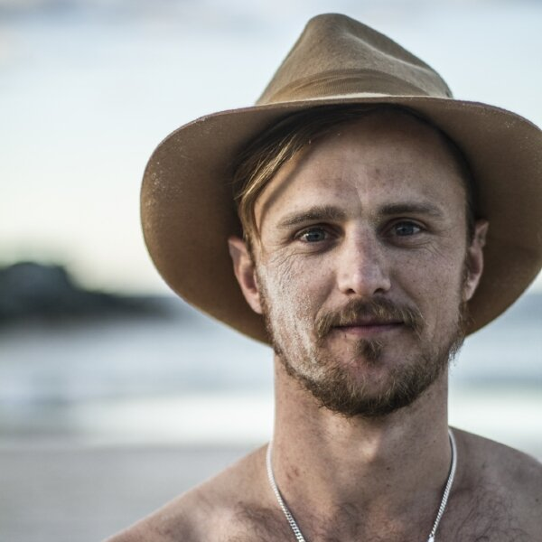 | Joshua Thomson is the Artistic Director of Legs on the Wall and has made numerous works that have toured nationally and internationally. He is a Performer, Choreographer, Director and Maker and holds a Bachelor of Fine Arts (Dance) from the Queensland University of Technology. For the past 16 years Joshua has worked nationally and internationally across many different performative art forms with companies such as Tasdance, dancenorth, Perth Theatre Company, The Farm and PVC – Physical Virus Collective (Germany), Legs On The Wall, Shaun Parker & Company, Stalker Stilt Theatre and Marrugeku. Joshua is one of the founding members of the new Gold Coast company The Farm. He specialises in dynamic physical performing work, ranging from live theatre to a 48 hour duration work in the ocean.
Visual Storytelling | An exploration of narrative invention and image-based storytelling through the mediums of presence, physicality and design. The team will be engaged in the devising of an innovative production of their own, which bases its creation in an imaginative use of bodies, space and light. It will be centered on play, making offers and experimentation. The process is organic, fun and highly inventive, with everyone getting a go and no wrong answers. Collaboration, teamwork, creation and invention are at the core of this thoughtful and original experience. | Tim Overton  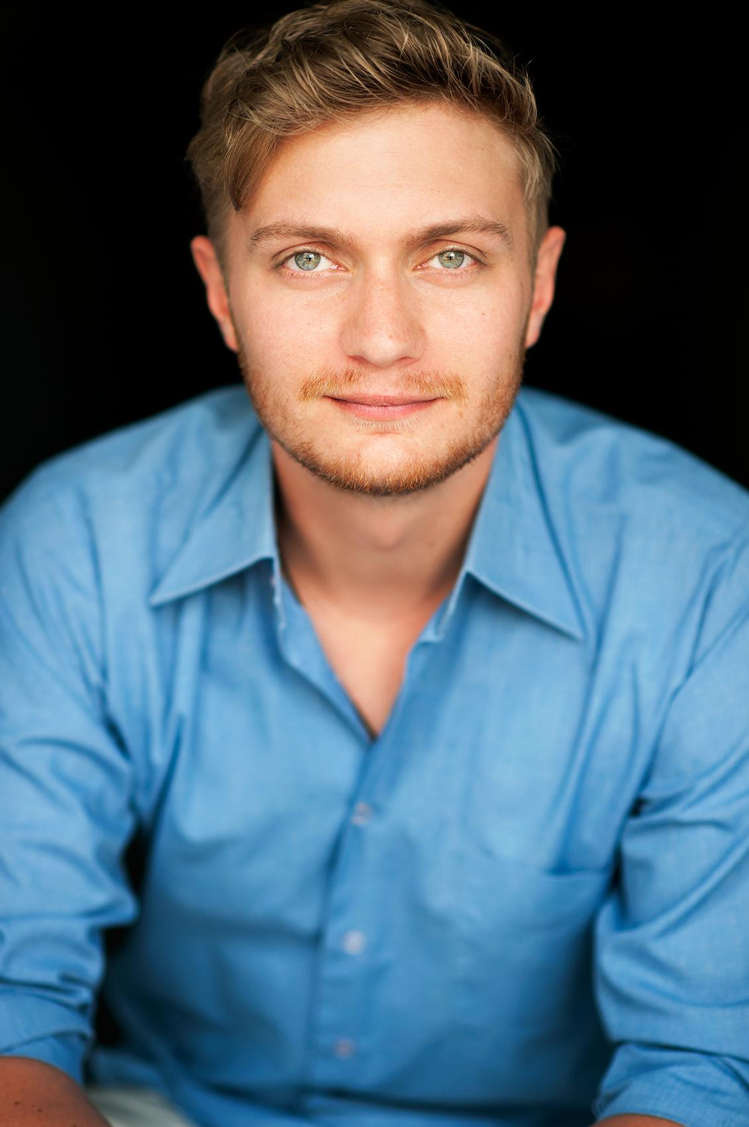 | Tim is a South Australian maker, director and performer. Tim has extensive devising and development experience working with renowned companies such as Slingsby, Patch Theatre Company, State Theatre Company of South Australia, August and September and Carte Blanche, as well as many independent companies and initiatives. Tim has performed considerably in theatres locally, regionally, nationally and across the world, including China, India, Ireland, USA and UK. He has worked for companies including State Theatre Company of South Australia, Sydney Theatre Company, Belvoir, Vitalstatistix, Slingsby Theatre, Patch Theatre Company, Windmill and August & September.
Musical Storytelling | LJ’s workshop will introduce young people to the Little Eggs practice creating a collaborative, devised theatre work based in live music and movement. Little Eggs places a strong emphasis on ensemble building practices, creating a positive and encouraging environment where divisors/performers share ideas and are able to create using their individual skill sets. Students can expect a range of physical theatre devising exercises and holistic sound/music composition culminating in a 10-minute live theatre performance. Students are encouraged to bring instruments to play with! | LJ Wilson | LJ Wilson is a multidisciplinary artist and core member of the Little Eggs Collective working on Gadigal Land. Their work spans across performance, music, film, drag and devising. LJ has been a part of the multi-award-winning collective since 2018, devising and performing in three original productions; Pinocchio (Sydney Fringe), The Rime of the Ancient Mariner (KXT) and most recently Symphonie Fantastique (KXT) which took home four Awards at the Sydney Theatre Awards. Outside of the Little Eggs Collective, LJ’s credits include Opera Australia’s La Traviata on the Harbour, Eye Contact Theatre Company’s Hairworm (Old 505) and Secret House’s Bird (Old Fitz Theatre). Later this year LJ will have their directorial debut with Daddy Developed A Pill at KXT Theatre. LJ would like to acknowledge the enduring resilience of all First Nations folks under the colony and pay their deepest & warmest respects to Elders past, present & emerging. Always Was, Always Will Be Aboriginal Land.
Scripted Storytelling | Creating engaging ways for plays to tell stories through performance for the stage, requires a particular understanding of stagecraft and a learned skill set in script construction.  In this workshop students will share stories together to create and perform playbuilt pieces using a range of methods guided by awards winning Playwright, Nicholas Thoroughgood. | Nicholas Thoroughgood  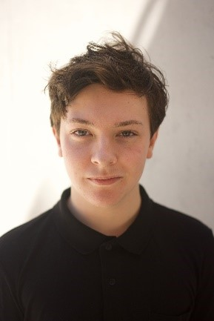 | Nicholas has been working in the Performing Arts Industry since he was a very young, beginning acting in local productions but soon moving to the Sydney stage in Mary Poppins the Musical. They’ve trained at 16th Street Actor’s Studio with some of Australia’s leading arts professionals, and now is an award-winning Director and Playwright; taking the CONDA awards for both Excellence by a Director (A Doll’s House), and Best New Play or Musical written for a Newcastle Company (Here, There and Everywhere) last year. His biggest passion is helping Artists and Actors discover new things about their abilities. Nicholas is a graduate of the DramaWorks program and our first student to return to this stomping ground, so we’re all very excited to have him join the DramaWorks team this year.
Immersive Storytelling | Students will explore the concept of immersive theatre through daily workshops, each with a specific emphasis on different dramatic elements. By playbuilding in the performance space, student’s work will culminate in a site-specific production that explores the themes and ideas that emerge from the Gaol’s unique character. | 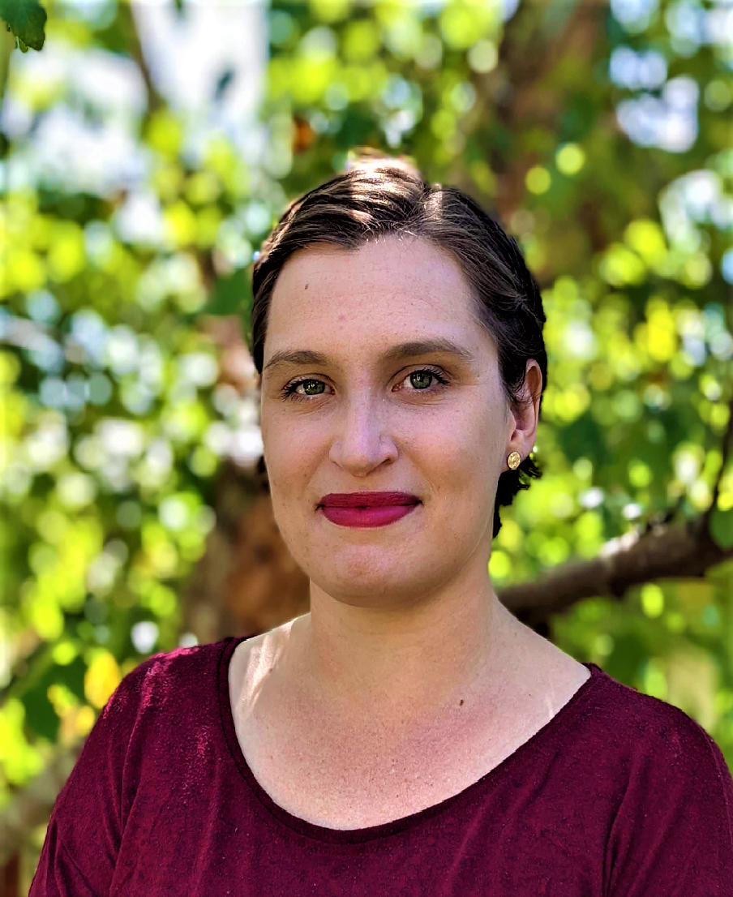  Sara Barlow | Sara Barlow has a passion for process drama and experiential learning, and holds a Graduate Certificate in Creative Industries, a Bachelor of Arts (Drama and Philosophy) and a Master of Teaching (Drama and English). She has performance experience of traditional theatre, ensemble work and immersive theatre, with a CONDA for her work with Tantrum Youth Theatre. More recently, Sara has been working with ‘DARK STORIES’ in a range of site-specific locations across Newcastle and the Sydney regions. She offers a point of difference to our DramaWorks program with a workshop designed to challenge and inspire young performers to ‘think outside the box,’ or, ‘the traditional stage’ when creating new works.

