Payment Portal guide
All participants must make payment through The Arts Unit website payment portal prior to the workshop to secure their position. Please follow the below steps to make payment:
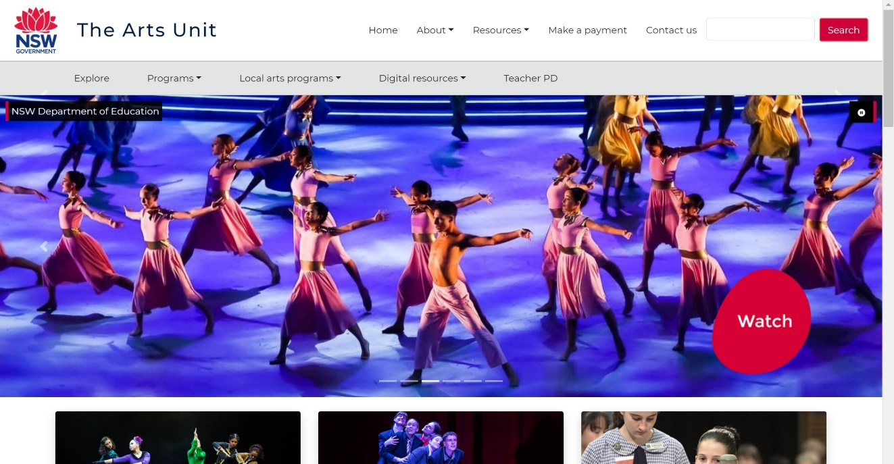
- Go to The Arts Unit website and select the ‘Make a payment’ button in the top right corner.
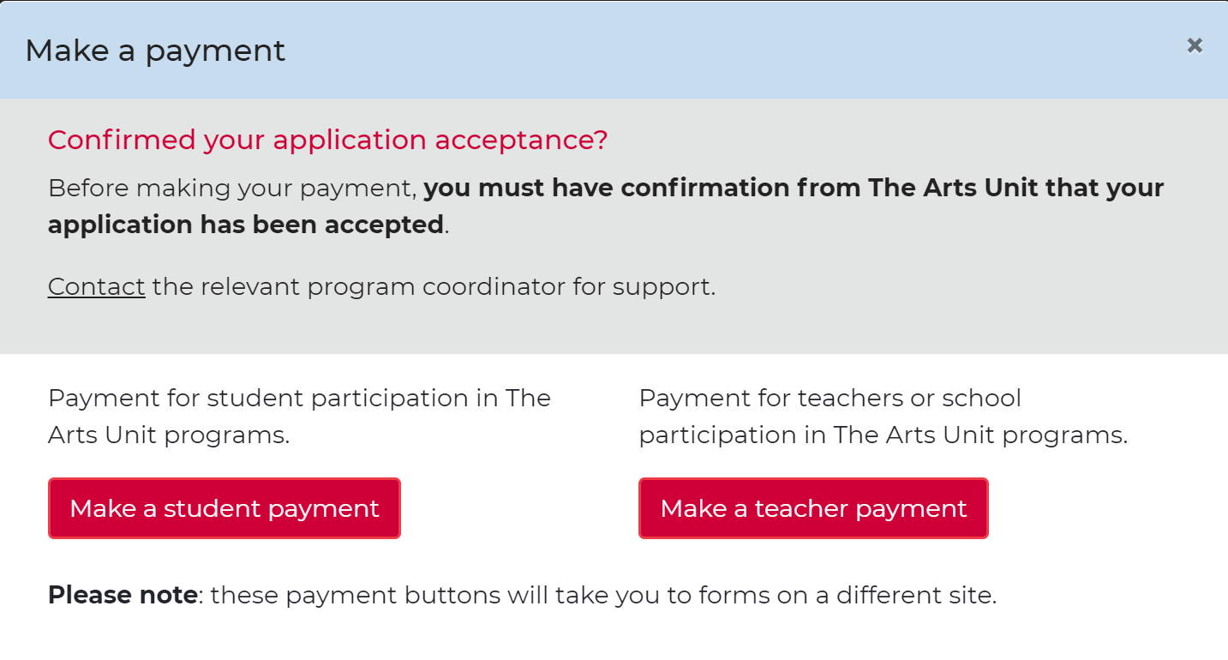
- Select the ‘Make a teacher payment’ button in the bottom right corner. You will now be directed to another webpage.
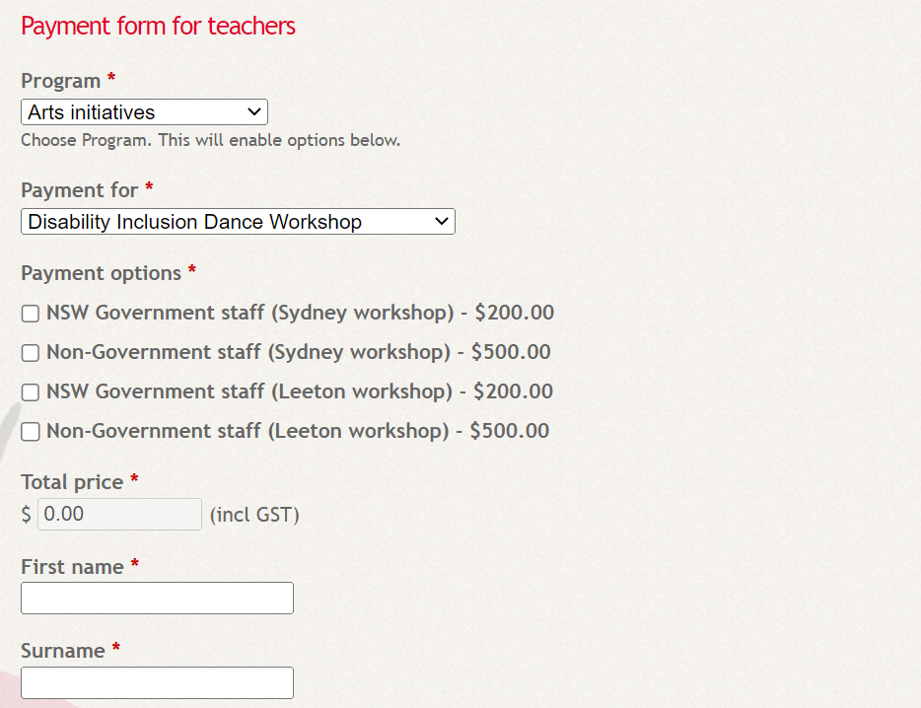
- In the ‘Program’ drop down, you will need to select ‘Arts Initiatives’. In the ‘Payment for’ drop down, you will need to select ‘Disability Inclusion Dance Workshop’
- Please proceed to select whether you are employed in a NSW Government School or Non-Government School, whether you are attending the Sydney workshop or the Leeton workshop, and enter your personal details, school and principal’s information.
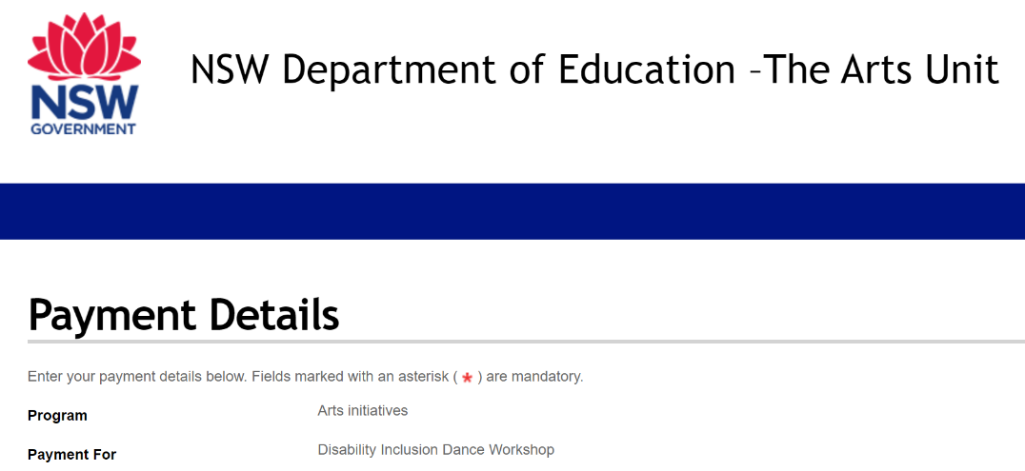
- Once you have entered all required details, select the ‘Submit payment via Westpac Quickweb’ button. You will now be redirected to a new webpage where you need to confirm the information you have entered is correct and enter your card details to finalise your payment.
If you have any issues or questions regarding payment through The Arts Unit Payment Portal, please contact Nicola Marshall via the Arts Initiatives email address below:
ArtsInitiatives@det.nsw.edu.au

My PL
Upon completion, the Disability Inclusion Dance Workshop for Teachers will provide 10 hours of elective professional development addressing standards 1.5.2, 4.1.2 and 6.4.2 from the Australian Professional Standards for Teachers.
Register for this course via MyPL, enrolling in Course ID NRG03313. You will receive a certificate of participation at the completion of the workshop.

