1b – Keystone
Use the following worksheet as a guide to help you plan out the key elements in your film.
Task
Brainstorm the elements for your film, write them around the keystone.
Think about what type of camera shots you might need? Close up? an establishment shot for the setting? Etc.
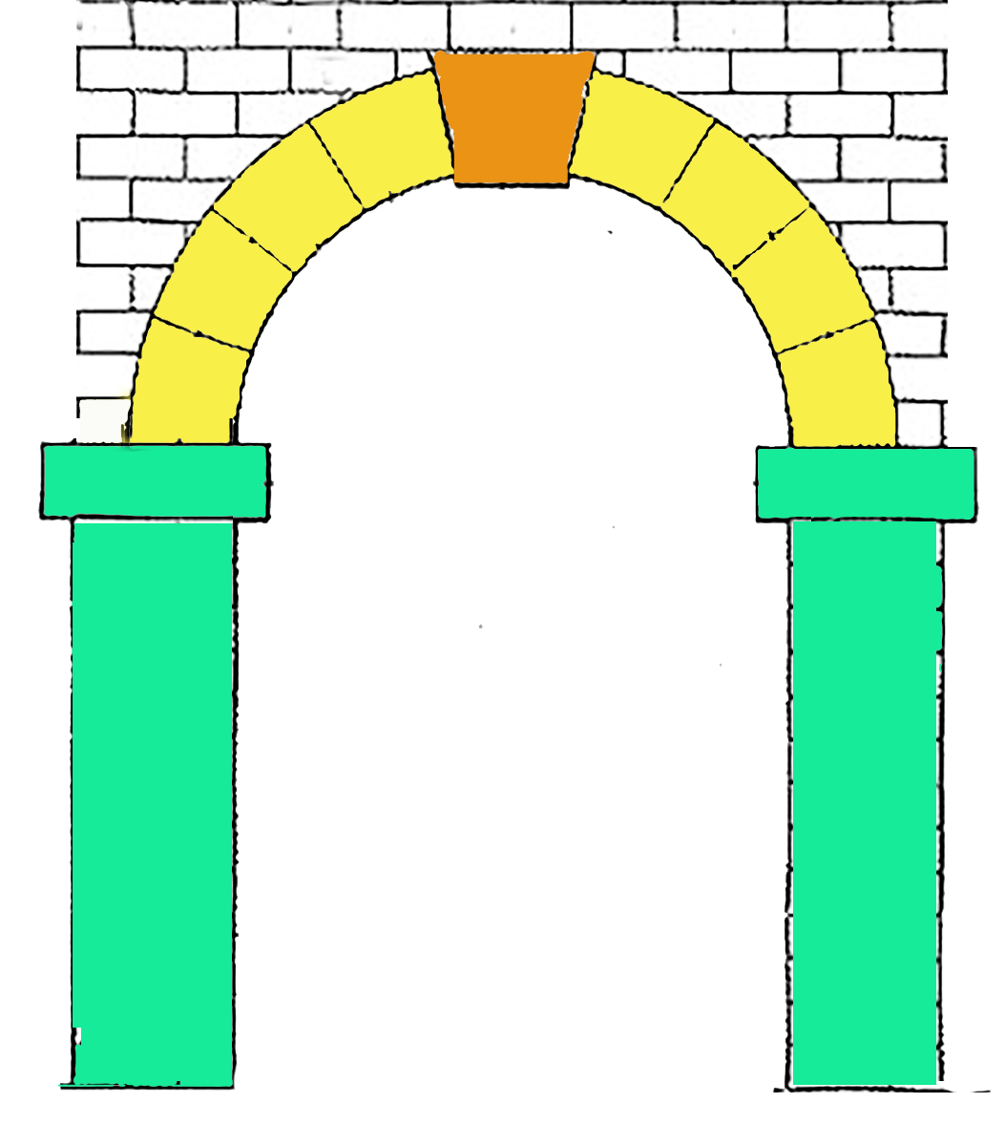
Will there be a twist in the story? Who are the characters?
What will you hear in this film? Is there speaking, sound effects? shots you might need? Close up? an establishment shot for the setting? Ect.
Camera
Story
Sound

