Costume Measurements Guide

Female Measurements Guide

**Please ensure all measurements are recorded in centimetres.**

**GIRTH:** Measure from the centre of one shoulder, down the front of the body, through the crotch and up the back of the body to the starting point.

**CHEST:** With arms relaxed down at sides, measure around the fullest part of the chest, keeping the tape measure parallel to the floor.

**WAIST:** Measure around natural waistline, the narrowest part of the upper body (not over shirt of pants).

**HIPS:** Measure around fullest part of the lower body, keeping tape measure straight and parallel to the floor.

**WAIST TO ANKLE:** Measure down the outside of the leg from the waist to ankle bone.

**HEIGHT:** Measure from the top of the head to the floor.

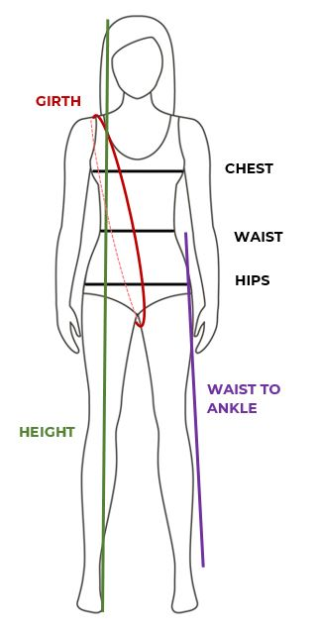

Costume Measurements Guide

**Please ensure all measurements are recorded in centimetres.**

**GIRTH:** Measure from the centre of one shoulder, down the front of the body, through the crotch and up the back of the body to the starting point.

**NECK:** Measure around the base of the neck.

**CHEST:** With arms relaxed down at sides, measure around the fullest part of the chest, keeping the tape measure parallel to the floor.

**WAIST:** Measure around natural waistline, the narrowest part of the upper body (not over shirt of pants).

**HIPS:** Measure around fullest part of the lower body, keeping tape measure straight and parallel to the floor.

**WAIST TO MID-THIGH:** Measure down the outside of the leg from the waist to the middle of the thigh.

**HEIGHT:** Measure from the top of the head to the floor.

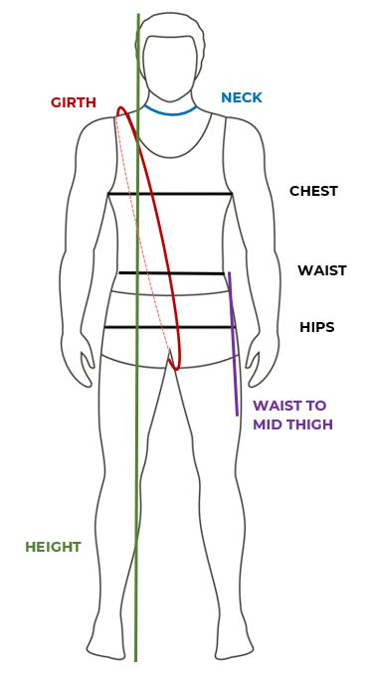Male Measurements Guide