NSW Public Schools Primary Aboriginal Dance Workshop 2024

Workshop Information Package

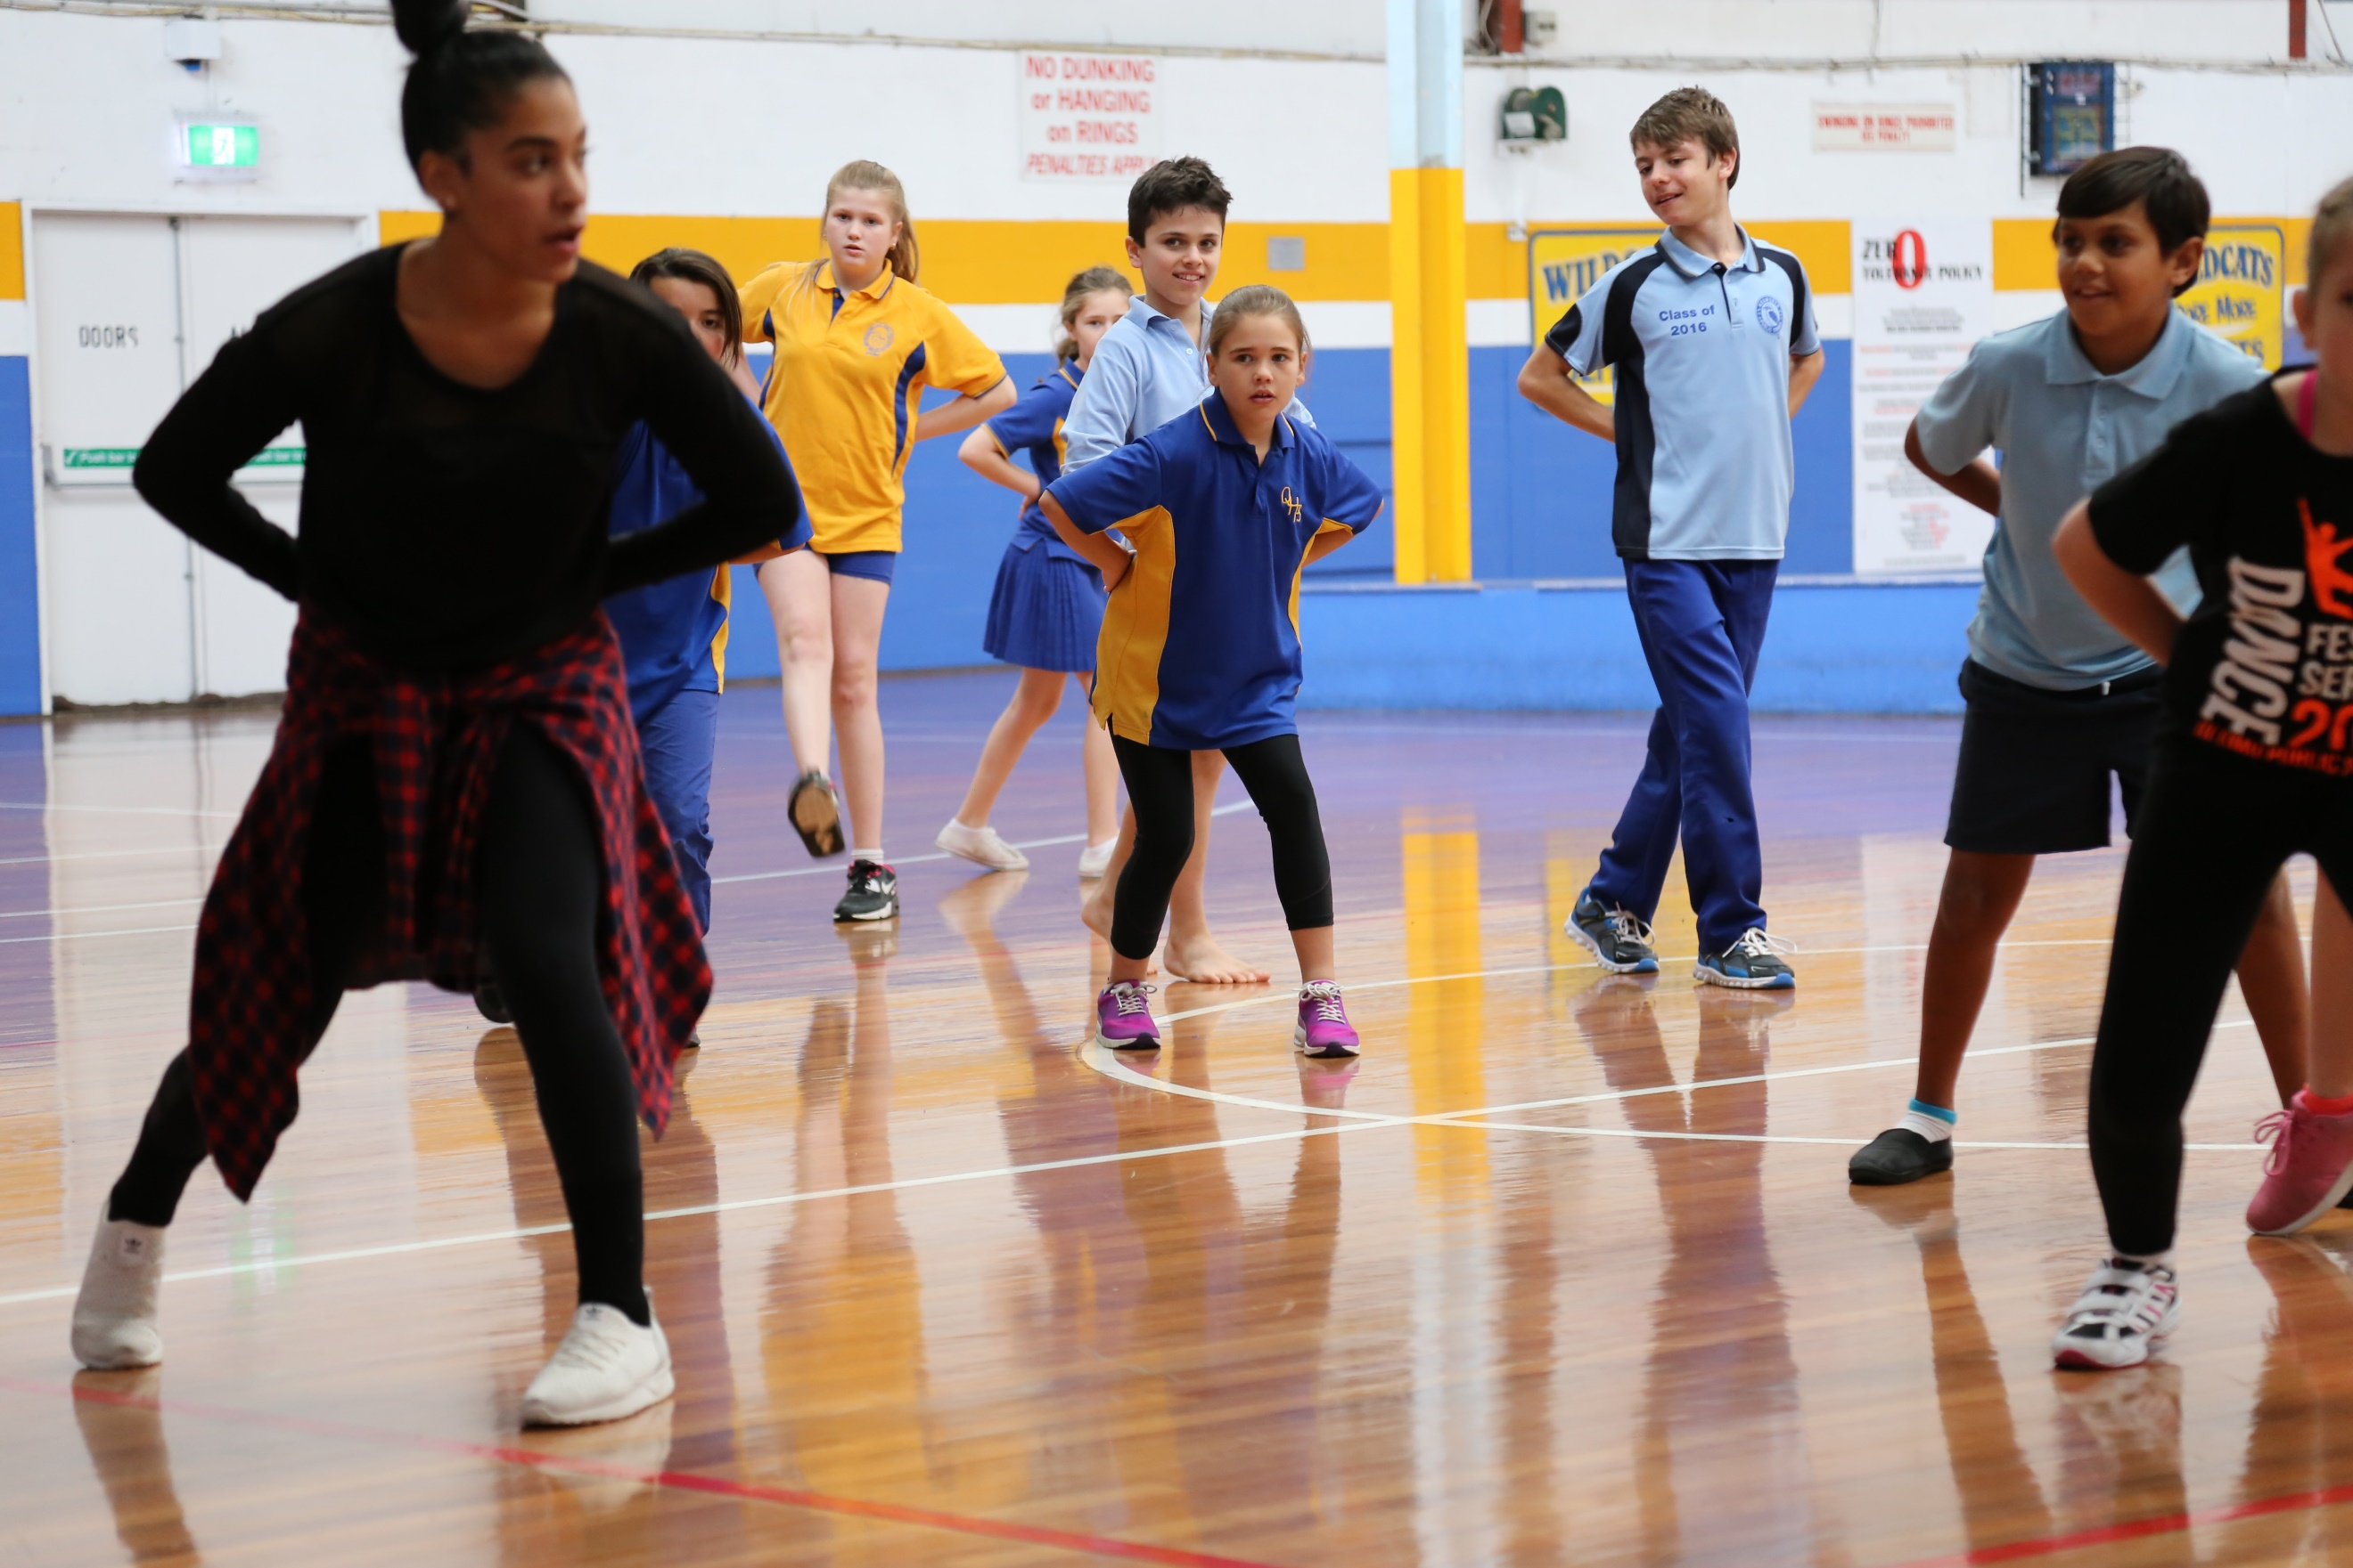

For further information or enquiries please contact the Arts Initiatives team
via email artsinitiatives@det.nsw.edu.au
The Arts Unit, Corner of Toothill Street & The Boulevard, Lewisham NSW 2049.
Locked Bag 1500, Petersham NSW 2049.
Program Coordinator – Ashley Napoleoni, R/Arts Initiatives and Events Officer
Ph (02) 8512 1190

Primary Aboriginal Dance Program 2024
- About the program
- Who should attend?
- Key information
- Workshop Schedule
- Program details and dates
- How to register
- Supervising teacher checklist
- About the Brolga Dance Academy
- Student behaviour code
- Payment Advice form

About the program
Thank you for your interest in the 2024 NSW Public Schools Primary Aboriginal Dance Workshops. These one-day workshops are run by the NSW Department of Education in collaboration with the Brolga Dance Academy. Throughout the workshop, students will learn a fusion of traditional and contemporary dance movement and apply these using their own knowledge of storytelling and their culture.

Who should attend this workshop?
This workshop aims to foster the development of dance skills and cultural significance for both experienced and inexperienced dancers, boys and girls from Years 3 – 6.
This is a highly motivational program that is recommended for all Aboriginal and Torres Strait Islander students. This workshop addresses the Australian Professional Standards for Teachers 1.4.2 and 2.4.2. Teachers attending the workshop will be able to attribute 5 hours of Teachers Identified Professional Learning (TIPD) to seek or maintain their accreditation.

Key information
Program dates: Term 2, Weeks 2 - 3
Mode: This program will be held face-to-face at various locations across NSW.
Attendees: Aboriginal and Torres Strait Islander boys and girls from Years 3 – 6 who are experienced or inexperienced in dance.
Program inclusions:
- 5-hour student workshop.
Fees: Schools will be charged $33.00 per participating student:
Fee | Program element | Inclusions
$33.00pp | Student workshops | Up to 10 students per school

Workshop schedule
Please note, actual times may vary on the day.
9:00am | Schools arrive and sign-in
9:15am | Introduction
9:50am | Warm Up / Stretch
10:10am | Storytelling through movement
11:10am | Lunch Break (30 mins)
11:40pm | Yandool Choreography – Aboriginal Contemporary
1:30pm | Recess Break (15 mins)
1:45pm | Yandool continued
2:00pm | Students Performance
2:20pm | Cool Down
2:30pm | Workshop Ends

Program details and dates

Storytelling
In this activity, tutors from Brolga Dance Academy will share their stories, songs, and dance. Students will learn to mimic movements of the Dhinawan (Emu), Burraalga (Brolga), Bigibila (echidna), Wandhala (eagle), Bundarr (kangaroo), Dhagaay (yellow belly fish) and more. Furthermore, students will use this newly acquired knowledge of animal names and movements to engage in games.

Creative Movement
In this activity students will be introduced to and explore travelling movements, techniques, and skills with infused Traditional and Aboriginal contemporary dance. They will be given a theme to create and improvise their own Aboriginal movements and storytelling through expression dance. Students will be working is small group to create a 30 second dance piece.

Week | Date | Location | Venue
2 | Tuesday 6 May | Bourke | Bourke Public School
 | Wednesday 8 May | Sydney | Brewarrina Central School
 | Thursday 9 May | Walgett | Walgett Community College
3 | Monday 13 May | Wagga Wagga
 | Tuesday 14 May | Blacktown
 | Wednesday 15 May | Newcastle
 | Thursday | Campbelltown
 | Friday | Moruya

How to register
Step 1 – Confirm your student numbers and receive approval from your school principal.
Step 2 – Fill out the ‘Payment Advice’ form (Page 8) and scan (pdf format).
Step 3 – Complete the online application using the following link: https://artsunit.nsw.edu.au/form/ -XXX
Step 4 – Attach the Payment Advice form to your online application.
Step 5 - Submit your online form. You will receive a confirmation email that your registration is complete.

Supervising teachers
On the day of the workshop, accompanying teachers are required to:
- Supervise students during the workshop and during breaks
- Ensure that students with medical needs have their relevant medication and Health Care or ASCIA plans. Please also ensure that due care has been exercised to accommodate student’s medical and dietary needs on the day of the workshop.
- Identify any students who suffer from allergies which may lead to anaphylactic shock and inform the coordinator at the workshop.
- As per the NSW Department of Education Excursion Policy, teachers are required to bring a first aid kit (including an Epipen) to the workshop venue.
- Accompanying teachers are encouraged to actively participate in the workshop activities.
Items to bring and wear
On the day of the workshop, students should:
- Wear their school’s sports uniform
- Bring a water bottle, snacks and a packed lunch
- Bring relevant protective wear (e.g. hat and/or school jacket)
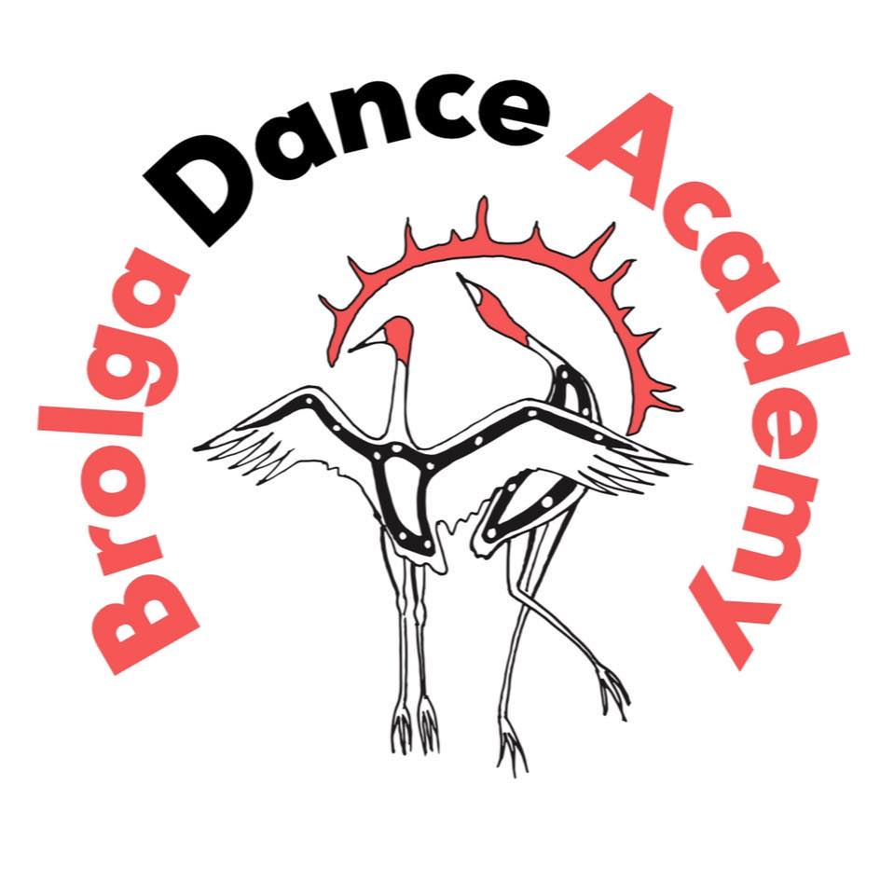
About Brolga Dance Academy

Brolga Dance Academy is an Aboriginal Dance School specialising in Traditional and Aboriginal Contemporary Dance based in Redfern, NSW. We are a 100% owned and controlled Aboriginal business built from deep respect, passion, desire and a long-standing commitment in the Aboriginal performing arts industry and community.
We value Aboriginal and Torres Strait Islander arts, culture, communities, and people – their passions, their creativity, and their commitment. Brolga Dance Academy brings a familiar perspective to representation that upholds our belief that our young people and culture are the most important part of our business. As a result, we provide a space for our young people to be storytellers through body movement using fused traditional and contemporary styles.
Our students will discover culture through body movement as a tool to discover the intricacies on words and language of the Aboriginal people.
We provide an authentic culturally safe and professional space for people to connect and be immersed in experiencing their own cultural journey.

Behaviour code for students

The Arts Unit is a specialist unit within the New South Wales Department of Education that provides a unique range of opportunities across all of the performing and visual arts, including dance, drama, music, visual arts, public speaking and debating to the students and teachers in NSW Government Schools.

Statement
The Core Rules of Discipline for students participating in arts-based programs, events or activities conducted by The Arts Unit provides a clear statement of the NSW Department of Education expectations of students.

Relevance
The Core Rules of Discipline apply to students enrolled in NSW Government Schools, who are selected or nominate to participate in arts-based programs, events or activities in respect to their conduct whilst participating in such programs, events or activities conducted by or for the Department.

The Core Rules of Discipline have been developed as a means of ensuring the safety of ALL students who participate in arts-based programs. Students must comply with the Core Rules of Discipline at all times whilst participating in the arts-based activity. Participation in arts-based activities is not mandatory for students in government schools, and a student who is unwilling to agree to comply with the Core Rules of Discipline will not be approved to participate in the arts-based activity.

Definition
‘Student’ means any students enrolled in a NSW Government School participating in programs, events or activities coordinated by The Arts Unit.
‘The Department’ means the NSW Department of Education.

Behaviour Code for students in NSW Public Schools

Students participating in programs, events or activities conducted by The Arts Unit will adhere to the Core Rules of Discipline in NSW Government Schools.
Prior to participation in a program, event or activity all students over 18 must sign an agreement acknowledging the Core Rules of Discipline and the student’s willingness to comply with them. Students under 18 must have a parent or carer sign an agreement on the student’s behalf.
- Comply with instructions given by teachers at all times. Attend every day required, unless they are legally excused, and be at the program, event or activity on time and be prepared to actively participate and learn.
- Maintain a neat appearance, including adhering to the requirements of the program, event or activities uniform, dress or costume requirements.
- Behave safely, considerately and responsibly, including when travelling to and from the program, event or activity.
- Show respect at all times for program, event or activity coordinators, teachers, other school staff, tutors, and helpers, including following rules specific to the program, event or activity, speaking courteously and cooperating with instructions and learning activities.
- Treat other students and adults involved in the activity with dignity and respect.
- Care for property belonging to themselves, the venue and others.
- Respect property belonging to themselves, the venue or others

Note: The department has a duty of care to all students, and provides a safe and secure learning environment for all of its students, including where the student is involved in an approved activity away from his or her school. Behaviour by a student that affects the safety of others, such as harassment, bullying, violence and illegal or anti-social behaviour of any kind will not be tolerated. This includes but is not limited to smoking, consumption of alcohol and possession or use of illegal drugs.

Consequences for student breaches of these core rules of discipline at a program, event or activity conducted by The Arts Unit
The Manager of The Arts Unit, in consultation with the relevant school Principal, may deal with any breaches of this code by imposing appropriate consequences which may include exclusion from the program, event or activity. Serious breaches of the code may also be subject to discipline in accordance with policies outlined in the document Students Discipline in Government Schools https://detwww.det.nsw.edu.au/policies/student_serv/discipline/stu_discip_gov/
As a result of a breach of the Core rules of Discipline, a student may face disciplinary action at his or her school. In cases of serious misbehaviour by a student, including but not limited to violence or possession of illegal drugs,
this may result in suspension or expulsion.

Payment advice form

Primary Aboriginal Dance Workshop
The Arts Unit, NSW Department of Education
School Name: _____________________________________________________________
School Code: ______________________________________________________________

Fee | Attending Students (Maximum 10 students) | Total ($33 x number of students)
$33.00 (no GST) | Enter number of students: _________

…………………………………………………………………………………………………….……………………………………………………………

Once complete, please upload this form into your application or email to the Arts Initiatives team artsinitiatives@det.nsw.edu.au.
I understand that the school will be charged a fee of $33.00 per participating student in the 2024 NSW Public Schools Primary Aboriginal Dance Workshop. Fees are processed as a direct debit via an Intercompany Journal (previously Sundry Tax) after the first session.

Organising teacher
Name __________________________
Signature _______________________
Date ___________________________
Principal
Name ___________________________
Signature _______________________
Date ____________________________

