2024 Boys Urban Showcase

Information package

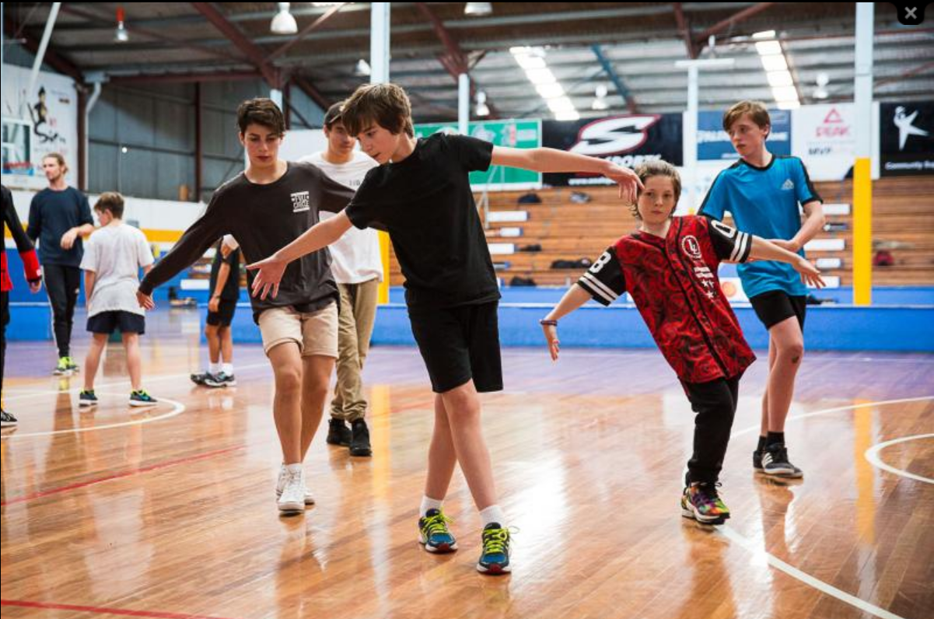
For further information or enquiries please contact the Arts Initiatives team
via email artsinitiatives@det.nsw.edu.au
The Arts Unit, Corner of Toothill Street & The Boulevard, Lewisham NSW 2049.
Locked Bag 1500, Petersham NSW 2049.
Program Coordinator – Ashley Napoleoni, Arts Initiatives and Events Officer
Ph (02) 8512 1190

Boys’ Urban Showcase 2024
- About the program
- Who should attend
- Key Information
- Workshop schedule
- Tutor information
- How to register
- Items to bring and wear
- COVID-19 information and processes
- Supervising teacher checklist
- Behaviour code for students

About the program
This Boys Urban Showcase aims to foster the development of dance skills for both experienced and inexperienced dancers. This is a highly motivational program that provides a differentiation opportunity for students to allow them to find their potential in dance, develop their talent and increase their engagement in education through the creative domain.
This festival addresses the Australian Professional Standards for Teachers 1.3.2 and 1.5.2. Teachers attending the workshop will be able to attribute 5 hours of Teachers Identified Professional Learning (TIPD) to seek or maintain their accreditation.

Who should attend
The Boys Urban Showcase workshops are run by the NSW Department of Education and are open to all boys from Year 3 to Year 12 who attend NSW Public Schools.

Key Information
Program Dates and Modes:
Thursday 4 July and Friday 5 July
9:00am – 3:00pm daily
Please arrive between 8:30am and 8:45am to sign in.
Venue: 3 Danks St Studios, 3 Danks Street, Waterloo
Attendees: Boys from Year 3 to Year 12 who attend NSW Public Schools who are inexperienced or experienced in dance.
Program inclusions:
- 2 days of workshops and showcases
Fees: Schools will be charged $60.00 per participating student.

Festival schedule
Please note, actual times may vary on the day
Day 1
8:30am – 8:45am | Schools arrive and sign on
9:00am – 9:30am | Ice breaker
9:30am – 10:00am | Tutor demonstration and chat, history of hip hop, Q&A
10:00am – 10:45am | Style session 1 – Breaking
10:45am – 11:00am | Break 1
11:00am – 11:45am | Style Session 2 - Popping
11:45am – 12:30pm | Style Session 3 - Unification
12:30pm – 1:00pm | Lunch
1:00pm – 2:00pm | Cypher
2:00pm – 2:45pm | Tutor showcase and repertoire
2:45pm – 3:00pm | Wrap up

Day 2
8:30am – 8:45am | Schools arrive and sign on
9:00am – 9:30am | Cypher
9:30am – 10:15am | Schools Performance
10:15am – 10:45am | Setting up for a battle – how to make 2 sets
10:45am – 11:00am | Break 1
11:00am – 12:00pm | Battle rounds – 1V1, 2V2 and crew V’s crew
12:00pm – 12:30pm | Exhibition battle 2V2 guest Stale Bizkits
12:30pm – 1:00pm | Lunch
1:00pm – 2:15pm | Cypher / Jam
2:15pm – 3:00pm | Presentation and Wrap up

Tutor information
Neale Whittaker
While completing his full-time dance training at Ev & Bow in 2008, Neale began to develop his own unique brand of movement, fusing contemporary and Urban techniques. This unique style led him to the top 40 competitors of the hit TV show ‘So You Think You Can Dance’ in 2010, a program for which he had been assisting Sarah Boulter with since 2008. His TV credits continued when he was cast in the ABC3 TV series Dance Academy and again in Australia’s Got Talent as a semi-finalist in 2012 and Grand Finalist in 2016.
In 2011 Neale toured throughout Australia with contemporary a based show ‘Shorter and Sweeter Dance’ gaining performance experience and insight from noted Australian choreographers such as Travers Ross who Neale collaborated with later in 2012 for the ARIAs, co-choreographing and dancing in a routine for artist ‘360’.
In 2014 and returning on scholarship in 2015 Neale attended Urban Dance Camp in Germany with the most prestigious choreographers in the world. After which he taught a series of Hip-Hop and Contemporary open classes in Europe.
Neale’s talent for Hip hop led him to become Co-Director and manager of ‘Phly Crew’ recentlytitled Grand Finalists on Australia’s Got Talent 2016, who are now Sydney’s Leading Comedy Hip-Hop group performing Independently produced variety stage shows and corporate events for companies including Nikon, Telstra, Blackberry, Beyond Blue and West mead Children’s hospital.
In 2017 Neale has been Performing and touring with Marko Panzic’s Dream Dance Company. Neale was lucky enough to be appointed dance captain in Dream Dance Co’s production of‘Enter the Vortex’ Choreographed by Sarah Boulter. He then continued his working relationship with Sarah performing a solo routine on 2017’s ‘The Voice’ a long side celebrity guest Jennifer Hudson.

Stale Biskitz
This year is the 20th anniversary of Stale Biskitz. Poppin Jack co-founded the pioneering dance crew when he was just 14 years old and he has spent the majority of his life nurturing it.
In the early days, the crew was made up of four popping dancers: Alby, Yuki, Adam and, of course, Poppin Jack himself. They met at Sydney Street Dance Studio ‘Dancekool’ and begun practising together, determined to get better and start entering competitions. Now tow decades on, the line up has changed and the aspirations have gotten bigger, but what drives them has remained the same: a love of dance and commitment to the community around it.
Together, Stale Biskitz have enjoyed some incredible successes. One of the biggest was winning team popping battle KOD in Sydney and being sent to Korea for the Oceania Preliminary, where they beat both China and Japan, and ended up proceeding to the world final. But as Poppin Jack sees it, the biggest highlight has just been the camaraderie.

How to register
Step 1: Confirm your student numbers and receive approval from your school principal.
Step 2: Complete the online application on The Arts Unit website. You will receive a confirmation email that your registration is complete.

Items to bring and wear
On the days of the showcase, students should:

- Wear comfortable clothes or their school sports uniform
- Bring a water bottle, snacks and a packed lunch
- Bring relevant protective wear (e.g. hat and/or school jacket)

COVID-19 information and processes
As your child is participating in an extracurricular off-site activity, it is essential that parents and carers acknowledge and understand the risk of COVID-19 and the risk management processes in place by the program organiser:
I acknowledge that this event/activity is required to be held in accordance with any current NSW Health COVID-19 Public Health Orders and the NSW Department of Education’s policies and procedures. I acknowledge and accept that there is a risk that my child may be exposed to COVID-19 whilst attending and participating at this event. I confirm that my child will not attend if displaying any symptoms of illness, and/or if directed to isolate under public health orders.
If your child presents as unwell (including with mild COVID-19 symptoms) they will be temporarily isolated and the parent/carer will be contacted to collect their child immediately from the venue. Throughout the entirety of this program, staff and students will be strongly encouraged to wear masks where possible and practice social distancing. Please see the NSW Department of Education COVID-safe advice and COVID-smart measures for further information.

Supervising teachers

Organising and supervising teachers are required to:
- Download and read the risk assessment (this will be provided prior to the student workshop).
- Identify students who do not have Authority to Film (please contact the program organisers if this is the case)
- Organise transport and accompany students to/from the workshop.
- Supervise students during the workshop and during breaks.
- Ensure that students with medical needs have their relevant medication and Health Care or ASCIA plans.
- Identify any students who suffer from allergies which may lead to anaphylactic shock and inform the coordinator at the workshop.
- As per the NSW Department of Education Excursion Policy, teachers are required to bring a first aid kit (including an Epipen) to the workshop venue.

Behaviour code for students
The Arts Unit is a specialist unit within the New South Wales Department of Education that provides a unique range of opportunities across all of the performing and visual arts, including dance, drama, music, visual arts, public speaking and debating to the students and teachers in NSW Government Schools.

Statement
The Core Rules of Discipline for students participating in arts-based programs, events or activities conducted by The Arts Unit provides a clear statement of the NSW Department of Education expectations of students.

Relevance
The Core Rules of Discipline apply to students enrolled in NSW Government Schools, who are selected or nominate to participate in arts-based programs, events or activities in respect to their conduct whilst participating in such programs, events or activities conducted by or for the Department.

The Core Rules of Discipline have been developed as a means of ensuring the safety of ALL students who participate in arts-based programs. Students must comply with the Core Rules of Discipline at all times whilst participating in the arts-based activity. Participation in arts-based activities is not mandatory for students in government schools, and a student who is unwilling to agree to comply with the Core Rules of Discipline will not be approved to participate in the arts-based activity.

Definition
‘Student’ means any students enrolled in a NSW Government School participating in programs, events or activities coordinated by The Arts Unit.
‘The Department’ means the NSW Department of Education.
Students participating in programs, events or activities conducted by The Arts Unit will adhere to the Core Rules of Discipline in NSW Government Schools.
Prior to participation in a program, event or activity all students over 18 must sign an agreement acknowledging the Core Rules of Discipline and the student’s willingness to comply with them. Students under 18 must have a parent or carer sign an agreement on the student’s behalf.

- Comply with instructions given by teachers at all times. Attend every day required, unless they are legally excused, and be at the program, event or activity on time and be prepared to actively participate and learn.
- Maintain a neat appearance, including adhering to the requirements of the program, event or activities uniform, dress or costume requirements.
- Behave safely, considerately and responsibly, including when travelling to and from the program, event or activity.
- Show respect at all times for program, event or activity coordinators, teachers, other school staff, tutors, and helpers, including following rules specific to the program, event or activity, speaking courteously and cooperating with instructions and learning activities.
- Treat other students and adults involved in the activity with dignity and respect.
- Care for property belonging to themselves, the venue and others.
- Respect property belonging to themselves, the venue or others

Note: The department has a duty of care to all students, and provides a safe and secure learning environment for all of its students, including where the student is involved in an approved activity away from his or her school. Behaviour by a student that affects the safety of others, such as harassment, bullying, violence and illegal or anti-social behaviour of any kind will not be tolerated. This includes but is not limited to smoking, consumption of alcohol and possession or use of illegal drugs.

Consequences for student breaches of these core rules of discipline at a program, event or activity conducted by The Arts Unit.
The Manager of The Arts Unit, in consultation with the relevant school Principal, may deal with any breaches of this code by imposing appropriate consequences which may include exclusion from the program, event or activity. Serious breaches of the code may also be subject to discipline in accordance with the Students Discipline in Government Schools policy.
As a result of a breach of the Core rules of Discipline, a student may face disciplinary action at his or her school. In cases of serious misbehaviour by a student, including but not limited to violence or possession of illegal drugs, this may result in suspension or expulsion.

