The NSW Premier’s Reading Challenge closes to students in [number] [days/weeks]!
We hope students have enjoyed exploring new and exciting books throughout the year.
All student reading records must be completed by 11:59pm on Friday 23 August, 2024 so that validation can occur. Only students who have a completed and validated reading record will receive a PRC certificate.
Quick guide for logging books:
- Log into the Student experience site using your DoE student username and password.
- Use the blue search bar to search for books you have read.
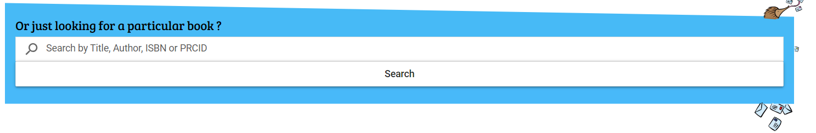
2a. If the title appears, click “Add to Reading Log” to add it as a PRC book
2b. If the title does not appear, you will need to enter it as a personal choice book.
To enter a personal choice book:
- Click on the icon in the top right hand corner:
- Click on “My reading log”
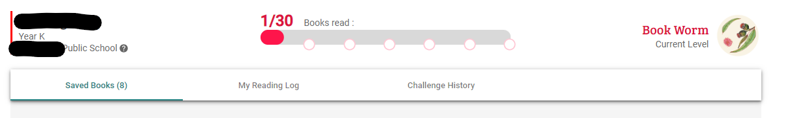
- Fill in the book details under the “Add a Personal Choice book” field and click “add”
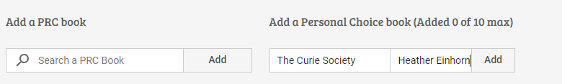
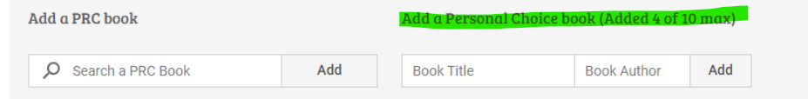

If you have any issues with logging books, please speak to [Coordinator/s name/s] before Friday 6 September 2024.
[PRC Coordinator name/s]

