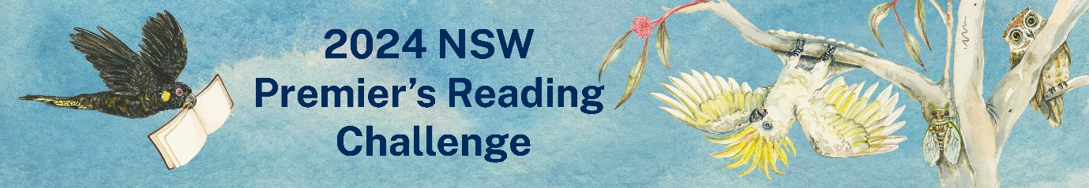
The NSW Premier's Reading Challenge is now open and [insert school name] is excited to be participating!
What is the NSW Premier’s Reading Challenge?
The PRC is a statewide Challenge that encourages students to develop a love of reading for leisure and pleasure in students and enables them to experience quality literature. It is not a competition, but a challenge to encourage each student to read, to read more, and to read more widely.
All students who complete the challenge and have their reading record validated by the school’s PRC coordinator will receive a certificate signed by the Premier of NSW.
How many books do students need to read?
Students in Kindergarten to Year 2 are challenged to read or experience 30 books. 20 of these books must be from the relevant Challenge booklists, and up to 10 books can be personal choice books. Books can be read with a parent, carer, teacher or another student.
Students in Year 3 to Year 10 are challenged to read 20 books independently. At least 10 of these books must be from the relevant Challenge booklists, and up to 10 books can be personal choice books.
If a book is from an approved PRC series, students can enter up to 5 books as Challenge books, and can read up to 10 other books from the same series as Personal Choice books. More information on the rules of the Challenge can be found on the PRC website.
Books must be added to a student’s online reading record by Friday 23 August 2024 in order for their reading record to be validated and receive a certificate.
How do students log their reading?
Students can access the PRC’s Student Experience site using their DoE username and password, or can log into the site via the Student Portal. A video guide explaining how to use the Student Experience site can be found here.
[delete if not relevant to your school] Students may also record their reading on the Personal Reading Log and submit it to the PRC Coordinator by 23 August 2024, who will complete the reading log on the students’ behalf.
How can students find books on the NSW PRC challenge lists?
[Include specific information about how PRC titles are identified in your school library].
[Include information about your local public library if they promote and collect titles on the NSW PRC].
PRC Coordinator name/s
PRC Coordinator/s at [School name]
A quick guide for logging books:
- Log into the Student experience site using your DoE student username and password.
- Use the blue search bar to search for books you have read.
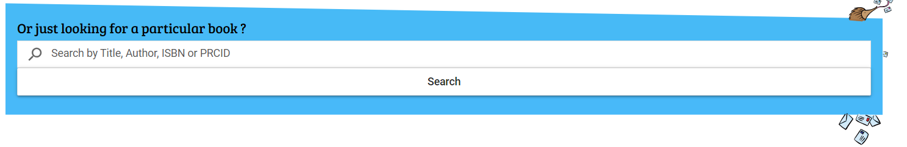
2a. If the title appears, click “Add to Reading Log” to add it as a PRC book.
2b. If the title does not appear, you will need to enter it as a personal choice book.
To enter a personal choice book:
- Click on the icon in the top right hand corner:
- Click on “My reading log”
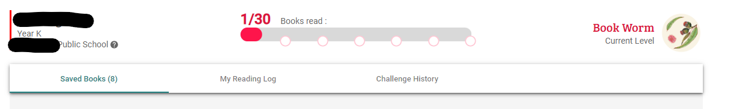
- Fill in the book details under the “Add a Personal Choice book” field and click “add”
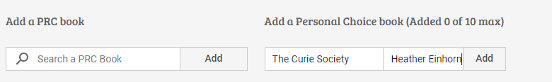

If you have any issues with logging books, please speak to [Coordinator/s name/s].
[PRC Coordinator name/s]

