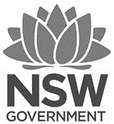

NSW Public Schools Drama Ensembles 2024
Video audition guide

Please perform and film any monologue of your choosing between 2 – 3 minutes long

Below are some suggestions that may help you when filming your audition

- Try to avoid filming the whole audition as an extreme close-up on the face only. The best framing tends to be mid-shot or showing the body and physical life in action. Avoid talking heads only in your piece. Think about appropriate actions in telling your character’s story. Stillness is good if it’s a dramatic choice as we get to see body control but it’s really important to see the whole actor.

- Remember this is an audition for a theatre piece so creating an edited short film where we don’t get to see you act does not work in your favour.

- Make sure it’s a solo performance. Group performances divert attention away from you and may not serve your interests by not showcasing your skills.

- Make sure the video is within time limits. Anything more than 3 minutes is unnecessary.

- Be careful of playing the emotion instead of the intention.

- Show variety. One emotional state for your character can get monotonous. We are rarely just one thing; so a character who demonstrates a range of states is a much better choice.

- We don’t expect a full character journey in this short time frame, but try to show us some kind of change in state for the character, rather than one mood or repetitive physical choice. How do they respond to new information or react differently to a change in circumstances?

- Learn your script. Don’t read from it in your audition.

- Consider good content choices. Whilst we are not “marking” content, there are decisions you can make in terms of appropriateness that are better than others. If you couldn’t perform it in front of your parents or your school community, probably don’t use it to audition for this.

- Consider the space you are performing in. Can you be seen? Does it affect sound quality? Is it big enough?

- Check your video for quality (including being in focus), sound and that the link works before you send it to us. Check it all serves your best needs before sending it to us.

NSW Public Schools Drama Ensembles 2024
Video audition guide

How to upload your footage to YouTube

- Visit www.youtube.com and create an account or “Sign In”

- Select “Upload” and follow the instructions onscreen to upload your video.

- Set your privacy settings to unlisted (anyone with the link can view), then “save changes”. This is important as it means that the general public cannot view the link.

- When this is finished, you will be given a URL for your video. Copy this URL into the online application form.
- How to upload your footage to Vimeo

- Go to www.vimeo.com

- “Log In” or “Join” and create an account if you don’t already have one.

- Select ‘Upload’

- Follow the instructions onscreen to upload your video.

- Set your privacy settings to “only people with a password can see this video” and set the password as Drama23. Please do not use a different password as we will not be able to view the video.

- After you have saved the privacy changes, please click on the “Go To Video” button. Copy this URL into the online application form.

NSW Public Schools Drama Ensembles 2024
Video audition

Digital resources

Top tips for auditioning

https://digital.artsunit.nsw.edu.au/art-bites-series/top-tips-for-auditioning

How to film a video

https://vimeo.com/487959279/fa84f2aceb

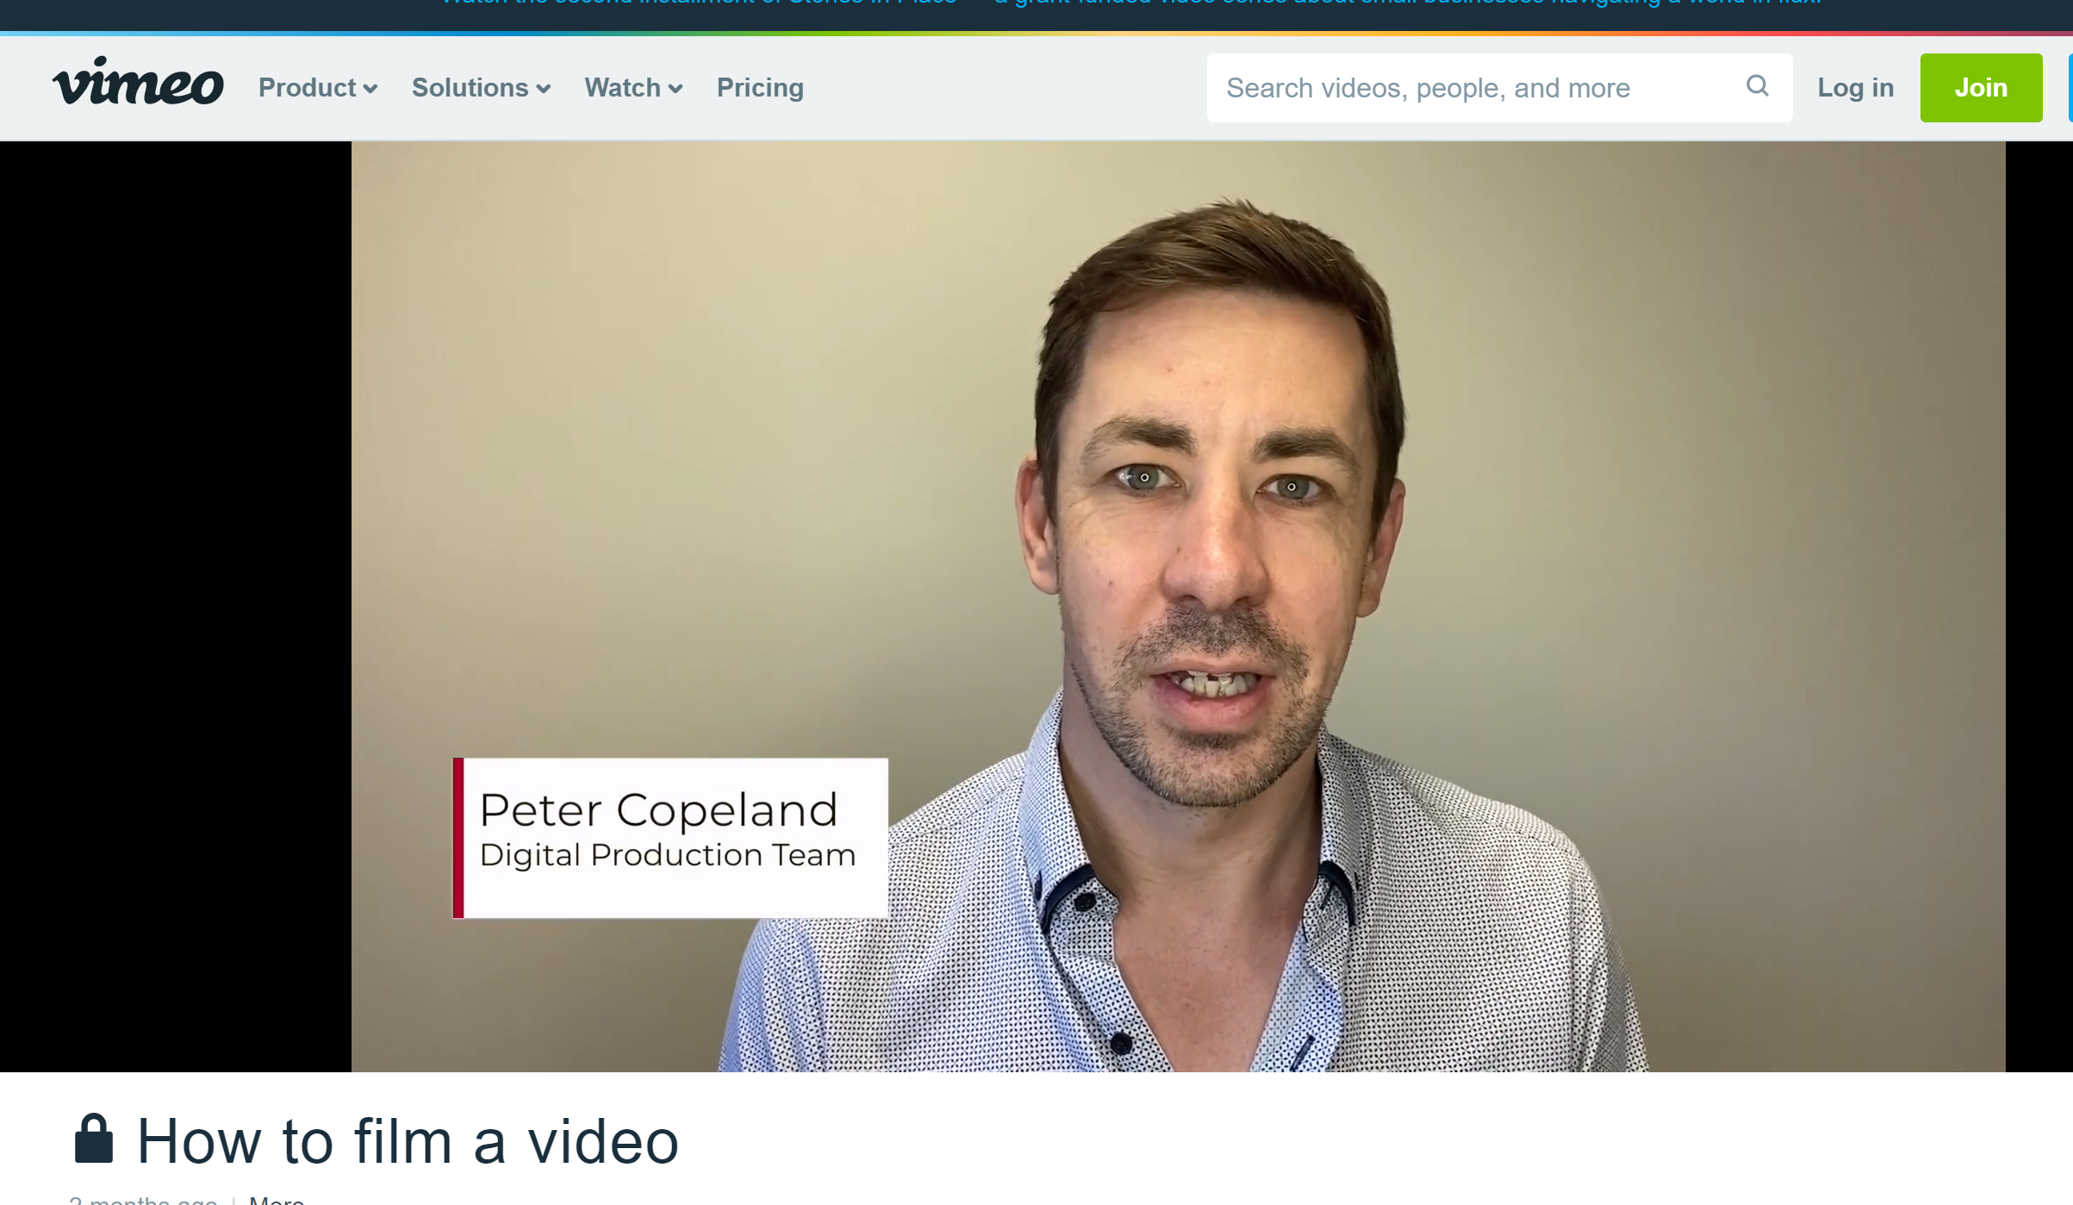

How to edit a video

https://vimeo.com/487959535/68841a5d77

