Bandfest Newcastle 2024

Invitation to Principals
Dear Principal,

Bandfest Newcastle is a DoE performing arts initiative and aims to be an annual festival of banding in our region. The competition celebrates school concert and jazz bands and involves primary and secondary students and last year saw 70 bands from over 40 schools competing. The adjudication is undertaken by some of the region’s finest musicians and provides quality feedback in the form of both a video and written comments to students and staff.

This year Bandfest will be held in Term 4 Week 4 (4-7 November) in the Harold Lobb Concert Hall at The Newcastle Conservatorium, Lamon Street Newcastle and we would love to see you there! Each school will be allocated a time and this can be found on the website artsunit.nsw.edu.au/local-arts-programs/regional-north/bandfest-newcastle or by asking your music or band coordinator.

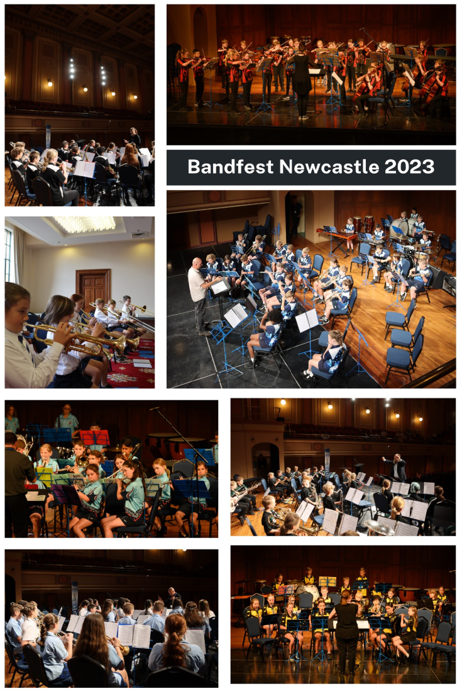
Supporting teachers and principals who have attended in the past have commented that they were not aware that there was such a high standard of music in the Hunter area. They have been pleased to have been able to attend their school’s section and performance and look forward to returning the following year.

The committee would like to take this opportunity to thank you for supporting your school ensemble, as without executive support, events like this simply cannot exist.

Regards
Bandfest Committee

