2024 Taiko Drumming Workshops

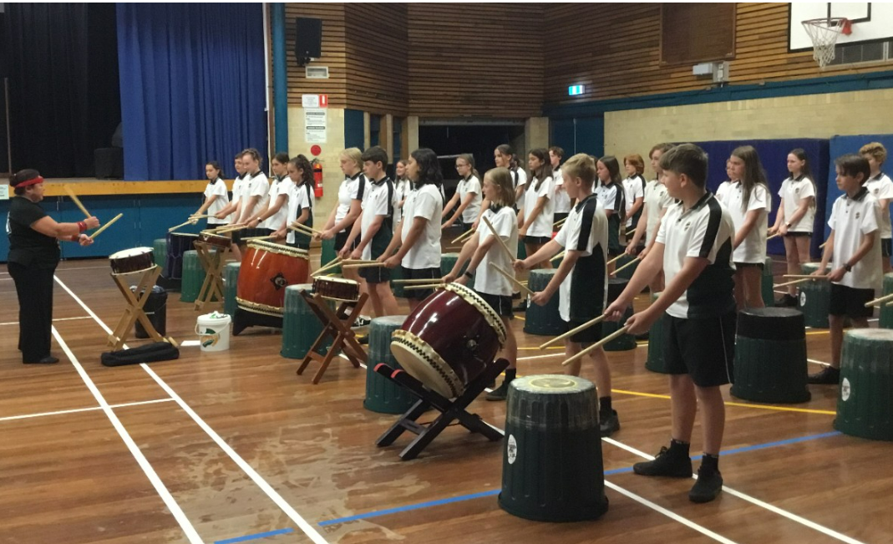
Information package
Image credit: Warners Bay High School
For further information or enquiries please contact the Arts Initiatives team
via email artsinitiatives@det.nsw.edu.au
The Arts Unit, Corner of Toothill Street & The Boulevard, Lewisham NSW 2049.
Locked Bag 1500, Petersham NSW 2049.
Program Coordinator – Ashley Napoleoni, Arts Initiatives and Events Officer
Ph (02) 8512 1190

Taiko Drumming Workshops 2024
- About the program
- Key information
- Student workshop schedule
- How to register
- Items to bring and wear
- Tutor Information
- COVID-19 information and processes
- Supervising teacher checklist
- Payment advice form (face-to-face workshops)
- Payment advice form (online workshops)
- Permission to publish form
- Unaccompanied student medical form
- Behaviour code for students

About the program
This one-day Taiko program is led by professional tutors from YuNiOn, Graham Hilgendorf and Masae Ikegawa. During the session students will learn about Japanese culture and how to play the taiko together. The art form of taiko drumming, which is referred to as Wadaiko, varies greatly from traditional Western instruments. In this art form image and movement are just as important as the sounds created. Through learning about the elements of the taiko art form, students will learn how to play the taiko and move together in unison while playing.
In this workshop students will learn a simple piece of music which includes movement and voice (Kakegoe) and will work through the order of events for the musical piece. The order of events is comprised of a simple introduction, theme, base rhythm, and coda (ending). Students will also have the opportunity to explore improvisation throughout this piece of music.

Key information
Program dates, modes, and venues:
Date | Time | Mode | Location
Monday 26 August | Session 1:  10:00am – 12:00pm  Session 2:  1:00pm – 3:00pm | Online | Online
Tuesday 27 August | 9:30am-2:30pm | In Person | Denison College of Secondary Education – Kelso Campus
Wednesday 28 August | 9:30am-2:30pm | In Person | Nangamay Public School
Thursday 29 August | 9:30am-2:30pm | In Person
Attendees: The program is a non-audition program and is open to all students that attend a NSW Public School in Years 5-12 who love music. Students do not need to have any music training or experience; they must be willing to participate actively in the workshops.
Time: 9:30am-2:30pm (in-person)
10am-12pm or 1pm-3pm (online)
Fees: $33.00 per participating student and maximum 10 students per school for in-person workshops.
$130 per participating school and maximum 20 students per school for online workshops.
This student fee is payable directly to schools. The Arts unit will direct debit the fee from the school after the completion of the workshop.

Student workshop schedule
Please note the below schedule is a guide and that actual times may vary on the day. It is also only applicable for 9am-2:30pm in-person workshops.
Time | Activity
9:00am | Sign On
9:30am | Introduction and stretches
10:10am | Basic taiko techniques
11:10am | Lunch
11:40pm | Learn the arrangement and improvisation
1:30pm | Recess
1:45pm | Arrangement continues
2:00pm | Student performance and Q&A
2:20pm | Cool down
2:30pm | Workshop concludes

How to register
Step 1: Confirm your student numbers and receive approval from your school principal.

Step 2: Complete the online application on The Arts Unit website.

Step 3: Submit your online form. You will receive a confirmation email that your registration is complete.

Items to bring and wear
On the day of the workshop, students should:

- Wear comfortable clothes or their school sports uniform
- Bring a water bottle, snacks and a packed lunch – there is no option to purchase food onsite.
- Bring relevant protective wear (e.g. hat and/or school jacket)
- Students may also choose to bring items such as handballs, books or card games to play during break times.

About the tutors
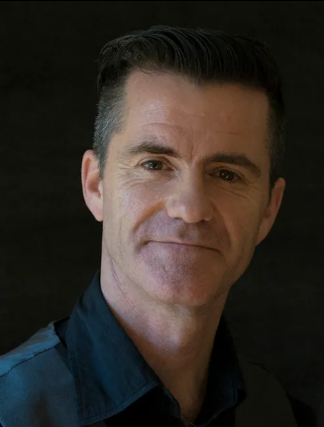
Graham Hilgendorf has studied various percussion instruments and styles of music from all over the world and has a Bachelor of Music Degree (performance) from The Sydney Conservatorium of Music, Sydney University.
Graham is not only a director of YuNiOn, but he is also a founding member of Sydney percussion ensemble B’tutta and was a member of Japanese style drumming ensemble TaikOz for 18 years. He has travelled extensively performing throughout Australia including group concerto performances of Maki Ishii’s ‘Monoprism’ with Australia’s major Symphony Orchestras, toured to Thailand, performing in the Bangkok International Arts Festival, Malaysia, Singapore, Hong Kong, China, Taiwan, and America and performed and given workshops throughout Japan.
As a director and performer in YuNiOn, Graham has taught in classes and schools, performed many school incursions, performed at major festivals, performed, and directed major corporate and sporting events, collaborated with many taiko groups around the Australia and collaborated with many artists including Satsuki Odamura and KANO Yasukazu from Japan.

COVID-19 information and processes
As your child is participating in an extracurricular off-site activity, it is essential that parents and carers acknowledge and understand the risk of COVID-19 and the risk management processes in place by the program organiser:
I acknowledge that this event/activity is required to be held in accordance with any current NSW Health COVID-19 Public Health Orders and the NSW Department of Education’s policies and procedures. I acknowledge and accept that there is a risk that my child may be exposed to COVID-19 whilst attending and participating at this event. I confirm that my child will not attend if displaying any symptoms of illness, and/or if directed to isolate under public health orders.
If your child presents as unwell (including with mild COVID-19 symptoms) they will be temporarily isolated and the parent/carer will be contacted to collect their child immediately from the venue. Throughout the entirety of this program, staff and students will be strongly encouraged to wear masks where possible and practice social distancing.
Please see the NSW Department of Education COVID-safe advice and COVID-smart measures for further information.

Organising teacher – checklist
Prior to the workshop, organising teachers are required to:
- Register students online and ensure all relevant paperwork is complete.
During the workshop, accompanying teachers are required to:
- Supervise students during the workshop and during breaks.

- Ensure that students with medical needs have their relevant medication and Health Care or ASCIA plans. Please also ensure that dur care has been exercised to accommodate students medical and dietary needs on the day of the workshop.

- Identify any students who suffer from allergies which may lead to anaphylactic shock and inform the coordinator at the workshop.

- As per the NSW Department of Education Excursion Policy, teachers are required to bring a first aid kit (including an EpiPen) to the workshop venue.

- Accompanying teachers are encouraged to actively participate in the workshop activities.

